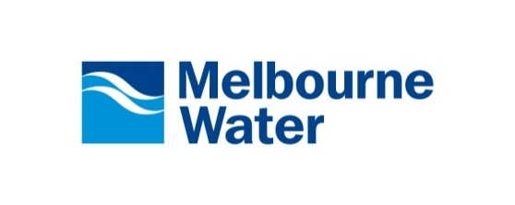
Consultant’s Construction Certification Statement
Job description: | _______________________________________
Municipality: | _______________________________________
Developer: | _______________________________________
Consultant: | _______________________________________
Nominated Rep.: | _______________________________________
Consultant Ref.: | _______________________________________
Melbourne Water Ref.: | _______________________________________

As the Consultant's nominated representative responsible for the construction of the Works detailed in Melbourne Water reference No. _________/________/_________, I certify that:
- the construction of the Works is in accordance with the Conditions of Agreement,
- the construction of the Works has been completed in accordance with our company's Quality Management System (ISO 9001),
- the construction of the Works is in accordance with section 5.0 of the Land Development Manual - Drainage Design and Construction Guidelines and Requirements,
- the construction of the Works is in accordance with Melbourne Water Guidelines and drawings,
- the construction of the Works has taken into account the requirements of all relevant specifications and relevant Australian Standards,
- the source documents have been filed in a manner that can be readily accessed for audit purposes,
________________________________ | ________________________________
Name  (Responsible Construction Representative) | Signature
________/________/________
Date
________________________________ | ________________________________
Name  (Nominated Representative) | Signature
________/________/________ | ________________________________
Date | Company Position

