December 2017

MELBOURNE’S WATER SUPPLY IS SECURE

Our water storages are in the High (Secure) Zone and we encourage our customers to continue to use water wisely.
Melbourne’s water supply system¹, which is made up of our water supply reservoirs and the Victorian Desalination Project, currently has enough water for coming years and our storages remain above the Low (Emergency) Zone under a range of modelled scenarios.
¹For more information on the Melbourne water supply system refer to Water for a future-thriving Melbourne.
Permanent Water Use Rules are currently in place supported by the Target 155 voluntary water efficiency program which encourages Melburnians to continue using water efficiently.
The Victorian Desalination Project is supplying Melbourne with at least 15 billion litres of desalinated water for this year and the next two years. A decision on whether any additional water should be ordered from the Desalination Project in 2018/19 will be made by 1 April 2018.
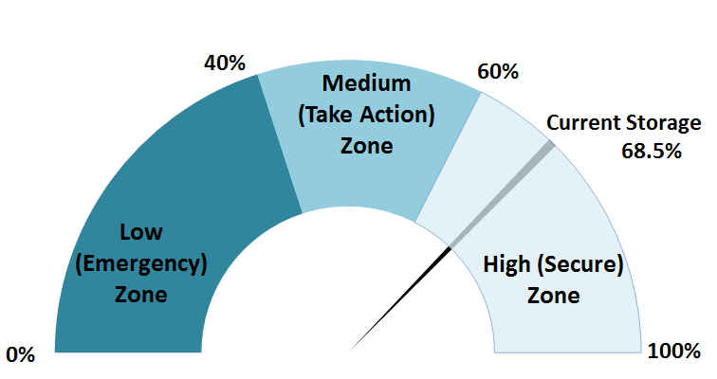
Figure 1: Our water outlook zones and corresponding actions
68.5%
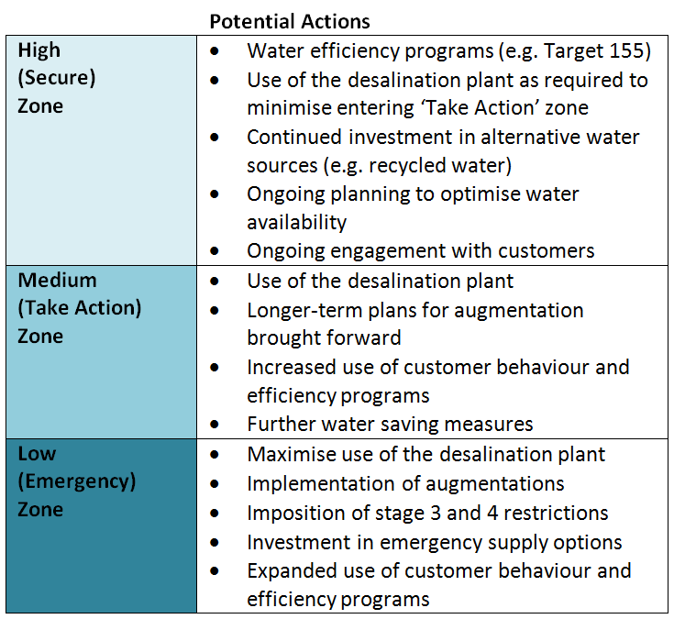

A look to the future

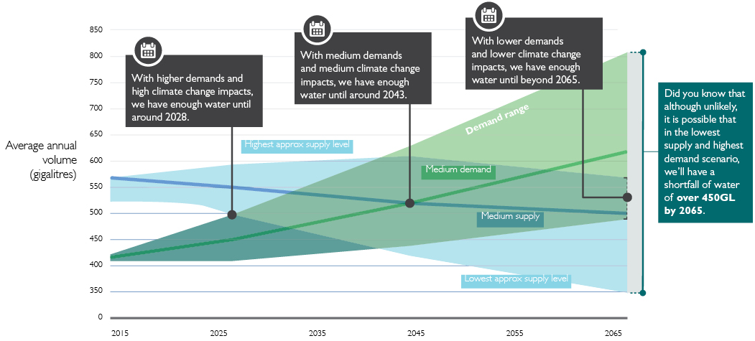
A number of scenarios were modelled to help us better understand our long term water availability.
In June 2017, the metropolitan retail water corporations released their Urban Water Strategies coupled with Melbourne Water’s release of the Melbourne Water System Strategy. Each strategy is reviewed every five years, to ensure ongoing water availability and to establish the strategic water resource investments and actions to 2065. Each aligns with the State Government of Victoria’s Water for Victoria plan. A joint summary of our actions is outlined in Water for a future-thriving Melbourne. Figure 2 shows projected long term water supply and demand trends for Melbourne, noting that there will be variability in specific years.
In addition to each strategy, each retail water corporation has prepared Drought Preparedness Plans (incorporating the Drought Response Plan) which set out actions to prepare for- and respond to - periods of water shortage.

Figure 2: Long term water supply and demand (Source: Water for a future-thriving Melbourne, 2017)

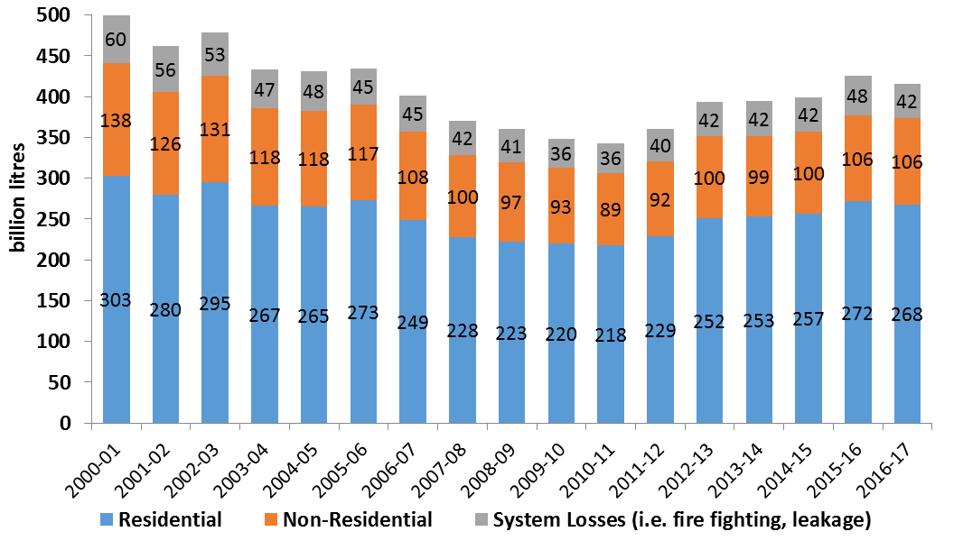
Melburnians continue to be
water wise

Residential customers remain our biggest water users. Both our residential and non-residential customers continue to use water wisely.
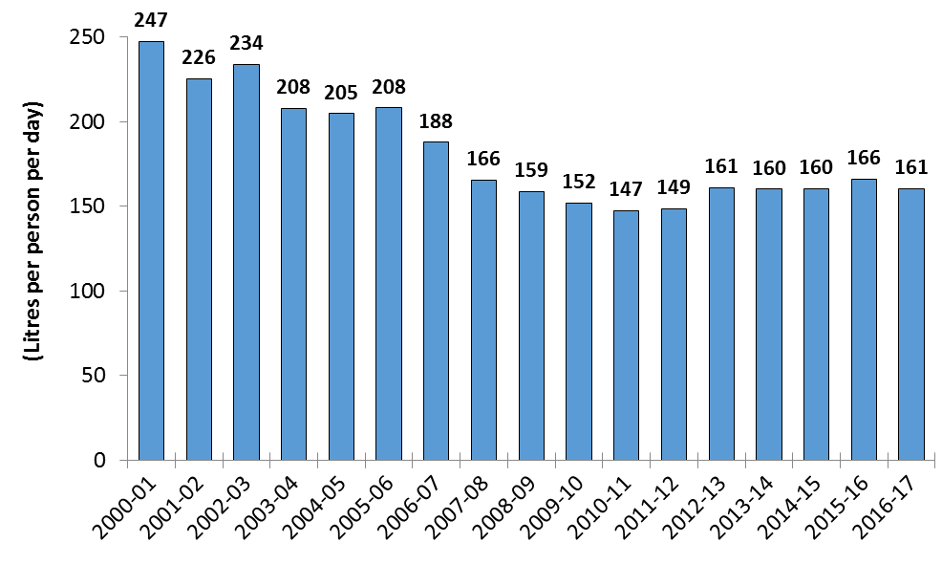
Melbourne’s water usage in 2016-17 decreased by a total of 10 billion litres compared to the previous year. Total water use (see Figure 4) remains below the peak levels experienced during the Millennium Drought (1997 – 2009) despite an increase in population. Residential water use comprised 64% of Melbourne’s total water use in 2016-17 (Figure 3).
Figure 4: Melbourne’s total water use by segment
The residential per-capita consumption for 2016/17 was 161 litres per person per day, as detailed in Figure 5, which is a reduction in 5 litres per person per day since the previous year, we are still working towards Target 155.
To support healthy waterways, since 2011-12 (as detailed in Figure 6), major flows have been released to the Thomson, Yarra and Tarago Rivers to replicate natural flow events to trigger environmental processes such as fish migration and spawning.
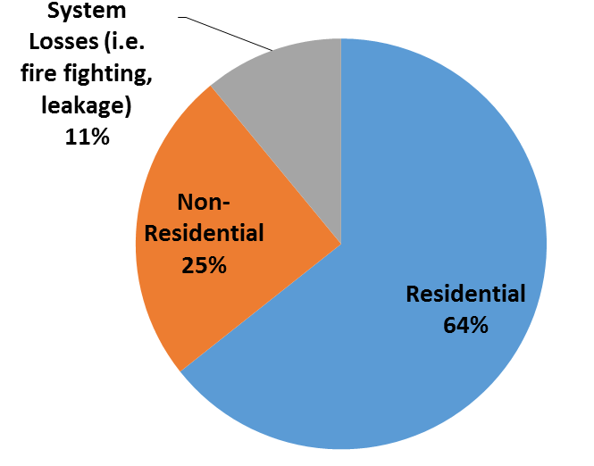
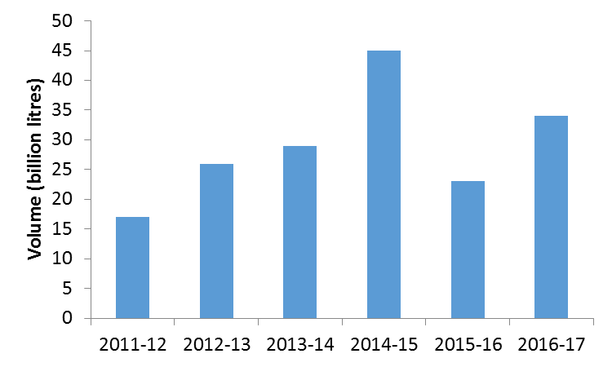
Figure 3: Water use breakdown for 2016-17
Figure 6: Environmental flow releases
Figure 5: Melbourne’s per capita residential consumption

A WARMER AND SLIGHTY WETTER SUMMER AHEAD

The Bureau of Meteorology outlooks show slightly above average rainfall, warmer temperatures, and low storage inflows are more likely for the Melbourne region over the next few months.
Temperature and rainfall influence water use, especially during summer periods for watering gardens, parks, and sportsgrounds. At the same time, rainfall and temperature also influence catchment soil moisture levels and inflows to Melbourne’s storage reservoirs. The water corporations continually monitor storage conditions and the Bureau of Meteorology’s seasonal climate outlooks, which are updated twice a month.
The climate outlook issued on 30 November 2017 indicated that slightly above average rainfall and warmer than average day time temperatures are likely for the Melbourne region this summer.
The Bureau of Meteorology seasonal streamflow forecast issued on 13 November 2017 for Melbourne’s four major storage reservoirs indicated low inflows for the three-month period (November 2017-January 2018).
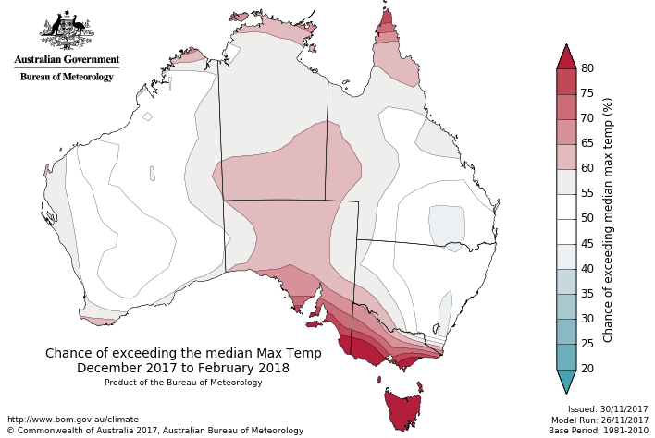
Figure 7: Seasonal temperature outlook for December 2017 to February 2018

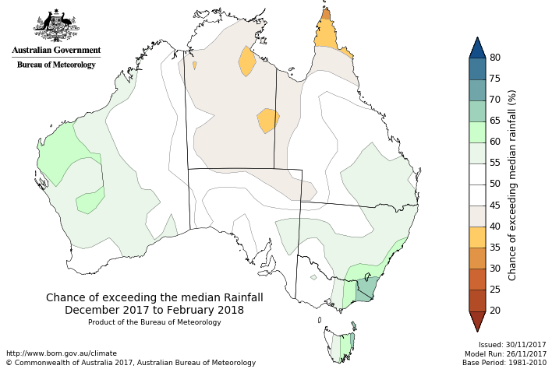
Figure 8: Seasonal rainfall outlook for December 2017 to February 2018
Figure 8: Seasonal rainfall outlook for November 2017 to January 2018

WHAT THIS MEANS FOR MELBOURNE
Water restrictions are not planned for Melbourne in the next 12 months.

As of 30 November 2017, the total system storage level is 68.5%, 4.1% less than the same time last year. The observed storage level trend was consistent with an extreme dry year scenario between December 2016 and July 2017, until Melbourne’s water supply catchments recorded above average rainfall in August and September (see Figure 9 below). Storages are currently lower than they were this time last year, however, as a result of the Victorian Government’s desalinated water orders for 2016-17 and 2017-18, storage levels are 3.4% higher than they otherwise would have been.
Figure 9: Melbourne Total System Storage Outlook (projected from 23 November 2017)
While storage levels are likely to remain in the High (Secure) Zone (above 60%) at 30 November 2017, modelling suggests that they could enter the Medium (Take Action) Zone if dry conditions occur in 2018 (see Figure 9). The modelling has taken into account of the potential water requirements of regional urban water corporations to be met through the water grid. We have a number of actions (as detailed in Figure 1) in the Medium (Take Action) zone, and based on this water restrictions are unlikely for Melbourne over the next 12 months.
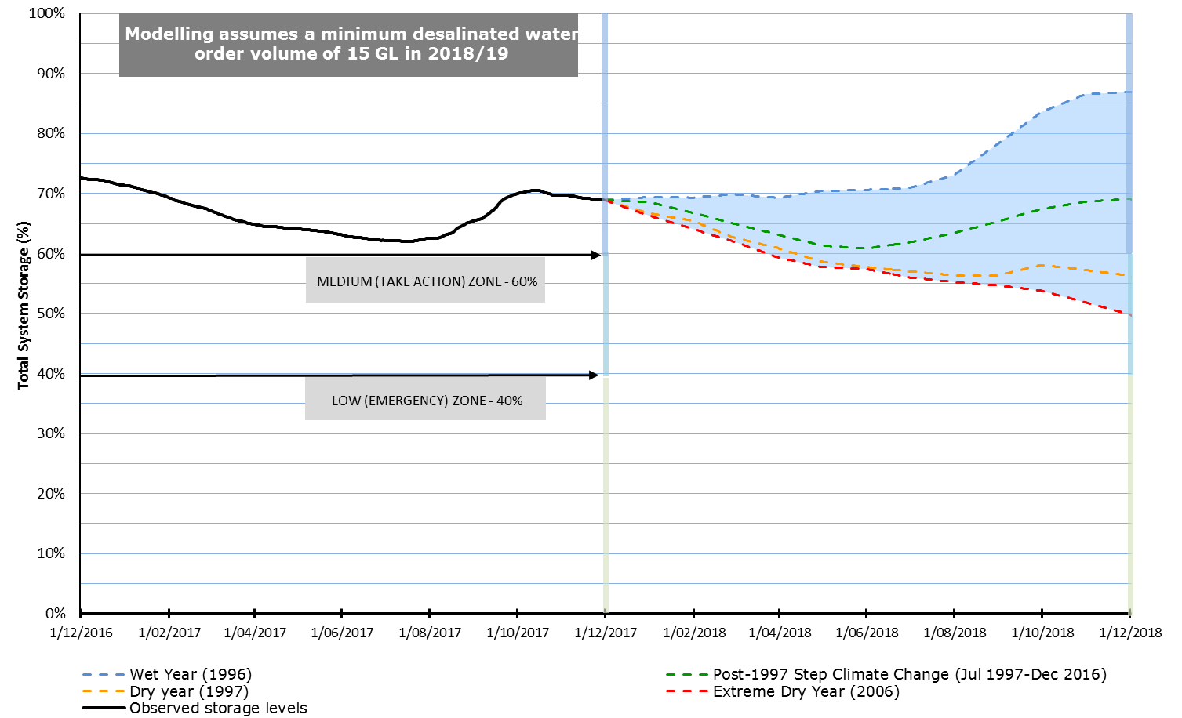

HOW WE WILL ENHANCE WATER AVAILABILITY
We have identified a number of actions in each of our Urban Water Strategies and the Melbourne Water System Strategy as well as our collaborative actions in Water for a future-thriving Melbourne. We have provided a summary of the key actions we are jointly and separately working on to enhance our water availability.
Permanent Water Use Rules | Continue to inform the community about the ‘common sense’ rules which ensure the wise use of water at all times. | 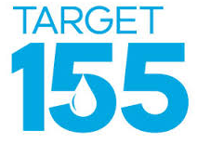  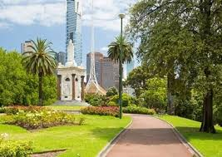
Target 155 voluntary water efficiency program | Continue to deliver the Victorian Government’s Target 155 voluntary water efficiency program that encourages metropolitan Melbourne households to use water efficiently, aiming for 155 litres per person per day.  Development of the Victorian Water Efficiency Strategy identifies opportunities to work together to deliver water efficiency measures.
Water efficiency | By 2020, as detailed in Water for a future-thriving Melbourne, we forecast demands of 150 litres per person per day for residential drinking water use across Melbourne.  We are currently on track to meet these forecasts.
Priority public open space | The three retail water corporations have engaged with the majority of their councils. Each is progressively working with them to develop an aligned approach to drought preparedness for priority open spaces.
Community Rebates Program | Funding provided by Department of Environment, Land, Water and Planning for proactive audit and retrofit programs targeting various vulnerable customer segments across Melbourne.
Integrated Water Management (IWM) | Actively support the Department of Environment, Land, Water and Planning in the formation and delivery of IWM forums and lead the development of place-based IWM plans.
Desalinated water order advice | Annually review the level of water availability and provide advice to the Minister for Water on the need for a desalinated water order.
Key achievements | Released our Urban Water Strategies, Melbourne Water System Strategy and Water for a future-thriving Melbourne which sets out our actions over the next five years to ensure our long term water availability.

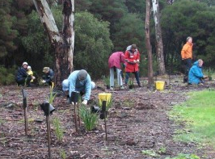
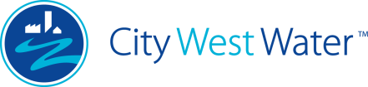
CITY WEST WATER PROGRAMS/PROJECTS
Greening the West | A preventative health initiative to link sustainable water supplies to enable healthy communities through increased greening.
Efficiency programs | Continue to work with residential and non-residential customers to deliver water efficiency projects focussing on sector specific programs.
West Werribee aquifer storage and recovery | Construction has been completed and testing is underway for an aquifer that could store Class A recycled water.
Network efficiency | Undertake active leak detection, reticulation mains renewals, pressure management, intelligent network technologies and rapid response to bursts and leaks.
Schools Water Efficiency Program | Continue to deliver education programs to our local schools and community organisations.
Key achievements | Stormwater Projects: Six projects are operational which equates to approximately 100 million litres per year.  West Werribee dual reticulation: Supply of blended Class A recycled water and potable water commenced in December 2016.  Greening the West: Stony Creek project commenced (a transformation of a 1.5km concrete lined drainage channel to a revitalised waterway and wetland with recreational facilities for residents, schools and community groups).
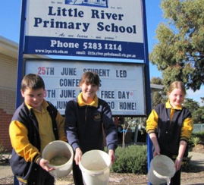
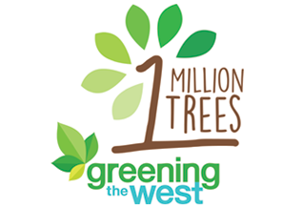

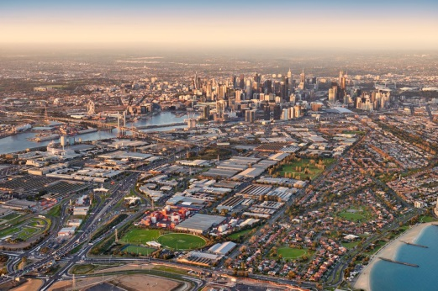
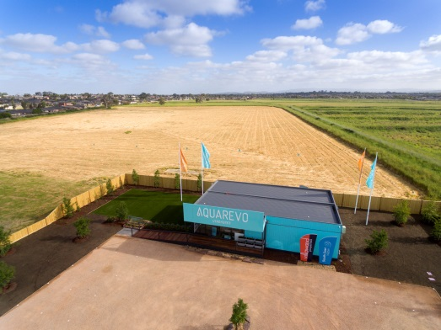
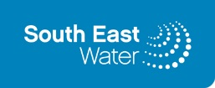
SOUTH EAST WATER PROGRAMS/PROJECTS
Fishermans Bend | Continue to work with key stakeholders and partners, leading edge and sustainable solutions to create a water sensitive city for 80,000 people.
Monash Employment Cluster | To identify most viable and beneficial integrated water management projects to enable the achievement of the vision for the employment precinct (with Yarra Valley Water).
Aquarevo | Integrated urban and water planning to create a liveable community. Utilisation of recycled water and rain water will achieve up to 70% water savings.
Rainwater tank risk review | Undertake research to assess long term regulatory risk and solutions for rainwater tanks, with a key focus on Fishermans Bend.
Efficiency | Continue to enhance the education of customers and stakeholders harnessing our new water education site.
Key Achievements | Fishermans Bend: Integrated water servicing strategy has been developed in collaboration with City of Melbourne, City of Port Philip, Melbourne Water, Environment Protection Authority and Fishermans Bend Hub.  Water Efficiency Appliance Survey: Completed a survey of 1,100 customers to assess the uptake of water efficient appliances and to gain perspective of water use behaviours. Analysis is to be completed.  Aquarevo: Land sales commenced in November 2016 and the first residents will move into their homes through 2018-19.
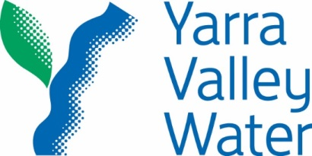
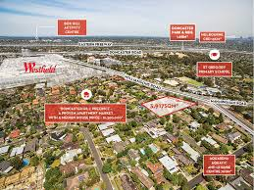

YARRA VALLEY WATER PROGRAMS/PROJECTS
Dual pipe recycled water projects – Northern growth Corridor | Ongoing provision of recycled water to over 100,000 properties in the northern growth corridor (Epping, Craigieburn West, Kalkallo, Wallan) as development proceeds.
Dual pipe recycled water projects – Doncaster Hill | Planning provision of recycled water to approximately 6,000 new lots in Doncaster Hill, predominantly high rise developments.
Network efficiency | Undertake active leak detection, district metering and reticulation mains renewals.
Water efficiency | Sensible water use engagement strategy for our customers to encourage water saving while enjoying the benefits of water and targeting children and gardeners
Schools Water Efficiency Program | Continuation of program in schools with identification of leaks, faulty appliances and inefficient practices – since 2012, SWEP has saved participating Victorian schools more than 4 billion litres of water equating to a saving of more than $11 million.
Key Achievements | Recycled water services in Northern growth corridor: continued roll-out including to suburbs of Beveridge, Craigieburn, Epping, Kalkallo, Mickleham and Wallan  Water recycling planning at Monash (with South East Water) and Latrobe National Employment Clusters: working with Department of Environment, Land, Water and Planning, Melbourne Water and local Councils to review opportunities for water recycling in areas of planned redevelopment  Non-revenue water reduction: continued investment to reduce leakage by 25% primarily through private mains metering and proactive leak detection.
