Accessing the portal and support material

How do I gain access to the ACDC portal for Melbourne Water?
If you are the initial user/ administrator for your organisation, please follow the instructions
below.
(If you already have an administrator within your organisation, please contact this individual and request to be added).

For initial users/ administrators:
1. Go to https://asconstructed.com
2. Click on Request account on the top right hand of the screen:

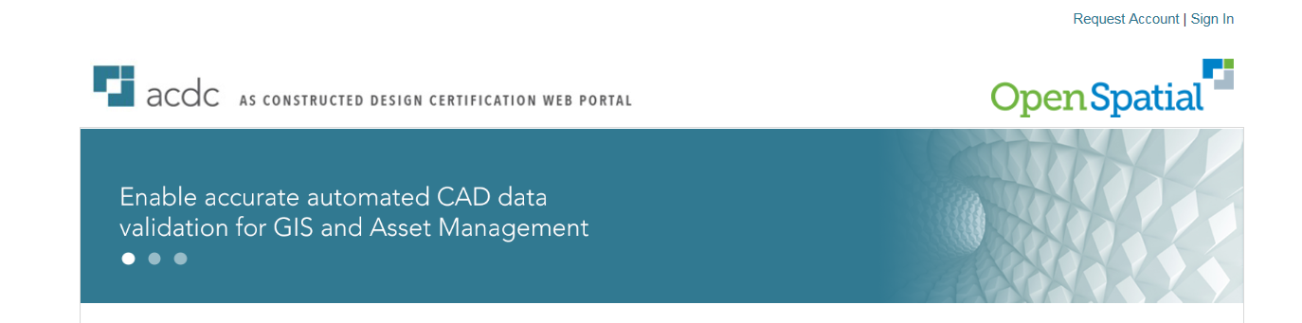

3. Your account will be set up and you will receive a confirmation email within 2 hours.

Please Note: the confirmation email may be directed to your Junk-Email Folder in Outlook. Please check in this folder before re-submitting your request for an account.

Where can I find training documentation and other support material for the MW
ACDC portal before I get started?

You will find all training and support material (including the MW changes for D-Spec, training
material, list of validation rules and FAQs) on the ACDC portal itself under the Documents tab
on the right hand side of the portal.

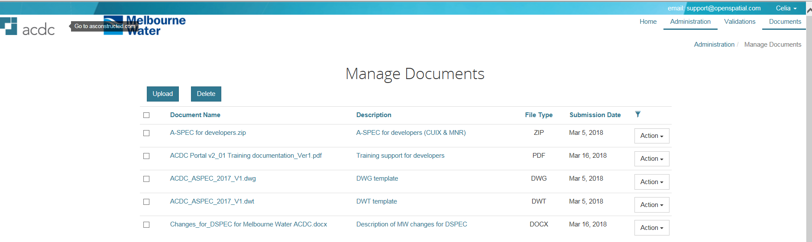

In what format should my drawings be in order to be accepted by the portal?
All as-constructed drawings for pipelines must be
- in AutoCAD format
- D-Spec compliant

What if my organisation doesn’t have Autocad?
There are a number of options.

- Your organisation can purchase one of the following apps:

- The AutoCAD Mobile app Premium (US$50 per annum or $5 per month)
- The AutoCAD Mobile app Ultimate (US$100 per annum $15 per month).

This can be purchased at the following link https://www.autodesk.com/products/autocad-mobile/compare-plans

- The system will also work with AutoCAD LT at $390 per year.

- The Open DWG systems such as BricsCAD will also work with the templates.

Submitting your drawings

I have tried to submit an arc/curve pipe sections as an Arc and as a polyline but neither work.
Arcs must be a segment of a 2D LWPOLY (bulge).

I am confused as to the Parallel_ID is maybe unnecessary as the Pipe_Con is where
you put 2x375 or 1x150 or even box culverts 2x450x900BC etc.
The Dspec submissions as per manual are supposed to be represented by one single
line from centre to centre of pits. Most pipes running parallel have the exact same
invert level so this has been the way we always submit them, I am yet to come
across parallel pipes with different ILs.
Melbourne Water requirements are to represent each pipe as a separate record. Parallel ID serves to create a unique key to identify a pipe record (upstream pit + downstream pit + parallel ID). Not all multi-celled culverts are comprised of identical cells. Pipe diameters, lengths, and invert levels can vary within the same culvert (such as when a dedicated low-flow cell is present).

MPolys don’t seem to work for pits. Our set up/lisp routine spits out mpolys for pits, however I found just exploding them to closed polylines works fine as long as the block for pit is contained inside the closed polyline.
Standard AUTOCAD does not support MPOLYGON features and for compatibility reasons it is not supported in ACDC. You need to use closed LWPOLYLINE objects.

The location field only accepts 20 characters so an address is too long. What is expected in this column from Melbourne Water?
A-Spec documentation (V8.0.2) says ‘Pipe location if not in a street EG: Park Name, Property, Address etc.)’ Twenty characters is the maximum length specified by A-Spec. A default value of ‘N/A’ is acceptable if you cannot fit the entire address in the field.

Are there naming conventions that Melbourne Water requires us to use in order to
submit drawings?
There are currently is no requirement to submit drawings with a particular naming convention.

Will design plans be issued in the current format for engineering drawings?
Yes.

Where to go for further support

Where do I go if I have questions for Melbourne Water after I have submitted my
drawing?
Please email EPMS.PlanRoom@melbournewater.com.au

What should I do if the ACDC Portal is not available?
Contact your organisation’s ACDC administrator who will raise a service request to report the
portal is down with Open Spatial. You may contact Open Spatial yourself via
support@openspatial.com

