Melbourne’s Water Outlook 2023
  - 1 December 2022
We respectfully acknowledge First Nations people as the Traditional Owners and custodians of the water and land throughout our catchment area. We also acknowledge the Traditional Owners of Country throughout Australia and recognise their continuing connection to waters, land and culture. We pay our respects to their Elders past, present and emerging.
In the spirit of reconciliation, we remain committed to establishing and maintaining partnerships with local Traditional Owners to ensure their ongoing contribution to the future of the water management landscape while maintaining their cultural and spiritual connections.

Table of contents
2023 Annual Water Outlook Summary 3
Melbourne’s water supply system 3
Melbourne’s water use in 2021–22 6
A wetter and cooler season ahead 8
Melbourne’s water availability and storage outlook for the coming year 9
The Victorian Desalination Project plays an integral role in our water supply 10
What this means for greater Melbourne in the coming year 12
Water for the environment 13
Meaningful partnerships with Traditional Owners in water management 14
Long-term water planning outlook 15
Planning for the future 16
Making every drop count 17
Key achievements 17
Greater Western Water programs and projects 18
South East Water programs and projects 19
Yarra Valley Water programs and projects 20

2023 Annual Water Outlook Summary
The Annual Water Outlook is developed collaboratively by Greater Western Water, Melbourne Water, South East Water and Yarra Valley Water due to the shared nature of Melbourne’s water sources.
The Annual Water Outlook provides the communities we serve a summary of our water availability and demand and what this means for Melbourne, including actions the water industry is taking to secure our water supplies over the next 12 months and longer term.
Melbourne’s water storages are at 98.2% (24 November 2022), benefiting from high rainfall and inflows into our catchments over the last three years, including the third consecutive La Niña. Our storages have recovered well and are almost at capacity, building resilience against climate variability. We are in the ‘Be Responsible’ water outlook zone and do not expect any water restrictions for Greater Melbourne over the coming 12 months. Still, with a long-term warming and drying trend and a population forecast to double by 2070, we must continue to use water responsibly and prepare now for the future.
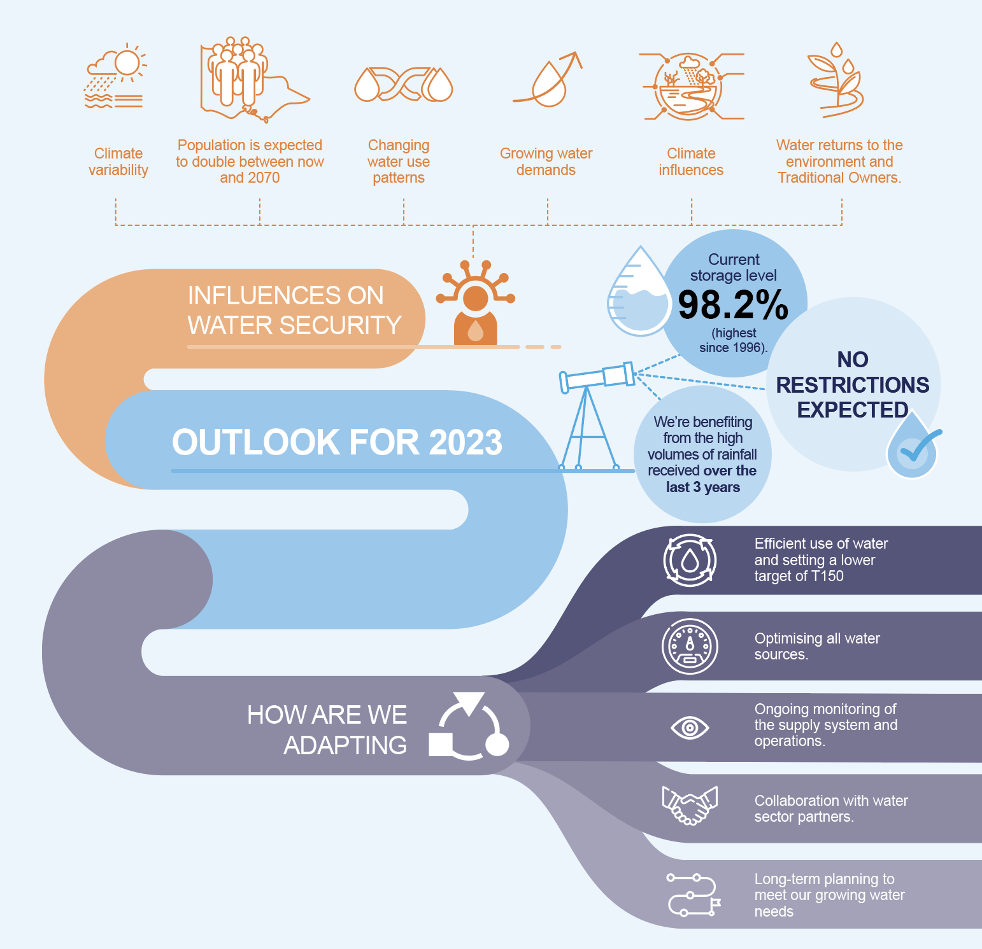

Melbourne’s water supply system
Delivering high-quality water to our customers and ensuring resilient water supplies into the future are high priorities.
The annual volume of water supplied to Melbourne and regional areas depends on a range of factors including climate conditions, population growth and customer use.
Melbourne’s retail water corporations – Greater Western Water, South East Water and Yarra Valley Water – deliver water to the community. Melbourne Water provides wholesale water services to the retail water corporations (Figure 1).
Around 62% of the water stored in Melbourne’s water supply system is available for greater Melbourne (Figure 2). The rest is water held by other water entitlement holders, like regional water corporations, the Victorian Environmental Water Holder (VEWH) and irrigators, or water that is not readily accessible under normal operating conditions (access to this water is limited due to infrastructure constraints and there is elevated risk to water quality or maintaining water transfers).
Melbourne Water supplies water to Southern Rural Water and other regional water corporations, including Barwon Water, Gippsland Water, South Gippsland Water and Westernport Water (Figure 3). While each regional water corporation has its own Annual Water Outlook, we account for their water use, along with other Melbourne Water customers, when planning for Melbourne’s water security. Water is also allocated for environmental purposes, to contribute to the ongoing health of our waterways and respond to drought.
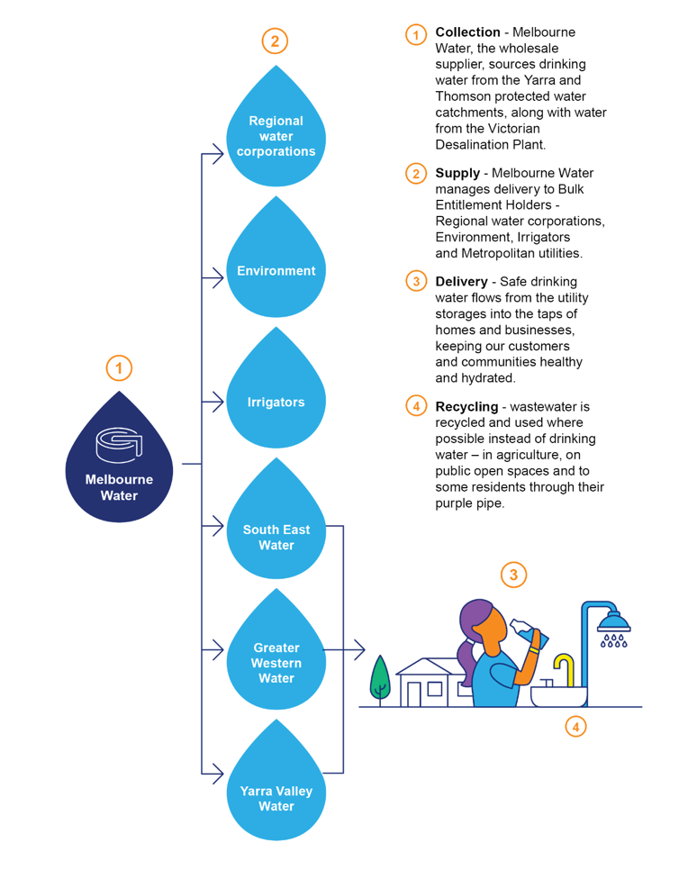
Figure 1: Delivering water to you
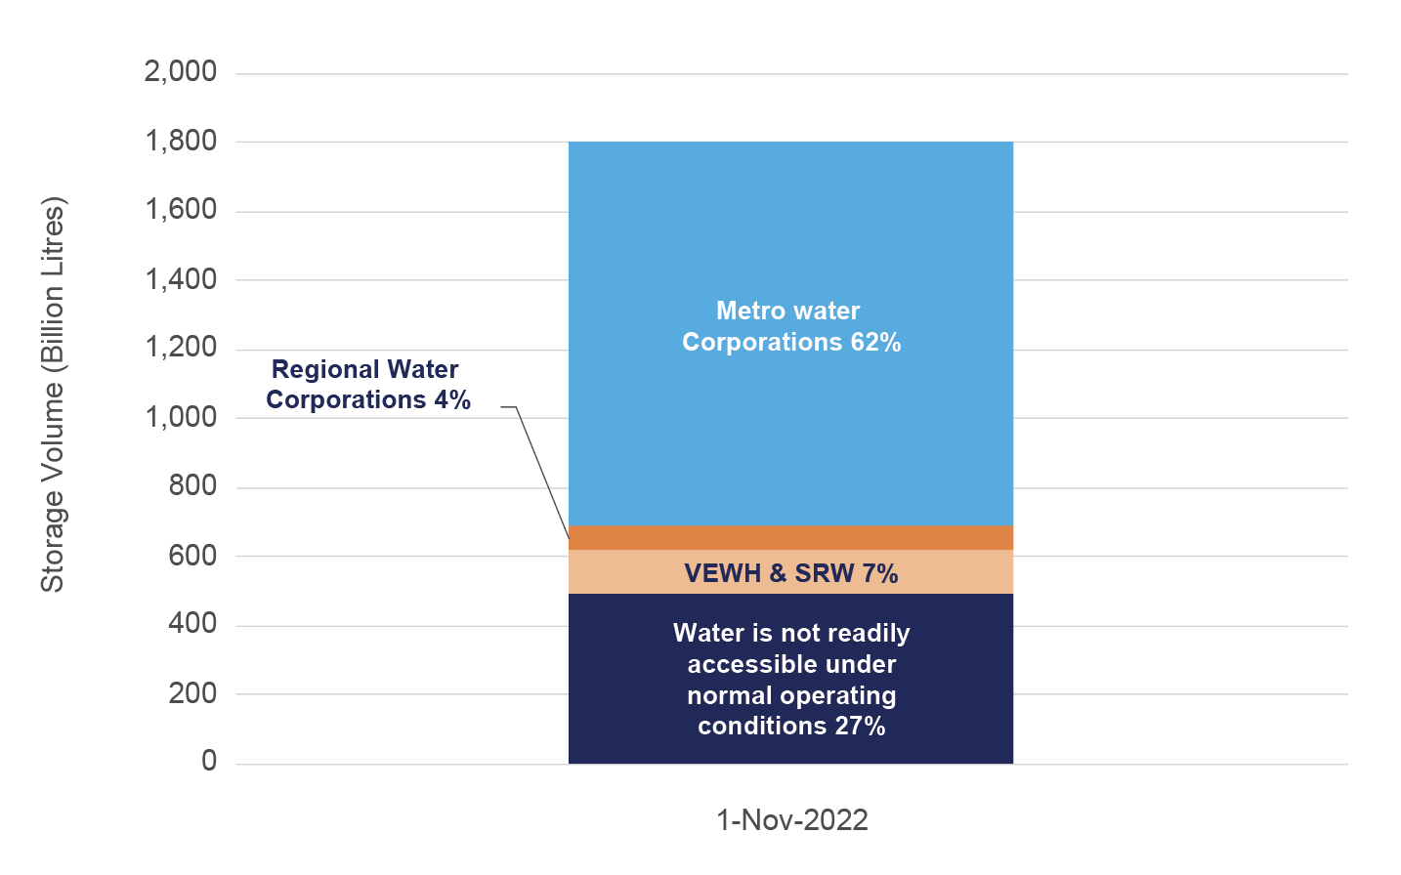F2
Figure 2: Water management in Melbourne’s storages
Note 1: Metropolitan water corporations are Greater Western Water, South East Water and Yarra Valley Water; VEWH is the Victorian Environmental Water Holder; SRW is Southern Rural Water; and regional water corporations are Barwon Water, South Gippsland Water and Westernport Water.
Note 2: Water is not readily accessible under normal operating conditions means access to this water is limited due to infrastructure constraints and there is an elevated risk to water quality or maintaining water transfers.
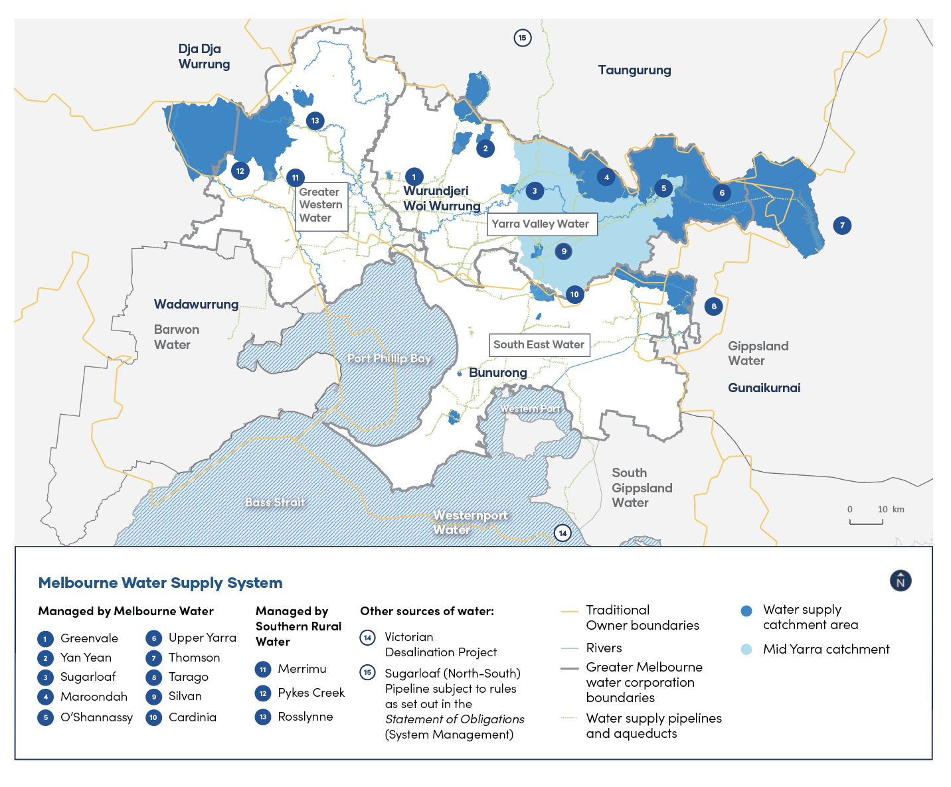
Figure 3: Melbourne water supply system

Melbourne’s water use in 2021–22
It’s important that we are prepared to respond to changes in climate and population.
The 2023 Outlook integrates all greater Melbourne water use and population data, including the north western areas (previously managed by Western Water, now Greater Western Water). This integration better reflects water use and demand across our entire service region (Figure 4, Figure 5 and Figure 6).
Residential water use accounted for 69% of Melbourne’s total water use in 2021–22 (Figure 4). Despite above average rainfall, a cooler-than-average summer and changes in water use patterns from continuing to work from home due to coronoravirus (COVID-19), per capita water use increased from last year.
Based on updated Census population data and integrating the previous north western service region, per capita water use across greater Melbourne for 2021–22 was 164 litres per person per day (Figure 5). In comparison, 2020–21 showed a Melbourne per capita rate of 160 litres per person per day.
Over the past few years, estimated population data may not have shown the complete picture. Census data released in June 2022 has given us more accurate population data, showing a slight decrease in population from last year’s estimate. In previous years, average water use per person appeared lower due to an overestimated population, as the total volume of water used was spread across a larger population (Figure 6).
With changes in water usage, climate and population we must be prepared for the future by continuing to use water responsibility.
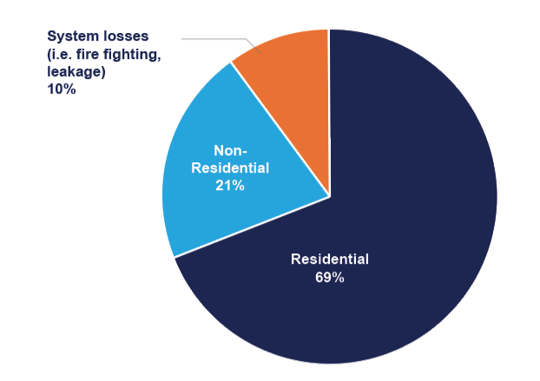
Figure 4: Greater Melbourne water use breakdown 2021–22
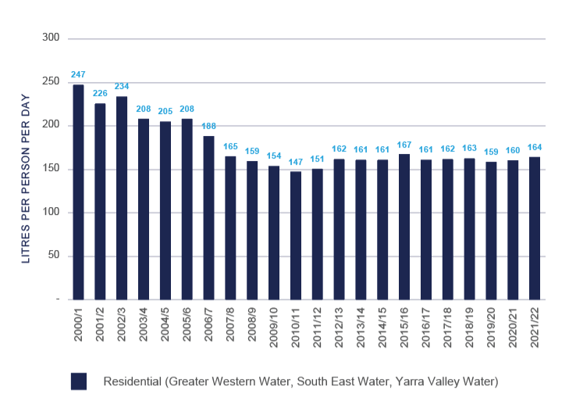
Figure 5: Greater Melbourne’s per capita residential consumption
Note: The 2021 bringing together of City West Water and Western Water to create Greater Western Water allowed for more integrated supply planning for the Melbourne system to the city’s western areas. In last year’s Outlook, consumption data for the north-western regions was reported separately due to the nature of the supply systems and reporting processes. Incorporating the full Greater Melbourne region has slightly increased previous year’s reported water consumption (Figure 5).
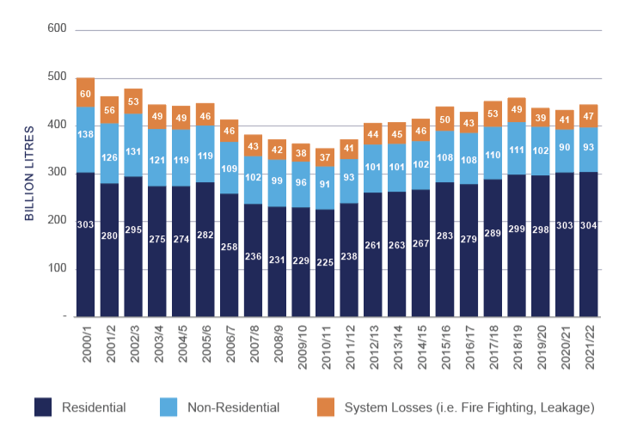
Figure 6: Greater Melbourne’s total water use by segment

A wetter and cooler season ahead
The Bureau of Meteorology outlooks show above-average rainfall and cooler weather is likely for Melbourne over the coming months with a third consecutive La Niña year established. A triple occurrence of La Niña has only been recorded twice since 1900.
Temperature and rainfall influence water use, particularly during summer periods when more water is used to water gardens, parks and sports grounds. The same factors also influence inflows to our storages.
The wet weather over recent years is the result of multiple climate influences, which vary yearly. This year, 2022-23, is the third consecutive La Niña year, and the latest Bureau of Meteorology data (22 November 2022) indicates that it is likely to ease in early 2023. A triple occurrence of La Niña has only been recorded twice since 1900. La Niña events, and other climate influences, such as the negative Indian Ocean Dipole that occurred in 2022, increase the seasonal chances of above average rainfall for eastern Australia.
Despite wet years in 2021 and 2022, research from the Bureau of Meteorology and the Commonwealth Scientific and Industrial Research Organisation (CSIRO) points to a long-term trend of less rainfall, less run-off into our rivers and storages, and more severe and prolonged droughts as a result of climate change. The State of Climate 2021/22 Outlook report produced by the Bureau of Meteorology notes, on average, Australia’s climate continues to become warmer, driving an increase in volatility and more extreme weather events, such as intense droughts and short duration heavy rainfall events.
We continually monitor storage conditions and the Bureau of Meteorology’s seasonal climate outlooks to support the resilience of our water supply.
Please refer to the Bureau of Meteorology’s website for further information about the rainfall and temperature outlooks and Climate Driver Update.
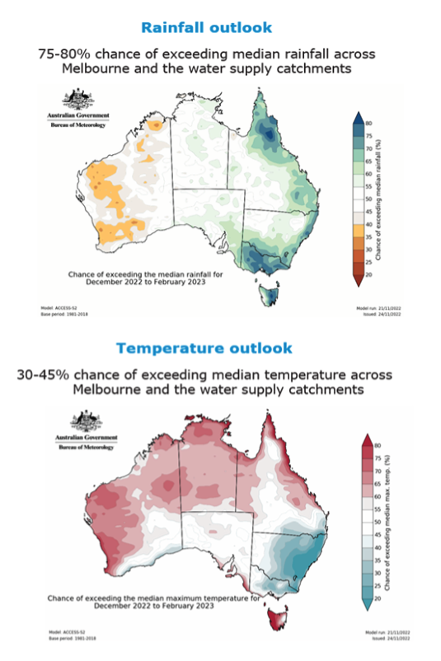
Figure 7: Seasonal rainfall and temperature outlook for December 2022 to February 2023

Melbourne’s water availability and storage outlook for the coming year
As of 24 November 2022, our storages are 98.2% full. This is the highest they have been since October 1996 and 157 billion litres or 8.7% higher than last year.
Several factors have helped increase storage levels and improve our water security:
- we’ve benefited from high rainfall and inflows into our catchments over the last three years (including the third consecutive La Niña year)
- desalinated water orders since 2016–17
- ongoing water efficiency and conservation programs.
In 2021–22, the inflows to Melbourne’s four major harvesting storages were 33.5% above the 30-year average. Since 2017, around 455 billion litres of desalinated water contributed to our supply. Our total storage volume would be around 25.2% lower (at 73.1%) without this extra water (Figure 8) and Melbourne residents would likely have seen water restrictions in recent years.
A greater volume of water in storage helps improve our water security and system resilience against challenges like bushfires, severe storm and rainfall events, and more frequent extended drought conditions. However, keeping storages high can also increase the potential for water from our storages to overflow into waterways.
These overflows are normal and happen most years at Melbourne’s smaller reservoirs, due to natural inflows. As we hold our storage levels higher, we expect overflows to be a normal part of our water system management in some years.
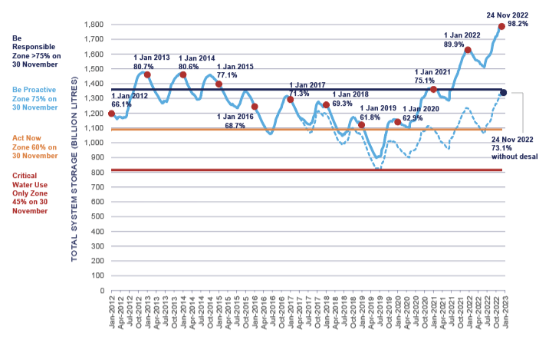
Figure 8: Contribution of desalinated water
Note: Figure 8 includes the revised water outlook zones, which help guide actions to maintain the security and resilience of our water supplies. The revised water outlook zones are further explained on page 11.

The Victorian Desalination Project plays an integral role in our water supply
Each year the Victorian Government considers a Victorian Desalination Project (VDP) water order for the following financial year, based on advice from Melbourne’s metropolitan water corporations. We base this advice on balancing the benefit of higher water volumes in storage and customer impacts.
On average, our annual water demand has regularly exceeded the yearly average catchment inflows by approximately 50-70 billion litres, and we make up the balance with desalinated water. The capacity of the VDP is 150 billion litres per year, or around one-third of Melbourne’s current annual water demand. In times of dry weather events storage levels can fall faster and there are limited opportunities to improve water security apart from desalinated water orders, water conservation campaigns and restrictions.
For 2022–23, 15 billion litres was ordered from the VDP, with 4.2 billion litres delivered. Based on current high storage levels, projected weather patterns including a third consecutive La Niña summer event, water demand and the resultant risk of potential overflows from storages, the remaining 10.8 billion litres of the 2022-23 desalination order will not be delivered.
An annual order allows us to adapt to current conditions while ensuring we keep storages high so that we are prepared for future variability and growing water demands.

Storage Outlook
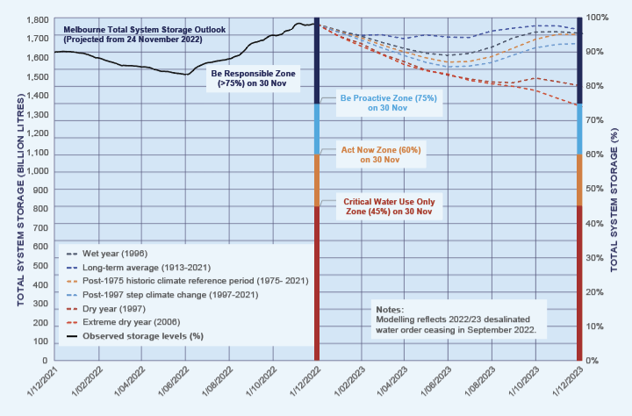
Figure 9: Melbourne total system storage outlook (projected from 24 November 2022)
While storage levels are high and are expected to remain high under average conditions, they could trend towards the Be Proactive zone (Figure 11) if there are extremely dry conditions, like those seen during the Millennium Drought.
Melbourne Water continues to monitor and operate the water supply system to minimise the risk of overflows from individual reservoirs by transferring water to reservoirs where there is capacity and increasing the water usage (demand) from reservoirs at risk of overflows. Water can also be released from reservoirs in a controlled manner before reservoirs overflow into waterways and this option will be considered during future system operation. For up-to-date storage level information, visit Melbourne Water - Water storage levels.
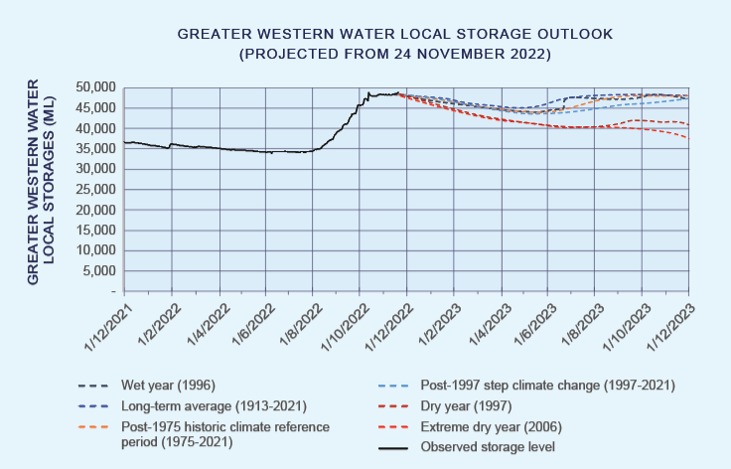
Figure 10: Greater Western Water total system storage outlook (projected from 24 November, 2022)
Some towns in the northwest of the Greater Western Water area are supplied with multiple sources, including surface water, groundwater and a reliance on a regional water grid. Greater Western Water currently holds 48.9 GL billion litres in Merrimu and Rosslynne systems (Figure 10), which is not included in Melbourne’s total system volume (Figure 9). These local water supply systems help maintain a balance between water supply, storage buffers and consistency in water quality. Ensuring these areas have the same level of service and water restrictions as the rest of Melbourne is a priority for system operators. We expect no water restrictions in any part of greater Melbourne throughout the coming 12 months.

What this means for greater Melbourne in the coming year
We assess and manage greater Melbourne’s water security position through water outlook zones, as shown in Figure 11. Every five years we review the water outlook zones to help guide the appropriate actions when needed, based on the volume of water in Melbourne’s storages at 30 November each year.
As of 24 November 2022, our storages are 98.2% full. We are in the ‘Be Responsible’ outlook zone (Figure 11) and do not expect any water restrictions for greater Melbourne over the coming 12 months.
Even with high storage levels, wet periods can be followed by dry and extremely dry years. As it is impossible to predict when the next drought will occur, the best way to protect the resilience of our supply now and into the future is by:
- maintaining high volumes of water in our storages
- optimising existing water sources
- ongoing investment in water efficiency and conservation campaigns
- continuing short and long-term water planning to improve the resilience and security of our supply.
Despite the very rare likelihood of restrictions, extreme events or emergencies such as bushfires in our catchments, major loss of power supply or water contamination could require the implementation of restrictions to manage water demands. We continue to monitor and operate the water supply system to minimise the risk of restrictions.
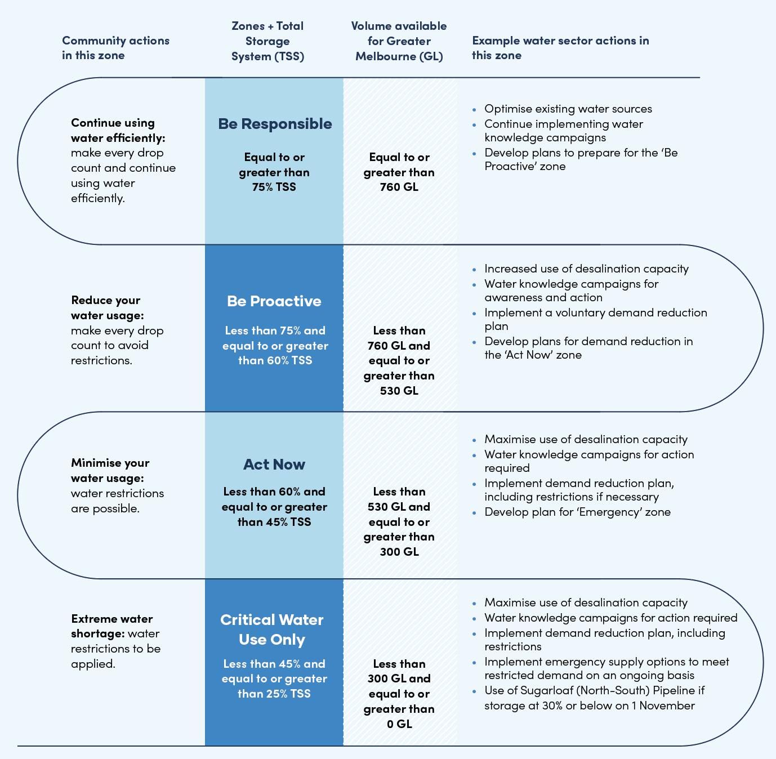
Figure 11: Water outlook zones
Note: The revised water outlook zones for all of greater Melbourne take into account growth in demand and align with the focus on keeping storage levels high and maintaining supply from all water sources.

Water for the environment
The recent wet conditions have provided additional opportunities to support the ecological health of our rivers and flood plains.
Our waterways are an important resource shared by people, plants and animals and have deep cultural significance for Traditional Owners. That’s why the environment holds water entitlements to keep waterways healthy. The Victorian Government’s Central and Gippsland Region Sustainable Water Strategy highlights that investing in the health of our rivers and waterways is essential to our region’s economic, social and environmental future. The strategy includes targets to return water to the environment in major rivers across the region over the next 10 years.
Melbourne Water is responsible for delivering water for the environment in the greater Melbourne region on behalf of the Victorian Environmental Water Holder (VEWH) and other partners. Melbourne Water conducts studies to identify the flows needed by a particular river or wetland and monitors them to ensure environmental flows are effective, in accordance with the VEWH’s Seasonal Watering Plan.
In most years, some of Melbourne’s smaller storages overflow and can support environmental outcomes downstream for the health of our waterways. This water is considered part of the environmental water reserve. In 2022, we saw overflows from Thomson Reservoir, the greater Melbourne system’s largest reservoir, spilling for the first time since 1996. We also saw overflows from O’Shannassy, Maroondah, Trago and Yan Yean reservoirs. We aim to manage water releases from our reservoirs ahead of any unplanned overflows to optimise environmental outcomes.
During 2021–22 (Figure 12), water for the environment was delivered in the Thomson, Yarra, Tarago, Maribyrnong and Werribee rivers. These releases are called ‘priority watering actions’. Higher than average streamflows achieved some priority watering actions naturally in 2021–22. The recent wetter conditions allowed us to deliver additional watering actions, improving the ecological resilience of more waterways and wetlands. We have rarely had the opportunity to meet these priority watering actions as our river systems experienced several dry years before 2020-21.
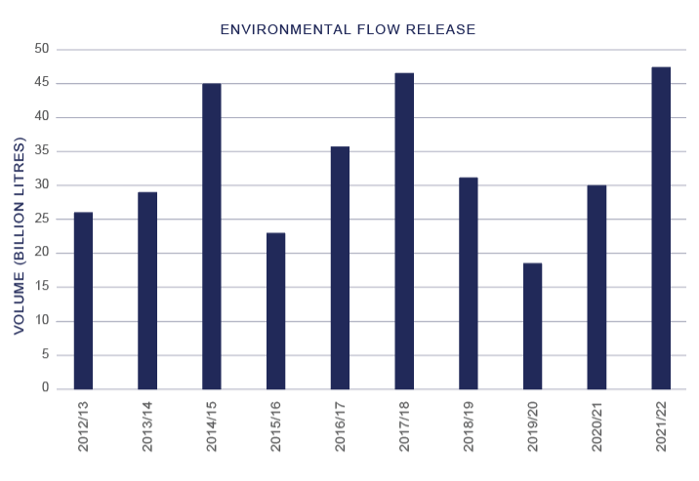
Figure 12: Environmental flow release
During 2022-23, more priority watering actions will be delivered in line with the VEWH’s Seasonal Watering Plan and monitored to capture what actions are achieved naturally or through water supplied for the environment. For example, the Annulus billabong will receive environmental water for the third year based on monitoring feedback. The watering helps reduce weeds, allows native vegetation to thrive and makes the billabong a haven for frogs and birds. For the lower Yarra (Birrarung) billabongs, Traditional Owners are included in the watering decision-making process, where we take a landscape-scale approach. Working on Country with Wurundjeri Woi Wurrung Cultural Heritage Aboriginal Corporation’s Natural Resource Management team, referred to as the Narrap Team, has helped build a meaningful monitoring program that includes eel monitoring.

Meaningful partnerships with Traditional Owners in water management
Traditional Owner groups’ deep understanding of water should be honoured and respected in water management and decision making.
Traditional Owners in the metropolitan supply and service region are Bunurong Land Council Aboriginal Corporation, Djaara (formerly Dja Dja Wurrung Clans Aboriginal Corporation), Gunaikurnai Land and Waters Aboriginal Corporation, Taungurung Land and Waters Council, Wadawurrung Traditional Owners Aboriginal Corporation and Wurundjeri Woi Wurrung Cultural Heritage Aboriginal Corporation. These are formally recognised Traditional Owner groups under the Aboriginal Heritage Act 2006.
Figure 3 shows the Traditional Owner Countries our corporations operate in, and where Traditional Owners are the primary guardians, keepers and knowledge holders. These five Countries are interconnected through water, and the water we rely on flows from Country inside and outside our operating regions.
We recognise the long history and connection that Traditional Owners have with land and water and, with that, the knowledge and expertise they bring to managing natural resources. Through genuine partnerships, we aspire to work together to maintain and improve the health of Country and support the health and wellbeing of all First Nations people.
We are committed to partnering with Traditional Owners, as the original custodians of the lands and waters, on water planning, management and enabling water justice. The Central and Gippsland Region Sustainable Water Strategy provides important commitments for our corporations to identify opportunities to return water to Traditional Owners, remove barriers to water ownership and strengthen the role of Traditional Owners in water planning and management. The Greater Melbourne Urban Water & System Strategy: Water for Life (see page 13) underpins these commitments through its approach to building longstanding partnerships with Traditional Owners.
We have various mechanisms to support these commitments, such as:
The Water for Victoria plan (Victorian Government)
- Water Is Life: Traditional Owner Access to Water Roadmap (Victorian Government)
- Central and Gippsland Region Sustainable Water Strategy (Victorian Government)
- Water for Life strategy
- Section 8a of the Water Act 1989 Victoria
- Commonwealth Native Title Act 1993
- Victorian Traditional Owner Settlement Act 2010
Further, the National Agreement on Closing the Gap commits parties to negotiate a new inland waters target. The inland waters target is expected to be agreed later this year, supporting returning water to Traditional Owners across Australia. These mechanisms highlight that First Nations people have a continued connection and responsibility to care for land and water, and together we must enable this.

Long-term water planning outlook
A variable climate, population growth, changing water use patterns and other factors influence long-term supply and demand for water.
Victoria’s climate and streamflow are highly variable and within this variability we have experienced a warming and drying trend over recent decades. With a warmer future and projections of declining water availability, we can expect lower stream flows on average into our dams and the potential for more frequent and severe droughts.
Victoria’s strategic water management framework guides Melbourne’s long-term water resource planning (Figure 13) to support our long-term challenges. The Greater Melbourne Urban Water & System Strategy: Water for Life (Melbourne’s joint urban water strategy and system strategy - pending release in 2023) will replace the existing urban water strategies (UWS) and Melbourne Water System Strategy (MWSS).
The new strategy has been developed jointly by Greater Western Water, Melbourne Water, South East Water and Yarra Valley Water and supports our ongoing approach to managing our water resources collaboratively.
The Water for Life Strategy is aligned with the Central and Gippsland Region Sustainable Water Strategy, released in September 2022, and the Victorian Government’s Water for Victoria plan. It builds on the commitments made in the 2017 UWS and MWSS, which support the ongoing resilience and security of our water supply and includes the need to provide more water for the environmental health of our waterways and returning water to Traditional Owners.
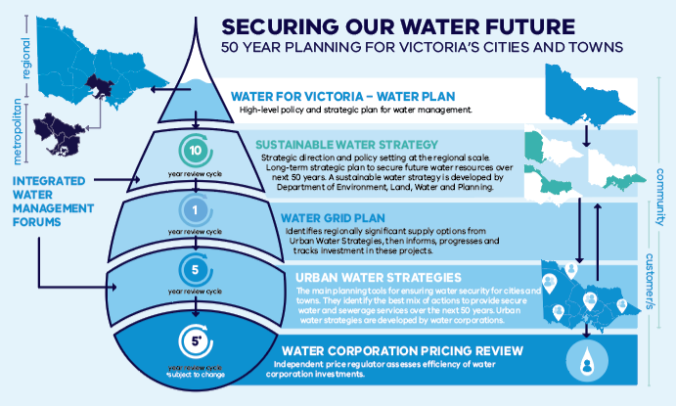
Source: Department of Environment, Land, Water and Planning, (DELWP)
Figure 13: Victoria’s strategic water management framework
We’ve delivered against the actions in our UWS and MWSS through partnerships with government, business and community. We’ve done this by finding innovative and sustainable ways to secure our water supplies, such as:
- implementing water efficiency measures
- investing in recycled water initiatives
- harvesting more stormwater for irrigation and other fit-for-purposes uses.
See page 16 for actions from each water corporation.

Planning for the future
We are operating in a drying climate over the long term, with the challenge of population growth and increased water demands. Against this backdrop, we should act now to prepare for the future while storages are high.
Through the Water for Life Strategy and the Central and Gippsland Region Sustainable Water Strategy, we are working with the Victorian Government to review options that provide additional water supplies for the Melbourne system to meet our growing water needs. To manage uncertainty and future volatility, these strategies are taking an adaptive planning approach, focused on finding more efficient ways to use the water we have, increasing our use of diverse water sources, and transitioning to more climate-resilient, manufactured water supplies (desalination, fit-for-purpose recycled water and treated stormwater).
We currently have high storage levels due to high inflows in our catchments over the last three years and supplies from the Victorian Desalination Project, giving us time to comprehensively explore our next augmentation options. By planning for new water supplies and continuing to strive for efficient water use, we will be better prepared for the future.

Making every drop count
Households and businesses are making every drop count by using rainwater tanks and efficient appliances, and simply avoiding water waste. Our customers and communities continue to be water wise, but we must continue to ‘make every drop count’.
We support the Victorian Government Central and Gippsland Region Sustainable Water Strategy water efficiency commitment by encouraging households to take the next step and change Melbourne’s water use target from 155 litres per person per day to 150 litres per person per day. Simple changes can add up to significant water savings, securing Melbourne’s water supply now and into the future. Simple changes include:
Stick to four minute showers – this could save thousands of litres of water each year.
Install a water efficient showerhead – an efficient 4-star shower that flows at 6L/min will save a 4 person family 105kL and $315 per year on their water bills.
Turn the tap off when brushing your teeth – a running tap can waste up to 16 litres of water every minute.
Install water efficient appliances and equipment – find out more about water efficiency labelling and standards at waterrating.gov.au.
Fit flow controlled aerators to your taps – these are inexpensive and can reduce water flow by 50%.
Fix leaky taps or toilets - they can waste tens of thousands of litres of water annually.
Be responsible by following the Permanent Water Use Rules, such as not hosing concrete or watering in the heat of the day.

Key achievements
We continue to progress key initiatives collaboratively, enhancing water availability across our regions as committed in our urban water strategies and Melbourne Water System Strategy.
Water management framework and strategy update | As Melbourne’s metropolitan water corporations, we’re working collaboratively to deliver our Water for Life strategy, our combined urban water strategies and water system strategy. Through this process we have identified how to make the best use of the water we have and look to long-term security.
Climate adaptation | We’re proactively identifying our climate risks and how we mitigate those risks into the future. These risks and mitigation measures are identified across all areas of our businesses, including water resources management. We found that most of the threats to our water supply services come from bushfire and drought, enhanced by climate change.
Integrated Water Management (IWM) | IWM is a collaborative approach to water planning and management to support sustainable and connected communities. We’ll continue with catchment-scale IWM strategies and work with organisations with an interest in all aspects of the water cycle, including metropolitan water corporations, councils and Traditional Owners. Outcomes include the use of stormwater and recycled water.
Community rebates program | This partly government funded program supports vulnerable customers to make plumbing improvements at home to improve efficient water use. This includes engaging a plumber to do a water audit and minor plumbing works (for example, replacing washers and showerheads, installing dual-flush toilets, fixing leaking taps).
Community Housing Retrofit Program | The Community Housing Retrofit Program works with not-for-profit community housing organisations to identify and repair leaks or replace fixtures with water efficient alternatives. This is a Melbourne-wide program that can enable vulnerable customers to save water, as well as money on their bills.
Network efficiency | Undertaking active leak detection, mains renewals, metering and trialling intelligent network technologies to minimise system losses.
Key achievements | Make Every Drop Count (MEDC): We continue to collaborate to support this campaign. The campaign educates the community on how to save water at home, and how water efficiency programs for schools and community housing are making a difference.  Schools Water Efficiency Program (SWEP): More than 848 schools across Melbourne have participated in the program, helping them identify leaks, faulty appliances and inefficient practices. This has saved more than 318 million litres of water and $1.5 million in 2021–22. Overall, SWEP schools have saved 9.88 billion litres of water (and $31.8 million) since the program began in 2012.  Recycled water: There are more than 112,000 recycled water customers across greater Melbourne households and businesses. Recycled water is used where possible instead of drinking water – in agriculture, on public open spaces and to some residents through their purple pipe to conserve our precious drinking water.

Greater Western Water programs and projects
At Greater Western Water we strive to enhance customer service and water security and provide more affordable services for our growing region and the communities we serve.
Did you know that the population of Melbourne’s west is expected to double in size over the next 30 years? In response to this, Greater Western Water was established as a new water corporation, bringing together City West Water and Western Water from 1 July 2021. This is the result of partnering with the Victorian Government to look at new ways of doing things, to continue to meet the growing demands of the region and maintain the reliable, efficient, affordable water services that are so important to our customers and community.
Recycled water schemes | We operate and continue to develop schemes to supply recycled water to commercial, industrial and residential customers, and for the irrigation of agriculture and open spaces. We supply 18,430 residential properties and 162 non-residential properties with recycled water, delivering over 8,000 million litres per year and reducing demand on drinking water.
West Werribee recycled water scheme expansion | We received $2 million in government funding to expand the recycled water supply network in the Werribee catchment, responding to growing demand for recycled water. Stage 1 is constructing a 2.7 km pipeline to service the Werribee Open Range Zoo, supplying 150ML/yr of recycled water. Demand may increase to over 400ML a year as the zoo expands. Supplying recycled water to the zoo saves drinking water and decreases extractions of water from the Werribee River, reducing environmental impacts on the river and connected waterways. Stage 2 will extend the pipeline to supply future developments in east Werribee.
Stormwater harvesting  partnership fund | Our stormwater harvesting (SWH) projects support a greener, cooler, more liveable west to benefit our community. We have contributed funding to 13 local stormwater harvesting schemes, with two currently under construction. Together these projects can supply more than 500ML of stormwater for irrigation, saving drinking water. In 2022, City of Brimbank Council and Greater Western Water completed the Dempster Park Oasis SWH project, which was co-funded by DELWP and Melbourne Water.
Arden Macaulay alternative  water plan | We completed a business case for a stormwater harvesting scheme to service internal non-drinking water demands and open space irrigation in the Arden Precinct. The concept design involved extensive collaboration with a range of stakeholders including Traditional Owners. The plan includes supplying alternative water for toilet flushing and laundry use in buildings, and irrigation of open space, green roofs and green walls.
Local water supply augmentations | We are continuing to improve water security for our regional towns by adding or improving local water supply options. An additional groundwater bore in Romsey has been tested and will support water security in Lancefield and Romsey. The Campaspe Reservoir upgrade will increase security of supply to Woodend. Detailed design of the project is currently in progress.
Water transfer network upgrades | We developed a program of capital investments to upgrade the water transfer networks that service our north-western region, enabling water to be supplied from different sources. We started work on high-priority sites, including transferring water from Melbourne to Rosslynne and Merrimu reservoirs ensuring that can supply water to our customers over summer.

South East Water programs and projects
Digital meters and sensors | As at September 2022, we’ve installed 50,000 digital meters across our network, replacing mechanical meters. Through our fleet of digital meters, our customers have so far saved over 300 ML and $1.28 million dollars in leaks they didn’t know they had. It’s part of our move towards a digital future, with over 25% of our meters also fitted with digital sensors that detect leaks in our own network, in many cases weeks or months before we would have detected them otherwise.  By the end of June 2023, we’re aiming for a total of 100,000 meters, with even more water and dollars saved.
Delivering recycled water to our customers | We deliver recycled water for non-drinking uses to over 52,600 homes across our service area, plus to open spaces, sporting grounds, vineyards, market gardens, a commercial laundry and turf growers. In 2021-22, our customers used over 6.4GL of recycled water, including over 1GL used by residential customers. This was a little lower than our target, because of the wet weather in our region. For 2022-23, our target is 7.1GL.
Expanding recycled water reach in the south-east | We received $24.8 million in Victorian Government funding for our Dingley Recycled Water Scheme. The scheme will allow us to dramatically progress our work to expand the availability of up to 1.8GL of Class A recycled water from the Eastern Treatment Plant to 46 sites (businesses and open spaces) in the Dingley Green Wedge by 2025.  We’ve partnered with City of Kingston to undertake a feasibility assessment to supply Class A recycled water from the Eastern Treatment Plant to open spaces north of the Patterson River (initially in Bonbeach, Chelsea and Edithvale). If feasible, the Patterson River Recycled Water Scheme could provide around 110ML per year across 70 hectares.
Customer insights and behaviour change | Through research we’re undertaking in collaboration with University of Melbourne, we’ll learn more about the information, goals and incentives that work best to help customers save water. We’re working with community organisations to install digital water efficiency devices that save water and energy in utilities, such as public showers, and we’re developing a customer behaviour change strategy for residential and business customers, to help all of our customers save water and money.
Stormwater in City of Casey | In 2021-22, we’ll deliver the first stage of the project to construct a large stormwater harvesting basin, storage and pump station to supply up to 15ML per year to Max Pawsey Reserve in Narre Warren, together with City of Casey and Melbourne Water. Through future stages, we’ll look to provide up to 200ML of stormwater for playing ovals, the aquatic centre, commercial areas and to residents, for non-drinking uses. The system will also help reduce flooding in a flood-prone area.

Yarra Valley Water programs and projects
Recycled water | We’re working to provide recycled water for non-drinking uses to more than 100,000 homes in Melbourne’s fast-growing northern growth corridor. During 2021-22, we started planning and designing to increase capacity at our Aurora recycled water treatment facility. We also secured a site for a new recycled water treatment facility at Wollert. We’re advancing plans to build an underground water recycling facility at Doncaster. This facility will bring recycled water to about 6,000 properties and supply water to irrigate and drought-proof local parks and reserves.
Integrated Water Management (IWM) | We’re actively involved in the collaborative, industry-wide Integrated Water Management (IWM) forums to deliver a range of IWM initiatives. These include a project to reimagine Tarralla Creek in Croydon, a sub-catchment plan for the Upper Merri Creek and the Wallan Wetland regeneration project. Our IWM work delivers on our purpose to help create a brighter future for communities and the environment.
Shower Shorter campaign | We relaunched our Shower Shorter water efficiency campaign to encourage customers to reduce their average shower time to four minutes. The campaign highlighted that spending less time in the shower can generate significant water savings and reduce energy use and water bills. The campaign spurred action amongst customers, with over 60% of those who recalled the campaign reporting that they had deliberately shortened their showers. The campaign was also a significant driver for advocacy, with customers who recalled the campaign 20% more likely to talk to someone about the impact of taking long showers.
Water Watchers | Our fun Water Watchers campaign continues to encourage behaviour change when it comes to saving water around the home. This multi-pronged program spans communications, a school incursion program and the creation of a friendly water saving reminder device that sits on taps as a visual prompt to save water. The education program was redesigned in 2021 and has since delivered 249 incursions across 39 primary schools, helping children build their water-saving knowledge.
Digital metering | Our digital water meter trials in Vermont South enabled customers to identify leaks and make significant savings on their water bills. The trials showed a promising reduction in demand, alerting customers to unnecessary water use (such as leaks). There was a very low opt out rate of less than 1 per cent. We’re planning to expand the trial to up to 25,000 customers across other suburbs in coming years.
Network efficiency | We continue to focus on reducing water losses in our network through active leak detection and drainage monitoring, water main renewal and the use of intelligent network technologies. We now monitor 32% of our water supply network in real-time, allowing us to investigate and repair leaks faster.
Whittlesea Community Farm | Plans are progressing to develop a community farm at our Aurora Treatment Plant. We’re working with community partners to establish the farm, providing land, recycled water and renewable energy. Our shared vision is to create a farming enterprise and community food hub which uses best practice sustainable agriculture and demonstrates the circular economy in action.

