Flood resilient guide to retrofitting your home

This guide was developed in collaboration with the City of Port Phillip
© Copyright October 2020 Version 1.0
ISBN: 978-1-925541-76-2 (Web)
Melbourne Water
990 La Trobe Street, Docklands, 3008
PO Box 4342 Melbourne VIC 3001
Melbourne Water website
Photography by Victoria State Emergency Services, unless noted otherwise.
Melbourne Water Corporation. All rights reserved.
No part of this document may be reproduced, stored in a retrieval system, photocopied or otherwise dealt with without prior written permission of Melbourne Water Corporation.
Disclaimer: This publication may be of assistance to you but Melbourne Water and its employees do not guarantee that the publication is without flaw of any kind or is wholly appropriate for your particular purposes and therefore disclaims all liability for any error, loss or other consequence which may arise from you relying on any information in this publication.
Contact us
If a person or group has any questions about these guidelines, please contact the Resilient Futures Planning team on:
Telephone
- General enquiries – 131 722
- Translating and Interpreting Service (TIS) – 131 450
National relay service
- TTY/voice calls – 133 677
- Speak and listen – 1300 555 727
Address: PO Box 4342, Melbourne VIC 3001
Email: enquiry@melbournewater.com.au
Or for more information visit Melbourne Water1
Table of Contents
1 The benefits of a flood resilient home 4
1.1 What is a flood resilient home? 4
1.2 How can you benefit from a flood resilient home? 4
2 How to use this guide 5
2.1 Who is this guide for? 5
2.2 What is the purpose of this guide? 5
3 The importance of flood resilience in Melbourne 6
3.1 Why is flood resilience in our city important? 6
3.2 What are the costs of flooding? 6
3.3 What are organisations doing to manage flooding? 6
4 Understanding local planning 8
4.1 What are the different organisations responsible for? 8
4.2 What are the chances of my home flooding? 9
5 Insurance and flood resilient design 11
5.1 What should I discuss with my insurance agency? 11
6 Approaches to flood resilient design 12
6.1 What is flood resilient building design? 12
6.2 What are the different approaches to making my home flood resilient? 12
6.3 What should I discuss with my retrofit professional? 12
7 Examples of flood resilient homes 14
7.1 Detached 15
7.2 Semi-detached 17
7.3 Attached 20
8 Flood resilient strategies 22
8.1 General considerations 22
8.2 Strategies 23
8.3 Materials 27
9 The next steps 30
10 Further information 31
10.1 Contact details for key organisations 31
10.2 Guidelines 31
11 Glossary 32
11.1 Flooding terminology 32
11.2 Building and landscape terminology 32
11.3 Planning terminology 33

The benefits of a flood resilient home

What is a flood resilient home?
A flood resilient home is one which is fitted, finished, designed and surfaced to reduce, as much as practical, the impacts of flooding, allowing you to recover sooner from flooding.
Flood resilient design measures include your house and outdoor areas. You can improve your home's flood resilience by retrofitting it with approaches and materials that are less likely to be damaged during multiple flood events.

How can you benefit from a flood resilient home?
Flood resilient homes have the potential to:
- Reduce the inconvenience and damage caused by flooding
- Save costs in the long-term from having to pay for temporary relocation and repairs
- Help you to acquire, maintain and potentially, reduce your insurance premiums
- Inspire new approaches to retrofitting your home
- Ensure that your home is suited to changing flood conditions in the longer term, particularly from climate change
- Allow you, as a homeowner, to prepare for, live through and recover from flood events.
This document is designed to get you started on the path to retrofitting your home to improve flood resilience.
Before you continue
This guide has been created for existing flood affected homes which have not been built to relevant flood protection standards, to reduce the impacts using flood resilient design. New homes should be constructed with raised floor levels to minimise the chance of flooding inside the home. All new homes should be designed and constructed in accordance with the objectives and standards outlined by the Department Environment Land Water and Planning (DELWP) guidelines for 'Development in Flood Affected Areas' and Melbourne Water's 'Planning for Sea Level Rise Guidelines'.

How to use this guide
Please note
This guide is for information purposes only, it is not a mandatory requirement.

Who is this guide for?
This is a self-help guide for people who want to reduce the cost, concern, and inconvenience of flooding, by retrofitting their home to prepare for future flood events.

What is the purpose of this guide?
The purpose of the guide is to provide practical and affordable options to retrofit three common types of homes in Melbourne:
- Detached (home)
- Semi-detached (dual occupancy – which may be two detached or two joined homes)
- Attached (terrace / town house)
Although this document does not cover all types of homes, the guidance in this document is intended to be applied to other types of dwellings, such as apartment buildings.
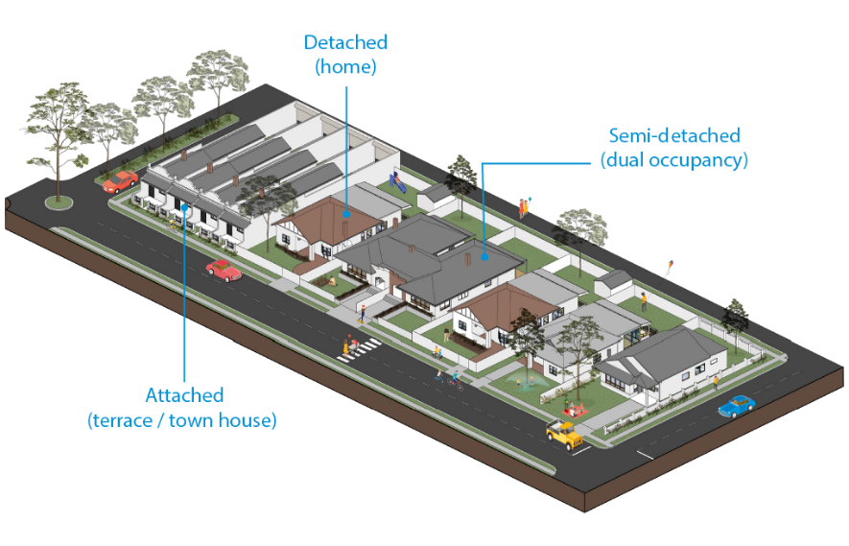

The importance of flood resilience in Melbourne
Whilst there is an extensive drainage network in place across greater Melbourne that helps to reduce the severity of flooding, we cannot entirely prevent flood events from occurring. Learning to live with flooding by making our homes and properties more flood resilient is one of the ways to reduce the impact of flooding. This includes making informed decisions about the materiality and construction systems in your home.

Why is flood resilience in our city important?
Do you remember the major floods we have experienced in Melbourne in recent years? In 2011 Melbourne was flooded with 150 mm of rain in 14 hours and significant floods have occurred in suburbs since then.
Flooding has always occurred in Melbourne as part of the natural weather cycle. The drainage network reduces flooding, however, extreme storms can mean rainfall exceeds the capacity of the drains and flooding occurs.
Adding to this, Melbourne has seen rapid development over the past few decades, and the increase in hard surfaces such as roads and roofs, combined with more frequent extreme storms means that more water is running into our drainage systems, rather than infiltrating into gardens and natural environments. This can make flooding worse. Coastal floods can also result from high tides and surges from the sea and will increase as sea levels continue to rise.
All these factors mean that many homes across Melbourne experience flooding.

What are the costs of flooding?
The costs of flooding are significant. People experience risks including loss of life and injury, loss of pets and valuable personal items, and a sense of fear and helplessness. People can be dislocated from their homes and experience ongoing stress and disruption. Flooding can damage the wall linings, carpets, flooring and electrical services of your property. There are more than 200,000 properties across the region with at least a 1% chance of flooding in any given year.
The total cost of flooding is estimated at $735 million a year. The costs include damage to property, infrastructure such as roads, disruption of services such as public transport and social impacts.

What are organisations doing to manage flooding?
Many organisations are responsible for flood management including Melbourne Water, state and local government and the Victoria State Emergency Service. These organisations have responsibilities for mapping flooding, managing drains and roads, and constructing new or enhanced drainage infrastructure, which are essential for flood management, and emergency response and recovery.
These organisations work with communities to help people prepare for flooding, know what to do when a flood happens, recover quickly, learn from our experiences and adapt over time.
Together we have made great progress on flood management however, with climate change, population growth and more development, we face many challenges.
You can be a part of reducing the impact of flooding in your life. You can learn about how to be prepared for flooding and the Victoria State Emergency Service offers support: website. You can also make changes to your home.
Costs of flooding
The total cost of flooding is estimated at $735 million for the greater Melbourne region.

Understanding local planning

What are the different organisations responsible for?
Following is a quick reference table of the key organisations that are responsible for flood management and their responsibilities.
Table 1. Organisations responsible for flood management and their responsibilities.
Organisation | Responsibility
Melbourne Water | - Coordinates planning and delivery of regional flood management and drainage services  - Undertakes catchment and coastal flood modelling and mapping  - Provides flood advice for new land use and development as a referral authority  - Contributes information to warning services, particularly, manages flood warning hydrographic infrastructure  - Manages regional drainage systems  - Manages waterways  - Contributes to development and use of integrated water management (IWM) knowledge and tools  - Undertakes technical research
The 38 councils in the Melbourne region | - Administer and enforce planning schemes, which include state and local flood policies and controls  - Manage local drainage systems  - Undertake flood modelling and mapping of local drainage systems  - Support local flood planning and coordinate local emergency planning  - Support development of local community resilience  - Implement state and regional strategies through the application of appropriate zones and overlays, and flood management decision-making and activities  - Can develop local water management strategies and plans  - Support community recovery from flood events
Victorian government departments and agencies | - Set policies, guidelines, standards and strategies for floodplain management, urban planning and development, water resource management, and emergency management  - Support recovery from floods.
Emergency services agencies | - Lead emergency preparation and response  - Deliver community awareness and education programs  - Provide flood warnings to the community (Emergency Management Victoria)  - Are the designated control agency for floods (Victoria State Emergency Service)
Australian government departments and agencies | - Set national policies and guidelines for flood and emergency management  - Coordinate national research and data on a range of flooding, weather and climate change issues  - Contribute to delivery of warning services  - Contribute funding to flood prevention and recovery activities.
Insurance Industry | - Projects and shares the financial consequences and recovery costs.
Communities, individuals and businesses | - Are responsible for understanding personal and local risks, and being prepared for floods  - Can contribute to development of local flood management projects and plans

What are the chances of my home flooding?

Relevant planning overlays
An overlay is a map in a council planning scheme showing the location and extent of special features, such as where land may be subject to flooding. Overlays are intended to give you an overview of your local area.
The relevant planning overlays illustrated on the map below in Melbourne are:
- Land subject to inundation overlay: Identifies land in a flood storage or flood fringe area affected by riverine and coastal flooding.
- Special building overlay: Identifies land at risk of overland stormwater flooding due to the capacity of the drainage system being exceeded.
- Floodway overlay: A floodway overlay identifies waterways, major floodpaths and high hazard areas with the greatest risk and frequency of being affected by flooding.
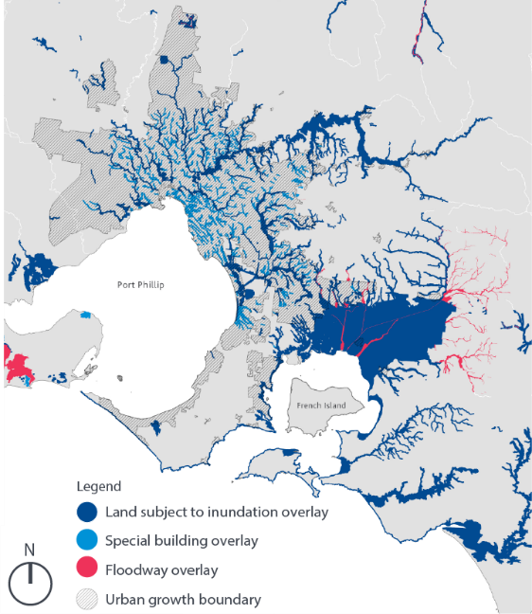

Finding out about your property
A flood level certificate is a document that is specific to your property and will tell you how high the water could go and what chance there is of a flood occurring. To get the most up to date information, it is recommended that homeowners in flood prone areas apply for a flood level certificate as there is a delay in flood data being available in the planning scheme.
For more information visit the Melbourne Water website

Insurance and flood resilient design
Many homes at higher risk of flooding face increasingly high insurance premiums. The insurance industry has begun to recognise the effectiveness of flood resilient design in reducing damage costs, which means that flood resilient homes could benefit from reductions in premiums.
There are examples in other capital cities where flood resilient design principles were incorporated into the lower level of a home at high risk of flooding resulting in reduced premiums. The retrofitting at the property pictured on the following page includes some of the strategies outlined in this document.

What should I discuss with my insurance agency?
While there is no guarantee your insurance agency will reduce your premium it is worth having a discussion with them. Insurance premiums consider a number of factors - one of these is flooding. Get in contact with your insurer prior to doing any work on your property to ask if they are open to reducing premiums if flood resilient retrofitting is done. It's also worth checking that your insurance covers you for all types of flooding on your property.
Common problems from flooding
Some parts of the home are more vulnerable to flooding in the short and long term.
- Mould and rot
- Disintegration of linings
- Swelling of cabinetry
- Malfunctioning services

Approaches to flood resilient design

What is flood resilient building design?
Repairing your home after a flood event can be a costly exercise. By using a resilient approach, some of these costs can be avoided. Flood resilient building design refers to modifications that adapt your home to reduce the impacts of flooding.
This is typically done using landscaping, water-resistant materials, raising floor levels and preventing flood waters from entering a house. Introducing flood resilient measures means it is easier to clean-up following a flood so life can get back to normal with minimal disruption. If your home is flood affected, you can explore several approaches to make it flood resilient.

What are the different approaches to making my home flood resilient?
There are four flood resilient design approaches. While considering what is physically and financially practical in your situation, you can use a combination of wet-proofing, dry-proofing, elevation and absorption to increase your home's flood resilience.
Strategy | Description
Wetproofing | Wet proofing involves using flood resilient materials and construction methods to allow flood waters to enter the house with a minimised chance of damage and moisture problems afterwards. By accepting a level of risk through wetproofing, and creating space for water to flow, you can be better prepared for any future flooding that may occur. This means going with the flow and working with water rather than against it.
Dryproofing | Dry proofing involves sealing the exterior of your house to prevent water from entering. Flood doors are one of the options to do this. For low-level floods this is effective, however, greater depths can result in an increase in force on the building and result in cracking or movement of foundations. It's worth noting that this method can also displace more water onto neighbouring properties.
Elevation | Raising the level of the house or its services above the projected flood level can be effective. Footings, posts, slabs and other structures all need to withstand an overland flow of water across the site. Services such as air conditioners, hot water units and electrical meter boards can be easily raised above the flood level to minimise the chance of important utilities failing.
Absorption | It’s also important to think about your property as a 'sponge' that can receive and slowly absorb water into ground surfaces. By increasing permeable surfaces on your property, you can decrease the amount of water flowing into your home, onto other properties and streets.

What should I discuss with my retrofit professional?
Preliminary questions based on being informed about flooding, and thinking through your own goals in relation to risk, cost and use:
- Have you got a flood level certificate to establish whether your home is prone to flooding?
- What is possible, and what is the cost difference between wet proofing, dry proofing and elevation to prepare a budget for your home?
- How can you retrofit to allow for current and future uses e.g. for young people, families, and older people?
Your neighbourhood:
- What exists currently - what is the nature of the landscape around your home e.g. impervious surfaces such as concrete paths and roads, and permeable surfaces such as grass, and how will they affect flooding?
Outside your home:
- What are the important issues and considerations in relation to the boundary of my home such as different types of fences and topography?
- What is the potential of landscaping to reduce the flow of water to the house once inside the boundary e.g. capturing water with above ground water tanks and underground detention basins?
- How can we improve the permeability of the landscape by considering alternatives to hard paved surfaces such as driveways and pathways with surfaces that are still safe, clean and attractive, e.g. soft paving, toppings and aggregate?
- Where are services currently placed and do they need to be moved e.g. external hot water and air-conditioning units?
- What are the critical ways to stop water coming in e.g. flood door and sealing external walls.
- What are the potential flood impacts of my own retrofit to my neighbours?
Inside your home:
- If following a wet proofing approach, how can we ensure water has free passage in and out of the space and doesn’t exceed water-resistant thresholds, doesn’t seep into cavities e.g. between the wall and floor, and doesn’t damage appliances and furniture?
- What water resistant materials are available for the different surfaces in my house?
Other professionals:
- Who else should we talk to given our specific property and needs e.g. drainage plumber, drainage engineer, landscaper, builder or architect?
The overall design:
- How do these different options we have discussed interact to reduce our flood risk and shape a solution that fits our initial goals including our comfort with different levels of risk, budget and current and planned use?

Examples of flood resilient homes
This section illustrates flood resilient strategies, and how they can apply to three common houses found in Melbourne’s flood-affected areas. While this is not an exhaustive list of house types, the strategies are common for many types of buildings and can help you reduce the impact of flooding in your home.
Talk to your neighbours
Talking to your neighbours is an important part of developing flood resilience. You can talk about each other’s experiences with flooding, approaches to reduce flooding, and ways you might work together in a flood event. Knowing about your risk, preparing for flood events, knowing what to do when it floods, and knowing how to get support can help to decrease your concern about flooding.
Prepare and plan for floods
A well prepared community can reduce the impact of flooding by up to 80% . People who are prepared are more likely to respond to floods appropriately and safely. To help you plan and prepare for floods visit the VIctoria SES website.
- 7.1 Detached homes: Detached homes refer to free-standing homes on a block of land that usually have a yard.
- 7.2 Semi-detached homes: Semi-detached homes refer to two homes that share a common wall, such as dual occupancy town houses.
- 7.3 Attached homes: Attached homes refer to homes that share one or multiple walls, these include but are not limited to terrace or row houses, and town houses.

Detached
Concrete slab on ground floors and timber framed walls with timber external cladding.
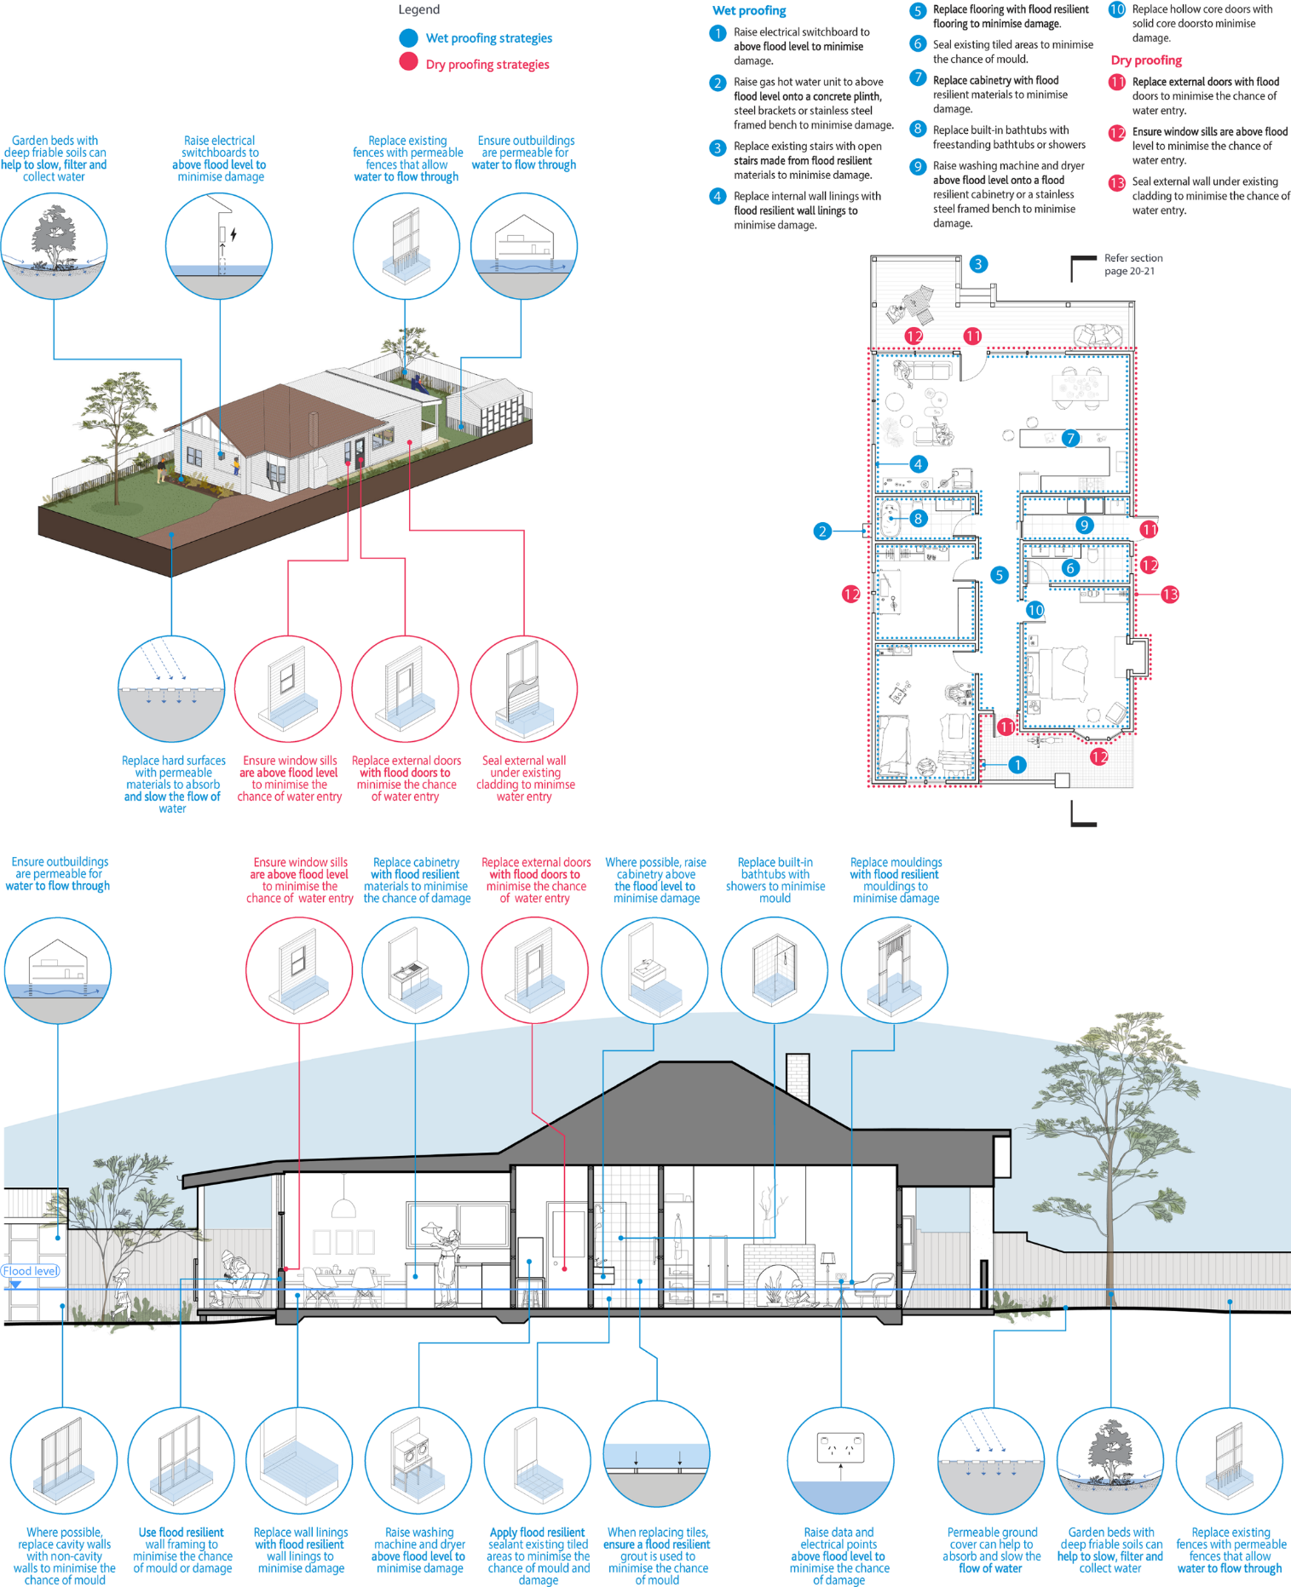

The wet proofing strategies for detached homes are:
- Garden beds with deep friable soils can help to slow, filter and collect water
- Raise electrical switchboards to above flood level to minimise damage
- Replace existing fences with permeable fences that allow water to flow through
- Ensure outbuildings are permeable for water to flow through
- Replace hard surfaces with permeable materials to absorb and slow the flow of water
- Ensure outbuildings are permeable for water to flow through
- Replace cabinetry with flood resilient materials to minimise the chance of damage
- Where possible, raise cabinetry above the flood level to minimise damage
- Replace built-in bathtubs with showers to minimise mould
- Replace mouldings with flood resilient mouldings to minimise damage
- Where possible, replace cavity walls with non-cavity walls to minimise the chance of mould
- Use flood resilient wall framing to minimise the chance of mould or damage
- Replace wall linings with flood resilient wall linings to minimise damage
- Raise washing machine and dryer above flood level to minimise damage
- Apply flood resilient sealant existing tiled areas to minimise the chance of mould and damage
- When replacing tiles, ensure a flood resilient grout is used to minimise the chance of mould
- Raise data and electrical points above flood level to minimise the chance of damage
- Permeable ground cover can help to absorb and slow the flow of water
- Garden beds with deep friable soils can help to slow, filter and collect water
- Replace existing fences with permeable fences that allow water to flow through
Following are ways to implement the wet proofing strategies:
- Raise electrical switchboard to above flood level to minimise damage.
- Raise gas hot water unit to above flood level onto a concrete plinth, steel brackets or stainless steel framed bench to minimise damage.
- Replace existing stairs with open stairs made from flood resilient materials to minimise damage.
- Replace internal wall linings with flood resilient wall linings to minimise damage.
- Replace flooring with flood resilient flooring to minimise damage.
- Seal existing tiled areas to minimise the chance of mould.
- Replace cabinetry with flood resilient materials to minimise damage.
- Replace built-in bathtubs with freestanding bathtubs or showers
- Raise washing machine and dryer above flood level onto a flood resilient cabinetry or a stainless steel framed bench to minimise damage.
- Replace hollow core doors with solid core doors to minimise damage.
The dry proofing strategies for detached homes are:
- Ensure window sills are above flood level to minimise the chance of water entry
- Replace external doors with flood doors to minimise the chance of water entry
- Seal external wall under existing cladding to minimise water entry
- Ensure window sills are above flood level to minimise the chance of water entry
- Replace external doors with flood doors to minimise the chance of water entry
Following are ways to implement the dry proofing strategies:
- Replace external doors with flood doors to minimise the chance of water entry.
- Ensure window sills are above flood level to minimise the chance of water entry.
- Seal external wall under existing cladding to minimise the chance of water entry.

Semi-detached
Suspended (raised) timber floors with timber framed walls and timber external cladding.
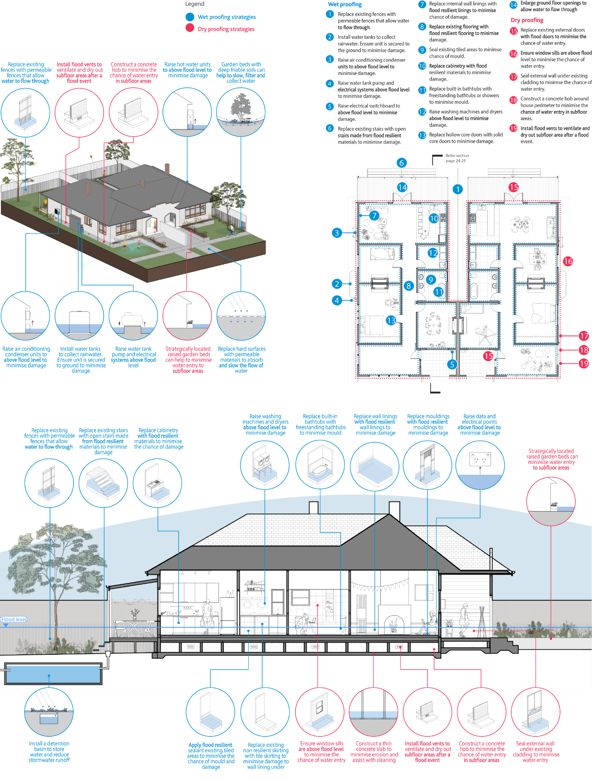

The wet proofing strategies for semi-detached homes are:
- Replace existing fences with permeable fences that allow water to flow through
- Raise hot water units to above flood level to minimise damage
- Garden beds with deep friable soils can help to slow, filter and collect water
- Raise air conditioning condenser units to above flood level to minimise damage
- Install water tanks to collect rainwater. Ensure unit is secured to ground to minimise damage
- Raise water tank pump and electrical systems above flood level
- Replace hard surfaces with permeable materials to absorb and slow the flow of water
- Replace existing fences with permeable fences that allow water to flow through
- Replace existing stairs with open stairs made from flood resilient materials to minimise damage
- Replace cabinetry with flood resilient materials to minimise the chance of damage
- Raise washing machines and dryers above flood level to minimise damage
- Replace built-in bathtubs with freestanding bathtubs to minimise mould
- Replace wall linings with flood resilient wall linings to minimise damage
- Replace mouldings with flood resilient mouldings to minimise damage
- Raise data and electrical points above flood level to minimise damage
- Install a detention basin to store water and reduce stormwater runoff
- Apply flood resilient sealant existing tiled areas to minimise the chance of mould and damage
- Replace existing non resilient skirting with tile skirting to minimise damage to wall lining under
Following are ways to implement the wet proofing strategies:
- Replace existing fences with permeable fences that allow water to flow through.
- Install water tanks to collect rainwater. Ensure unit is secured to the ground to minimise damage.
- Raise air conditioning condenser units to above flood level to minimise damage.
- Raise water tank pump and electrical systems above flood level to minimise damage.
- Raise electrical switchboard to above flood level to minimise damage.
- Replace existing stairs with open stairs made from flood resilient materials to minimise damage.
- Replace internal wall linings with flood resilient linings to minimise chance of damage.
- Replace existing flooring with flood resilient flooring to minimise damage.
- Seal existing tiled areas to minimise chance of mould.
- Replace cabinetry with flood resilient materials to minimise damage.
- Replace built-in bathtubs with freestanding bathtubs or showers to minimise mould.
- Raise washing machines and dryers above flood level to minimise damage.
- Replace hollow core doors with solid core doors to minimise damage.
- Enlarge ground floor openings to allow water to flow through
The dry proofing strategies for semi-detached homes are:
- Install flood vents to ventilate and dry out subfloor areas after a flood event
- Construct a concrete hob to minimise the chance of water entry in subfloor areas
- Strategically located raised garden beds can help to minimise water entry to subfloor areas
- Strategically located raised garden beds can minimise water entry to subfloor areas
- Ensure window sills are above flood level to minimise the chance of water entry
- Construct a thin concrete slab to minimise erosion and assist with cleaning
- Install flood vents to ventilate and dry out subfloor areas after a flood event
- Construct a concrete hob to minimise the chance of water entry in subfloor areas
- Seal external wall under existing cladding to minimise water entry
Following are ways to implement the dry proofing strategies:
- Replace existing external doors with flood doors to minimise the chance of water entry.
- Ensure window sills are above flood level to minimise the chance of water entry.
- Seal external wall under existing cladding to minimise the chance of water entry.
- Construct a concrete hob around house perimeter to minimise the chance of water entry in subfloor areas.
- Install flood vents to ventilate and dry out subfloor area after a flood event.

Attached
Suspended (raised) timber floor and double brick walls at the front. Concrete slab on ground floor and brick veneer cavity walls at the rear.
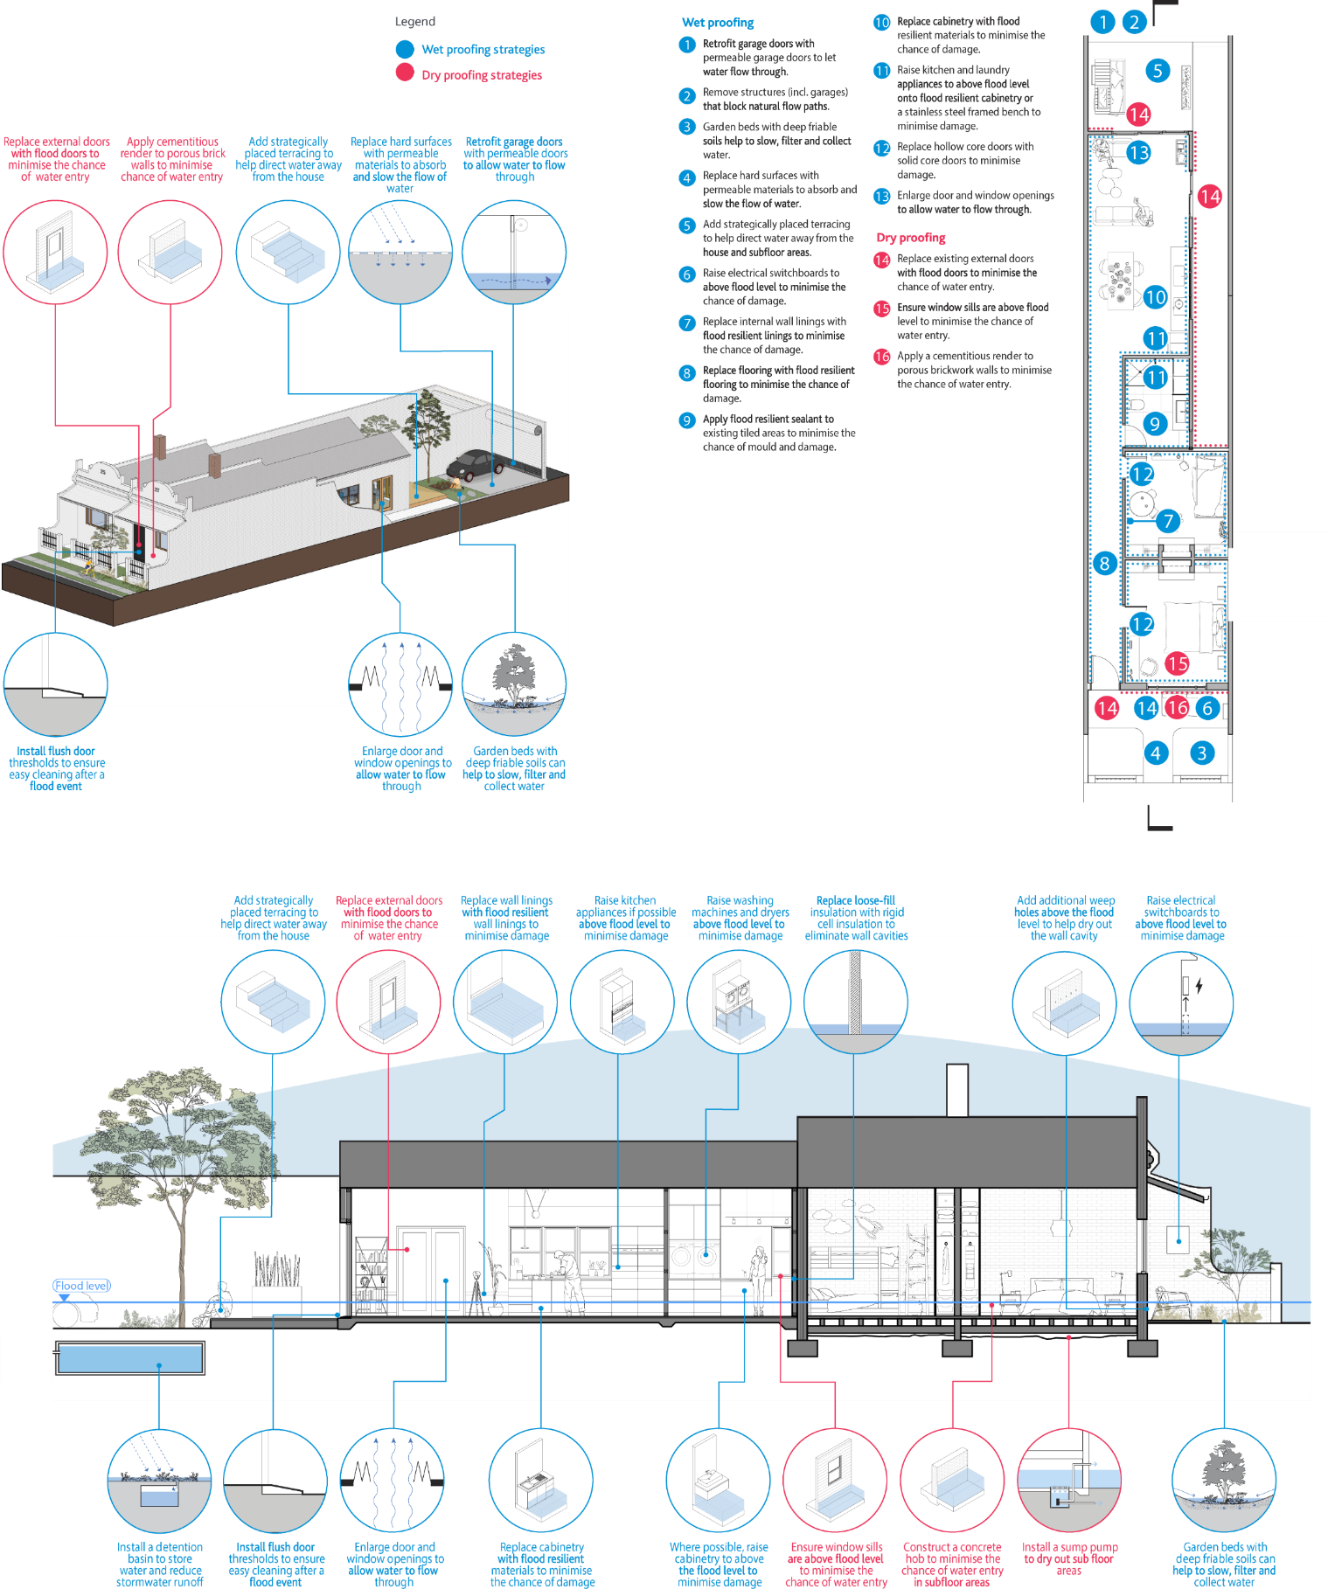

The wet proofing strategies for attached homes are:
- Add strategically placed terracing to help direct water away from the house
- Replace hard surfaces with permeable materials to absorb and slow the flow of water
- Retrofit garage doors with permeable doors to allow water to flow through
- Install flush door thresholds to ensure easy cleaning after a flood event
- Enlarge door and window openings to allow water to flow through
- Garden beds with deep friable soils can help to slow, filter and collect water
- Add strategically placed terracing to help direct water away from the house
- Replace wall linings with flood resilient wall linings to minimise damage
- Raise kitchen appliances if possible above flood level to minimise damage
- Raise washing machines and dryers above flood level to minimise damage
- Replace loose-fill insulation with rigid cell insulation to eliminate wall cavities
- Add additional weep holes above the flood level to help dry out the wall cavity
- Raise electrical switchboards to above flood level to minimise damage
- Install a detention basin to store water and reduce stormwater runoff
- Install flush door thresholds to ensure easy cleaning after a flood event
- Enlarge door and window openings to allow water to flow through
- Replace cabinetry with flood resilient materials to minimise the chance of damage
- Where possible, raise cabinetry to above the flood level to minimise damage
- Garden beds with deep friable soils can help to slow, filter and collect water
Following are ways to implement the wet proofing strategies:
- Retrofit garage doors with permeable garage doors to let water flow through.
- Remove structures (incl. garages) that block natural flow paths.
- Garden beds with deep friable soils help to slow, filter and collect water.
- Replace hard surfaces with permeable materials to absorb and slow the flow of water.
- Add strategically placed terracing to help direct water away from the house and subfloor areas.
- Raise electrical switchboards to above flood level to minimise the chance of damage.
- Replace internal wall linings with flood resilient linings to minimise the chance of damage.
- Replace flooring with flood resilient flooring to minimise the chance of damage.
- Apply flood resilient sealant to existing tiled areas to minimise the chance of mould and damage.
- Replace cabinetry with flood resilient materials to minimise the chance of damage.
- Raise kitchen and laundry appliances to above flood level onto flood resilient cabinetry or a stainless steel framed bench to minimise damage.
- Replace hollow core doors with solid core doors to minimise damage.
- Enlarge door and window openings to allow water to flow through.
The dry proofing strategies for attached homes are:
- Replace external doors with flood doors to minimise the chance of water entry
- Apply cementitious render to porous brick walls to minimise chance of water entry
- Replace external doors with flood doors to minimise the chance of water entry
- Ensure window sills are above flood level to minimise the chance of water entry
- Construct a concrete hob to minimise the chance of water entry in subfloor areas
- Install a sump pump to dry out sub floor areas
Following are ways to implement the dry proofing strategies:
- Replace existing external doors with flood doors to minimise the chance of water entry.
- Ensure window sills are above flood level to minimise the chance of water entry.
- Apply a cementitious render to porous brickwork walls to minimise the chance of water entry.

Flood resilient strategies

General considerations
- These strategies are recommendations only. Please consult a builder to find out which of these strategies is possible and practical for your home.
- Generally, slab on ground houses are easier to keep the water out of. Dry proofing strategies can be an effective way of increasing flood resilience. Engage a professional builder to assist in determining the right approach for your home.
- When considering flood vents, seek guidance from your builder or a Victorian Registered Professional engineer to determine whether this solution is appropriate for your home.
- Generally, houses constructed with a raised floor level and sub floor area are harder to keep water out of. Wet proofing strategies can therefore help to increase flood resilience. Engage a professional builder to assist in determining the right approach for your home.
- Flood doors and vents are used commonly throughout the world and work best with masonry structures. Seek guidance from a Victorian Registered Professional engineer to ensure minimum structural requirements are in place.
- Avoid 'floating timber floors' over concrete slabs (either composite or hardwood) where possible to prevent damage to flooring.
- Refer to the National Construction Code provisions relating to condensation, damp and weatherproofing, and energy efficiency of houses. Refer also to managing the risks of condensation in the non-mandatory Condensation in buildings Handbook by the Australian Building Codes Board.
- Speak to your builder about how your home is constructed. There are four common construction types found among detached, semi-detached and attached homes in Melbourne. These are shown in the diagram in the figures below. If you're not sure which one is relevant to your home, engage a professional builder to find out more information.
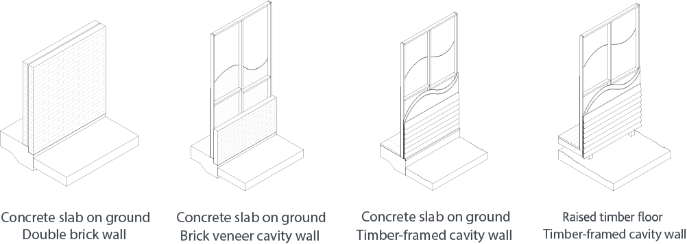

Strategies

Power and plumbing
Recommendation | Strategy
Raise external services | Raise external services, such as air conditioner condensers, hot water units and electrical meter boards above the possible flood level to keep your house’s utilities functioning and minimise the chance of damage. Note: Consult an electrician.
Secure external structures, such as rainwater tanks & sheds | Ensure external structures and rain water tanks are fixed to a concrete slab. Floods have the ability to uplift structures such as rain water tanks and sweep them downstream toward other properties causing serious damage.
Install separate circuits on the lower and upper levels | Install separate circuits to each storey of your house. This allows electricity to run on the upper level if lower levels circuit cuts off in a flood event. Note: Consult an electrician.
Raise powerpoints | Ensure the power points, data points and all other electrical services are raised to above the flood level to minimise the chance of power outages and faults. Allow provision for safety cut-off switches. Note: Consult an electrician.
Raise appliances | Raise stand-alone appliances such as washing machines and dryers to above the flood level on stainless steel framed benches, wall brackets or cabinetry made from flood resilient materials in order to minimise the chance of damage.
Raise pool / water tank pumps and power systems | Pool and tank pumps are often very costly to repair, and flooding of the electrical components can be the cause of their breakdown. This can also affect other electrical equipment in the property. Raise pumps and pump power systems to above the flood level to minimise the chance of damage.
Use low voltage garden lighting | Use low voltage (12 volt) garden lighting where possible and minimise any high voltage (240 volt) cabling within garden areas to minimise the chance of electrical issues.

In the yard
Recommendation | Description
Create a rain garden system | Rain gardens collect water and are vegetated with water loving plants and help slow, filter and collect flood water. Note: Consult a landscape architect.
Increase garden bed areas and use deep friable soil or mulch | Increasing the garden areas on your property can help filter & slow flood waters. Deep friable top soils are recommended for a greater collection of water and healthy growth of plants and collection. Note: Consult a landscape architect.
Install water tanks below your driveway, lawns or gardens | Underground water tanks can be installed to reduce the amount of site run-off, and in low-level floods help reduce the level of flood around the property. They are also useful in times of drought for water storage. Note: Consult a registered structural engineer and/or landscape architect.
Replace solid fences and screening with permeable fences | Reduce flood damage to fences by ensuring the fence is water permeable and made of resilient materials. If privacy or noise is a concern, fences should be permeable up to a height that allows water to flow through with ease, and then solid above that point. Some suggested screening materials include: aluminium, composite timber, hardwood timber, and recycled plastic palings. Note: Consult a builder.
Increase permeable surface areas | Use permeable paving materials and/or remove any unnecessary hard surfaces to allow ground to absorb water. Some options include: gravel, decomposed granite, permeable pavers, permeable concrete. It is recommended to reduce the width of large paved areas such as driveways, or only paving the tyre tread tracks. Note: Consult a registered structural engineer if there are expansive soils and/or if surfaces are close to house.
Remove or make garden structures permeable that block natural flow paths | Strategically place garden structures to help in maintaining existing flow paths to reduce adverse impacts on neighbouring properties. Make garden structures permeable so that they do not block the natural flow of water and restrict the use of retaining walls that could act as barriers. Note: This type of works may require a planning permit, please consult Melbourne Water.
Install a smart water tank | Consider retrofitting a smart tank system to automatically release water and increase water storage capacity before a flood event.

Around the house - dry proofing
Recommendation | Description
Install flood vents below flood level to assist in drying out subfloor spaces | Flood vents are designed to prevent water entry, whilst allowing water to escape subfloor spaces and assist in drying out after a flood event. Note: consult a Victorian Registered Professional engineer to ensure minimum structural requirements are in place.
Ensure window sill heights are above flood level to prevent water entry | Similar to doorways, windows are point of ingress where water can flow in. If dry-proofing strategies are being used, such as flood doors, ensure that the bottom (sill) of all windows is above the predicted flood line to minimise the chance of water entry.
Replace external doors with flood doors to prevent water entry | For low-level floods below 600mm, flood doors can be a viable option to prevent water from entering the building through doorways. These doors must be used in conjunction with strategies preventing water entering through exterior walls as the must create a seal around the building perimeter. Note: consult a Victorian Registered Professional engineer to ensure minimum structural requirements are in place.
Construct concrete hob to prevent water entering subfloor space | For buildings with floors elevated low above the ground, a concrete hob can be used to prevent water entering the space under the floor, avoiding issues such as mould and odours after a flood. The hob should be used in conjunction with flood vents to ensure any water trapped in the subfloor space can dry out or escape. Note: consult a Victorian Registered Professional engineer to ensure minimum structural requirements are in place.
Apply cementitious render to porous brick walls to minimise water entry | Treating the external wall finishes of spaces that are likely to be flooded is highly recommended. In situations where there is existing brick externally, a cementitious render can be used to make the wall less porous, helping to prevent water entering through the bricks.
Seal under existing external cladding to minimise water entry | Install a flood resilient fibre cement substrate and apply a waterproof membrane underneath existing external cladding to minimise the chance of water entry into the house. This strategy is most effective when installed in conjunction with installing flood doors.
Repair and/or seal all possible gaps to minimise water entry | When dry proofing, treating the external wall finishes of spaces that are likely to be flooded like is highly recommended. In situations where there are gaps in the external walls below the flood line, these should be sealed to prevent water from entering. Please note that this does not include existing weep holes.

Around the house - wet proofing
Recommendation | Description
Use single-skin walls rather than cavity walls where possible | Walls with cavities such typical plasterboard stud walls are prone to trapping water within the wall linings, damaging the wall framing, and forming mould. Where possible, replacing cavity walls with single-skin construction walls is recommended. Seek guidance from your builder when considering replacing walls.
Replace loose-fill insulation with rigid insulation | Loose-fill insulation such as 'batts' found in wall cavities absorb a great deal of moisture and must be replaced after a flood to avoid moulding. Replace loose-fill insulation with rigid or closed-cell insulation such as extruded polystyrene insulation as it is flood resilient and helps to fill the gap in a typical cavity wall.
Use flood resilient wall framing | When building framed walls, it is not recommended to use softwoods such as pine as it is prone to rot and mould after inundation and can decay quickly. Use hardwood timber or steel framing where possible. Consider using sustainable plantation hardwood timbers.
Construct flood resilient open stairs | Make stairs resilient by using flood resilient materials, such as metals or hardwood and make them open to avoid water being trapped in any cavities beneath the stair. This should be used in conjunction with other wet-proofing strategies if stair is internal.
Make the bottom riser of stairs removable | If an existing cavity stair on your property is at risk of flooding and you cannot retrofit the stair to have open risers, make the bottom riser removable to enable easy post-flood clean-out.
For houses with suspended timber floors, construct a concrete blinding layer in subfloor area | A concrete blinding layer is a thin layer of concrete which can be added to the space under a house to allow for easy clean out after a flood event. This seals the underlying material and prevents dirt and mud from interfering with the structure of the house.
Create large door and window openings on the ground floor | Having only few small openings in your ground floor makes it difficult for water entering your house to escape, trapping water inside and taking longer to dry after a flood event. By having large openings, water can flow out quickly, reducing pressure on your walls and provides more ventilation to dry out after a flood.
Replace non resilient with flood resilient cabinetry | Cabinetry is often the most expensive element in a house to replace after a flood event. This can be avoided through using flood resilient materials for all cabinetry including the carcass (frame).
Raise cabinetry above flood level where possible | Raise cabinetry above the flood level where possible (e.g. vanity basin in bathrooms). And ensure you have a safe place above the flood level to store belongings in preparation of a flood event.
Make cabinetry kickboards removable | Make the kickboard on cabinetry units removable to enable easy post-flood clean-out.
Replace hollow core doors with solid core doors | Avoid the use of hollow core doors to mitigate damage and limit mould growth after a flood event. As an alternative, use solid core, aluminium or glass doors.
Install flush thresholds in doorways, external pavements and garden edges | Small steps and sills are often the cause of a small layer of water to remain inside of a house, complicating the clean up process after a flood event. Limit thresholds which obstruct the drainage and discharge of flood waters from the interior of your home by installing flush thresholds recessed into a concrete floor.
Install corrosion resistant door and window hardware | Install corrosion resistant door and window hardware so these do not need to be repaired or replaced following a flood event.
Replace non resilient flooring with flood resilient flooring and substrate | Replace non resilient flooring with flood resilient flooring materials. When replacing flooring, ensure non resilient substrates (subsurface materials) are replaced with flood resilient substrates. This will minimise warping, rot and damage to the flooring and below the floor.
Apply sealant to existing tiled areas to above flood level to minimise damage | Apply a grout sealant to an existing tiled floor with non flood resilient grout. Adding a grout sealant will help to increase the water-resistance of the grout, which will minimise the chance of mould and water damage to the tiles after a flood event.
Use flood resilient grout when tiling or re-tiling wet areas | When tiling or re-tiling wet areas, ensure flood resilient grout is used. Otherwise referred to as ‘semi-epoxy’ this grout is less porous and ensures that the wall lining beneath tiles is protected and minimises the chance of mould.
Replace mouldings with flood resilient mouldings | Pine and other softwood moulding is prone to buckling after becoming wet. Replace these with flood resilient mouldings, such as composite or hardwood to ensure resilience. For very low levels of flooding, flood resilient moulding can also be used to protect the bottom of a wall.
Replace non flood resilient skirtings with flood resilient skirtings | Replace non flood resilient skirtings with flood resilient skirtings such as hardwood timber or tiles to minimise the effects of flood damage. Non flood resilient skirtings such as pine and other softwoods are prone damage such as warping and rot after becoming wet. Flood resilient skirtings also allow for easy wash out after a flood event.
Replace non-resilient wall linings with flood resilient wall linings | Replacing wall linings in areas that are likely to be flooded is highly recommended. This means using fibre cement or villaboard linings instead of plasterboard, and floor finishes such as tiles or polished concrete instead of carpet. If a timber floor is desired, ensure it is a hardwood floor. Apply waterproofing membrane onto a substrate such as fibre cement sheeting underneath internal wall linings
Raise kitchen appliances if possible above flood level | If possible, ensure fridges, dishwashers, ovens and all other appliances are installed above the possible flood line to keep your houses kitchen functioning and prevent failure. This is useful for low levels of flooding or when kitchen cabinetry is being made resilient.
Replace cavity bathtubs with freestanding bathtubs or showers | Built-in baths with cavities, often built into cabinetry or in tiled areas, are prone to trapping water in the gap between the tub and exterior, damaging the framing, and forming mould. A freestanding bathtub or shower eliminates gaps where water can be trapped and enables easy access for cleaning around the entire tub.
Create terraced landscape | Terraced areas are a way of preserving external space while acting as a flood barrier. They can also help reduce the scale of walls, or elevated parts of a building. These should be constructed out of a flood resilient materials and have appropriate structural reinforcing.
Install permeable garage door to let water flow | Permeable garage doors can help in maintaining existing flow paths to reduce adverse impacts building structures and on neighbouring properties. Make garage doors permeable so that they do not block the natural flow of water. This should be used in conjunction with other wet-proofing strategies if the garage is inside a building.
Create raised garden beds adjacent to the house | Raised garden beds made from concrete or blockwork can help to act as a flood barrier. These should be constructed out of a flood resilient materials and have appropriate structural reinforcing.
Clean out any existing weep holes to assist in drying out wall cavities | It is important to clean out any existing weep holes to prevent water getting trapped in the wall cavity.
Add additional weep holes and air vents above flood level in cavity walls | Installing additional weep holes and air vents will allow subfloor areas and garages to dry out after a flood.
Retrofit a sump pump to dry out subfloor areas | Install an automatic submersible pump and sump at the lowest point under your home to assist in the removal of flood water in a subfloor area after a flood event.
Add mechanical heat recovery ventilation systems to dry internal spaces | Mechanical heat recovery ventilation systems (MHRVs) ventilate and dry out internal spaces by allowing fresh air into the house and reduce condensation build up.

Materials
Identify which of the following non resilient materials (shown in the middle column) are present in your home and where possible, replace with flood resilient materials (shown in the right hand column).
Building element | Non flood resilient materials | Flood resilient materials
External ground cover  (Increase permeable surfaces) | - Concrete  - Asphalt | - Grass  - Mulch, deep friable soil  - Permeable concrete  - Permeable paving  - Gravel, stones
Fencing  (Create openings for water to flow through and construct from resilient materials) | - Pine and other softwoods | - Hardwood timber fencing  - Composite timber fencing  - PVC gencing  - Metal fencing
Wall construction  (Where possible, replace cavity walls with single skin walls) | - Wall with cavities | - Single skin stud walls  - Single skin brick walls  - Solid block walls  - Off-form concrete walls
Wall framing  (Where possible, replace non resilient materials with flood resilient materials) | - Pine | - Hardwood  - Steel
Internal wall linings  (Where possible, replace non resilient materials with flood resilient materials) | - Plasterboard  - Panelling made from pine or other softwoods  - MDF (medium-density fibreboard) | - FC (fibre cement sheeting)  - Villaboard  - Tiles  - Hardwood panelling  - Metal  - Polycarbonate / translucent sheeting  - Marine grade / moisture-resistant plywood
Internal flooring  (Where possible, replace non resilient materials with flood resilient materials) | - Carpet  - Floating timber floors  - Vinyl on a non resilient substrate  - Cork | - Polished concrete  - Tiles  - Hardwood flooring on a flood resilient substrate  - Rubber / vinyl on a flood resilient substrate
Internal floor substrate  (Where possible, replace non resilient materials with flood resilient materials) | - MDF  - Particle board (yellow tongue sheet flooring)  - Low grade, non-marine plywood | - FC (fibre cement sheeting)
Insulation  (Eliminate wall cavities by replacing loose fill insulation with rigid insulation) | - Wool and fibre cement batts  - Other spray products | - XPS (rigid) insulation  - Closed cell flexible sheet insulation  - Sprayed polyeurethane foam
Doors and windows  (Replace cavity doors) | - Hollow core doors | - Solid core doors (wet proofing)  - Flood doors (dry proofing)
Cabinetry frame  (Where possible, replace non resilient materials with flood resilient materials) | - Particle board  - MDF panels | - Compact laminate  - Acrylic solid surface  - Marine grade ply  - Composite timber panels  - Stainless steel frame (open)
Cabinetry benchtops  (Where possible, replace non resilient materials with flood resilient materials) | - Laminate  - Particle board  - MDF | - Acrylic solid surface  - Marine grade ply  - Stone  - Composite stone  - Stainless steel
Grout  (When retiling, use a flood resilient grout) | - Cementitious grout | - Semi-epoxy grout  - Epoxy grout  - Polymer resin grout
Please note
This table is to be read in tandem with the flood resilient strategies shown in sections 7, 8.1 and 8.2 of this document.

The next steps
From reading this guide, we hope that you have an understanding of flooding in Melbourne and the importance of flood resilience and practical strategies you can implement in and around your home to reduce the risk, inconvenience, cost and damage of flooding.
The next steps you might take include:
- Identify your home's flood risk by checking the planning scheme for flood overlays and apply for a flood level certificate
- Discuss the approach that best suits your home
- Talk to your neighbours about each other’s experiences with flooding, approaches to reduce flooding, and ways you might work together in a flood event
- Explore your preferred approach with a builder
- Consider the costs involved and your budget
- Establish a plan and discuss this with your insurance agency
- Develop an emergency response plan by considering the Victoria State Emergency Service’s resources. For more information visit the SES website.

Further information

Contact details for key organisations
Organisation | Website
Victoria State Emergency Service | Victoria SES website
Emergency Management Victoria | Emergency Management Victoria website
Melbourne Water | Melbourne Water website
Local Councils | Know Your Council website

Guidelines
Department of Environment, Land, Water and Planning 2018, Guidelines for Development in Flood Affected Areas (PDF 2504KB)
Hawkesbury-Nepean Valley Flood Risk Management Steering Committee 2006, Reducing Vulnerability of Buildings to Flood Damage: Guidance on Building in Flood Prone Areas (PDF 6077KB)
National Construction Code (NCC) via the Australian Building Codes Board (ABCB) 2012, Construction of Buildings in Flood Hazard Areas - The Flood Standard Australian Building Codes Board website
National Construction Code (NCC) via the Australian Building Codes Board (ABCB) 2012, Construction of Buildings in Flood Hazard Areas - The Flood Handbook Australian Building Codes Board website
Queensland Reconstruction Authority (QRA) 2019, Flood Resilient Building Guidance for Queensland Homes (PDF 10418KB)
Melbourne Water 2017, Planning for Sea Level Rise Guidelines (PDF 3583KB)
Melbourne Water 2020, Building and Home Renovation Resources, Victorian Government, Melbourne, Melbourne Water website

Glossary

Flooding terminology
Annual exceedance probability (AEP) – AEP is the likelihood of a flood of a given size happening in any one year. AEP is usually expressed as a percentage.
Average reoccurrence interval (ARI) – ARI is the estimated number of years between floods of a given size which is expressed in years. ARI is another way of expressing the likelihood of occurrence of a flood event (see also AEP).
Australian height datum (AHD) – A reference datum for defining levels in Australia. The level of 0.0m AHD is approximately mean sea level.
Catchment – A catchment is an area of land that drains to a particular point. All runoff within a given catchment will flow down to the same outlet.
Designated flood level (DFL) – Designated flood level is set by Melbourne Water considering factors including rainfall and future climate impacts.
Finished floor level (FFL) – Finished floor level is the level of the finished surface of your floor.
Flood damage – The tangible and intangible costs of flooding.
Flood depths – The level of inundation relative to the designated flood level (DFL) and the property’s ground level.
Flood risk – Potential for loss or damage to property, including environmental assets, or harm to people due to flooding.
Freeboard – A height above a flood level to account for factors such as wind, waves, unforeseen blockages and other localised hydraulic effects.
Mitigation – To reduce risk through a range of strategies.
Riverine flooding – Riverine flooding occurs when water runoff from major storms exceeds the capacity of a river or creek and overflows onto surrounding floodplains.
Overland flow flooding – Overland flows occur when flood waters rise quickly following heavier than usual rainfall, exceeding the capacity of the underground drainage system. The excess flows are then forced to run above ground (overland).

Building and landscape terminology
Blinding slab – A thin concrete slab to prevent erosion and assist with cleaning.
Cabinetry – The fixed furniture in a house, such as a kitchen, cupboards, or bathroom vanity.
Cavity – The space in between the wall linings and structure inside a wall. Often between timber studs or between bricks.
Detention basin – A tank or other water body designed to hold water for a period of time during a rainfall event.
Flood doors – Doors that seal to resist penetration of water to a certain extent.
Flood vents – Special vents that allow water to exit a space but not enter into it.
Freestanding – An element, such as a bath, which stands on its own and is not attached to cabinetry or within a wall.
Grout – Material used to fill the gaps between tiles.
Hob – A solid horizontal edge, otherwise know upstand
Mouldings – Skirtings, architraves and cornices
Permeable – An element which allows water to flow through it, often with gaps or holes to pass through.
Rain garden – A system that collects water from paving, roofs and other surfaces and filters it using natural vegetation.
Services – The electrical, heating, cooling, water, gas and communications infrastructure attached to a home.
Single skin wall – A wall which has a finish on one side of the structure only, meaning there are no gaps inside the wall itself.
Stair riser – The vertical section between the horizontal treads on a stair.
Studwork – The structural supports inside a timber wall.
Stair tread – The horizontal section you walk on using a stair.
Substrate – The sub-surface material layer underneath a visible floor or wall finish.
Wall cladding – The material fixed to the inside of a wall frame. This is often timber boards, fibre cement or metal sheeting.
Wall lining – The material fixed to the outside of a wall frame. This is often plasterboard, timber panelling or fibre cement.
Water-resistant – A material which is able to resist penetration of water to some degree, but not entirely.
Waterproofing – A material which is able to resist the penetration of water.

Planning terminology
Flood level certificate – A certificate that provides an estimated flood level for a property based upon a 100 year Average Recurrence Interval (ARI) storm
Property flood level information search – Process involved in determining if an application for a flood level certificate is required.

https://www.melbournewater.com.au
https://www.ses.vic.gov.au/get-ready/floodsafe
https://www.melbournewater.com.au/planning-and-building/apply-to-build-or-develop/property-flood-level-information
Source: Grothmann, T., Reusswig, F. People at Risk of Flooding: Why Some Residents Take Precautionary Action While Others Do Not. Nat Hazards 38, 101–120 (2006). https://doi.org/10.1007/s11069-005-8604-6
https://www.ses.vic.gov.au/get-ready/at-home
https://www.ses.vic.gov.au/get-ready/at-home
https://www.ses.vic.gov.au/get-ready/floodsafe
https://www.emv.vic.gov.au/
https://www.melbournewater.com.au/
https://knowyourcouncil.vic.gov.au/
https://www.water.vic.gov.au/__data/assets/pdf_file/0025/409570/Guidelines-for-Development-in-Flood_finalAA.pdf
https://www.ses.nsw.gov.au/media/2247/building_guidelines.pdf
https://www.abcb.gov.au/Resources/Publications/Education-Training/Construction-of-Buildings-in-Flood-Hazard-Areas-Standard
https://www.abcb.gov.au/Resources/Publications/Education-Training/Construction-of-Buildings-in-Flood-Hazard-Areas
https://www.qra.qld.gov.au/sites/default/files/2019-04/flood_resilient_building_guidance_for_queensland_homes_-_april_2019.pdf
https://www.melbournewater.com.au/sites/default/files/Planning-for-sea-levels.pdf
https://www.melbournewater.com.au/building-and-works/building-and-home-renovation

