Activity: Helpful, hardworking bacteria wanted (Years 7 and 8)
  - Micro-organisms at work—at the sewage treatment plant
Victorian Curriculum F–10 links:
Levels 7 and 8
Science
Science Understanding
Science as a Human Endeavour
Science and technology contribute to finding solutions to a range of contemporary issues; these solutions may impact on other areas of society and involve ethical considerations
Biological sciences
There are differences within and between groups of organisms; classification helps organise this diversity
English
Literacy
Creating texts
Plan, draft and publish imaginative, informative and persuasive texts, selecting aspects of subject matter and particular language, visual, and audio features to convey information and ideas to a specific audience
Students elaborate on aspects of the sewage treatment process observed during the visit. Using the context of a job advertisement, students describe what they know about bacteria and their role in sewage treatment.

Equipment
Per student: one copy of Student worksheet: Job advertisement—Sewage treatment

Activity steps
- Explain that bacteria are tiny organisms (micro-organisms) that are not visible to the naked eye and can only be seen with the aid of a microscope. Use the analogy that if you laid 1,000 bacteria end-to-end they would be equal to 1 mm.
- Students research the role of bacteria at the Western and Eastern Treatment Plant processes and information about the stages in the treatments that use bacteria, with resources from the Micro-organisms at work at the sewage treatment plant web page, plus:
Where does wastewater go? ABC Splash video [3:43]
http://splash.abc.net.au/home#!/media/524873/>
- Share the information provided in the Teacher background about the role of other micro-organisms such as algae, protozoa and zooplankton in the treatment process.
- Students share what they found out about bacteria used in the sewage treatment process. Add any key information that may have been missed:
- there are two key types of bacteria; those that require oxygen and those that do not
- one type of bacteria produces methane gas as it breaks down organic matter under anaerobic conditions (no oxygen)
- another type of bacteria requires oxygen for respiration (aerobic conditions) as it breaks down organic matter
- oxygen is added to the sewage using mechanical beaters that mix together the sewage and bacteria to form ‘activated sludge’ (Western Treatment Plant)
- adding oxygen and mixing speeds up the treatment process as the oxygen-loving bacteria grow and reproduce and break down organic matter
- bad odours are produced by anaerobic bacteria in the form of the gas hydrogen sulphide; these bacteria also produce methane and carbon dioxide
- given a suitable environment and sufficient food, bacteria reproduce and multiply at a great rate
- anaerobic bacteria take longer to break down organic matter than aerobic bacteria as they have a slower metabolism and get their energy from sulphates and nitrates
- several different types of bacteria are used to remove nutrients from sewage before it can be released back into the environment.
- Explain that the science ideas about bacteria that are incorporated into the job description must be accurate.
- Show examples of several job advertisements so that students are familiar with the format. List relevant headings to prompt students, such as employer, location, work environment, working conditions, job description and their role, skills required, work as a team/individually. Provide students with the Student worksheet: Job advertisement sewage treatment.
- Share students’ completed job advertisements and discuss the science ideas presented.
Note: This task could be used for assessment purposes to assess student understanding of the role bacteria plays in the treatment of sewage.

Extension activities
Organise half the class to write the job advertisement and the other half of the class (after the advertisements have been completed) to respond to a job advertisement from the point of view of the bacteria.
Use the context of a job advertisement to describe the role of algae and zooplankton in the sewage treatment process.

Teacher background
There are two main types of environments used in sewage treatment—anaerobic (without oxygen) and aerobic (with oxygen). Anaerobic and aerobic environments suit different types of bacteria and the treatment plant needs both types of bacteria to break down the sewage.
At the Eastern Treatment Plant, the primary treated effluent is moved to secondary treatment tanks where it is aerated to encourage the growth of oxygen-loving bacteria. The amount of oxygen supplied to the tanks is automatically controlled based on the level of dissolved oxygen in the tanks. There are six rectangular tanks approximately 4.5 m deep. Diffusers mounted on the tank floors release bubbles of air which provide agitation to maintain the bacteria in suspension and give them the oxygen they require for the aerobic breakdown of the sludge. Not all the tank floors are covered with diffusers (15–25% are not covered). This creates alternate areas of aeration and non-aeration. Different types of bacteria exist side by side in aerobic (with oxygen). and anaerobic (without oxygen) environments, breaking down organic material and removing nutrients in the plant's aeration tanks. This results in a significant reduction in ammonia load.
The activated sludge contains micro-organisms; mainly bacteria and protozoa.
Under anaerobic conditions, bacteria produce strong, unpleasant smells and release greenhouse gases (methane).
As part of the secondary sedimentation process, algae feed on nutrients in the sewage stored in the holding basin. Algae are eaten by zooplankton, waterbugs and water birds. Zooplankton also feed on bacteria and protozoa.

Student worksheet: Job advertisement—Sewage treatment

Introduction
Bacteria are an important part of sewage treatment.
Create a job advertisement that describes the role of bacteria in the sewage treatment process.
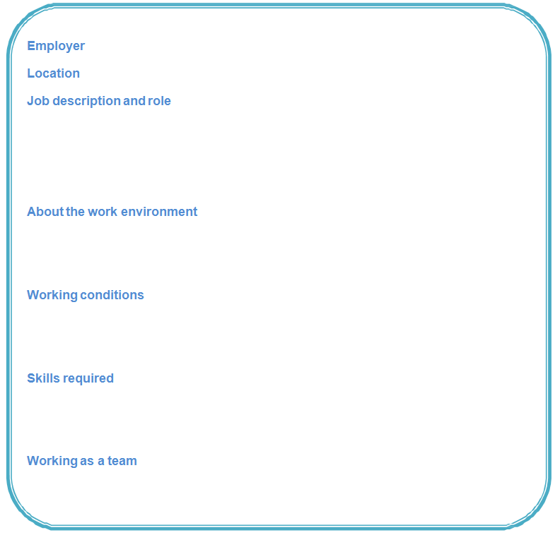

Conclusion
In what ways are bacteria important in the sewage treatment process?

Victorian Curriculum and Assessment Authority (VCAA) <http://victoriancurriculum.vcaa.vic.edu.au/> Accessed 14 August 2016.

