Activity: Managing stormwater (Years 5 and 6)
Victorian Curriculum F–10 links:
Levels 5 and 6
Geography
Geographical Knowledge
Factors that shape places and influence interconnections
Environmental and human influences on the location and characteristics of places and the management of spaces within them
Science
Science Understanding
Science as a Human Endeavour
Scientific understandings, discoveries and inventions are used to inform personal and community decisions and to solve problems that directly affect people’s lives
Design and Technologies
Technologies and Society
Investigate how people in design and technologies occupations address competing considerations, including sustainability, in the design of solutions for current and future use
  - Why worry about stormwater
Students consider city design features for managing stormwater in urban areas. They devise stormwater management statements which highlight what people can do.

Duration
Two sessions

Equipment
For each group:
One set of Mystery envelopes (see below)
For each student:
One copy of Student worksheet: Drainage and flooding in Melbourne
Interactive whiteboard or data projector

Preparation
Prior to this activity, prepare enough Mystery envelopes (Student worksheet: Mystery envelopes) for groups of four students. Each Mystery envelope holds a collection of 4–6 different images which may be different. For example, different types of drains, roadside gutters, roofs, building gutters, tanks, stormwater pipes, roads and footpaths, creeks and rivers, the bay, wetlands, litter in drains, factories, farmland and waterways may be provided.

Activity steps
- Watch the video ‘Water Smart City at the Collingwood Children’s Farm’ [1:25] at <https://www.youtube.com/watch?v=0pEdAATvFGk>. Before they watch the video, cue the students to look for the answers to these questions:
- What are some of the problems caused by stormwater in urban areas? (The rain doesn’t soak into the ground. Because of all the hard surfaces, the rainwater flows straight out into the bay.)
- What solutions to the problems were highlighted in the video? (Green roofs, using water tanks, porous paving)
- Working in groups of four, students receive a Mystery envelope with a number of images inside. The group is to discuss the images and decide on a creative way to tell how the images are connected and the implications for managing stormwater and looking after our rivers and bays.
- Each group shares their ‘story’ with the class. The class agrees on a set of key ideas that arise from the story-sharing, for example:
Teacher tips
Run-off describes the water from rain, snowmelt or irrigation that flows over the land surface and is not absorbed into the ground, instead flowing into streams, other surface waters or land depressions.
Stormwater can come from any precipitation and is surface run-off that is transported eventually to the stormwater system.
- run-off is rain or water that does not soak into the ground and flows from a catchment into a river, stream, lake or reservoir
- different surfaces produce different amounts of run-off
- stormwater is carried in pipes and drains to rivers and the bay
- stormwater can be polluted, which harms rivers and the bay
- we can change what we do with stormwater.
- Ask students what they have observed when rain falls at school and home. For example, puddles form, muddy areas appear, water runs across the netball courts, gutters overflow. Ask students if there are differences when there are different types of rainfall, for example, light showers versus a thunderstorm. As a result of the discussion establish an understanding of the key terms: run-off and stormwater. Your local council may be able to supply the class with maps of the local stormwater drainage system, including pipes and litter traps as well as surface channels, creeks and wetlands.
- For the next part of the activity, students will need access to a computer. Alternatively the teacher can show the website using the interactive whiteboard or a laptop and data projector.
- Students explore what happens when it rains in urban areas, how houses and parks are affected and the consequences of different amounts of stormwater on the community, and the impacts of stormwater pollution. They complete the Student worksheet: Drainage and flooding in Melbourne, recording what they find out about the responsibilities of individuals, councils and other organisations that work together on planning and responding to different degrees of rain, including floods.
- In pairs or small groups students use the information they have gathered from the websites to develop stormwater management statements which highlight what people can do to minimise the impacts of stormwater and flooding. For example, individuals can install rainwater tanks to capture rainwater to use for watering the garden and flushing the toilet; councils sweep streets, monitor building works and clean out roadside drains to help keep the stormwater system clear of rubbish. Students should consider:
- urban design
- environmental impacts and solutions
- individual and community responsibilities.
- Display statements and provide students with an opportunity to speak to their statements. The class can vote on the statements with the most powerful message for managing stormwater.

Student worksheet: Mystery envelopes
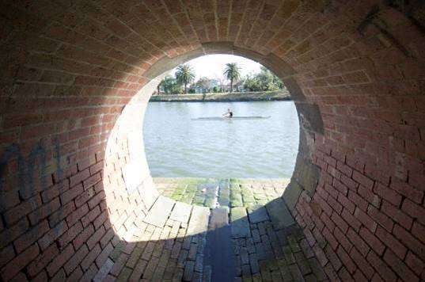  Stormwater drain |  | 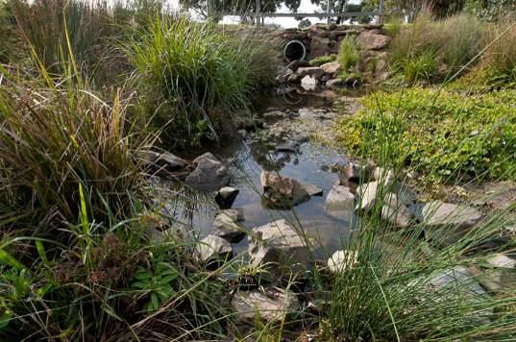 Stormwater drain
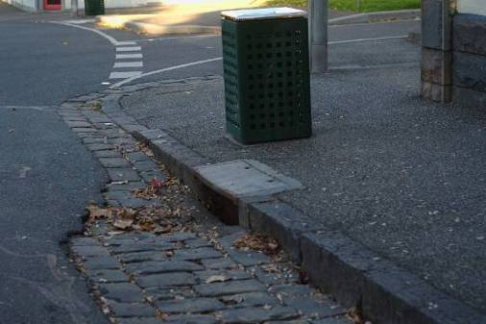  Roadside gutter |  | 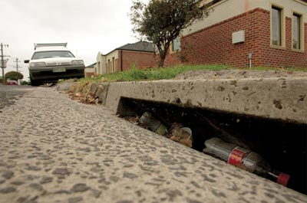  Roadside gutter with litter
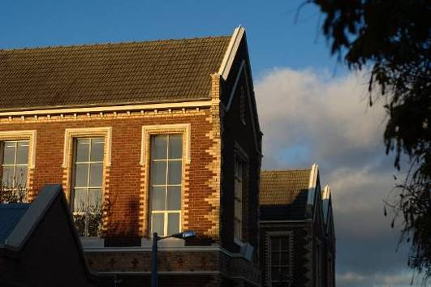  Roof |  | Roof gutter
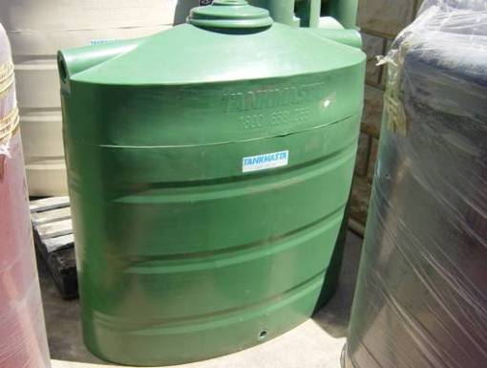 Rainwater tank |  | 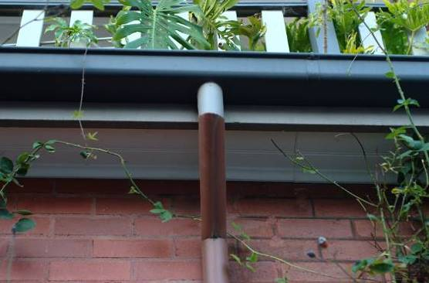  Stormwater pipe
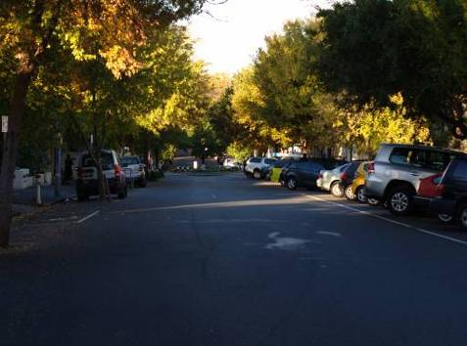  Road | 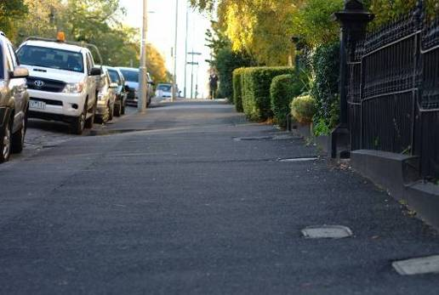  Footpath
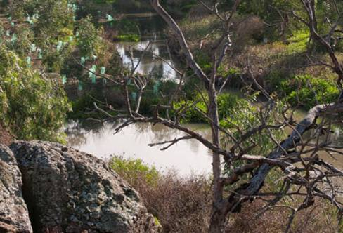  Creek | 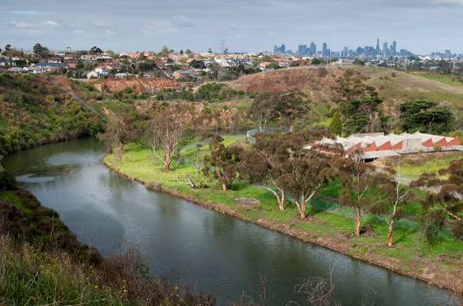  River
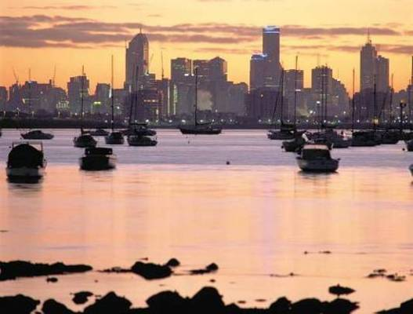  The Bay | 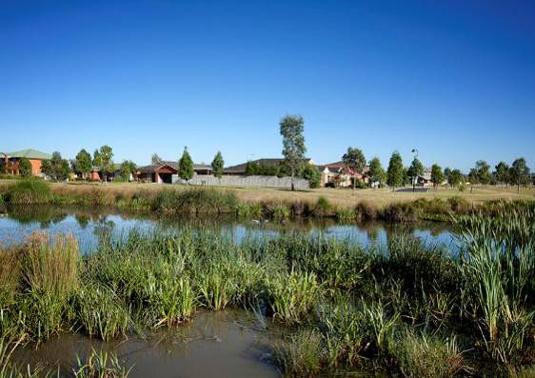  Wetlands
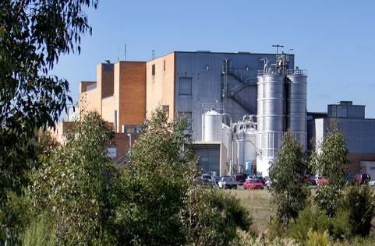  Factory | 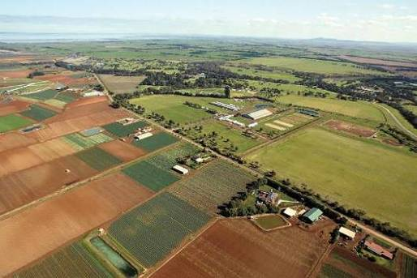  Farmland

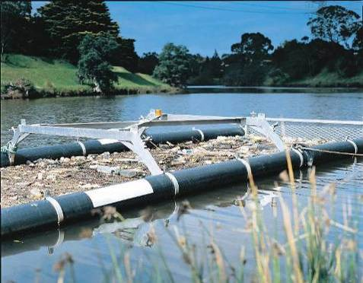  Litter trap | 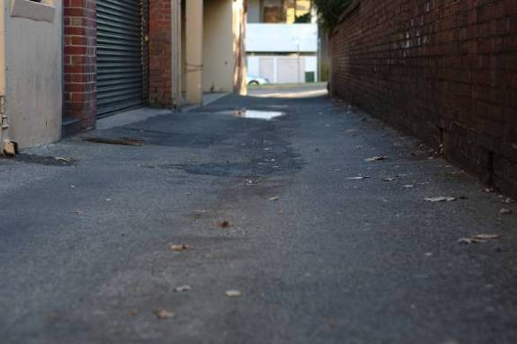  Hard paving
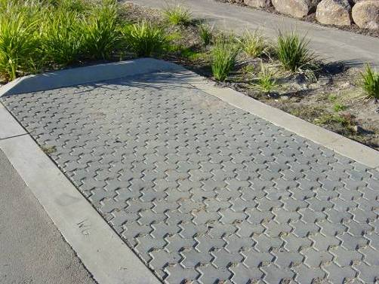
Porous paving

Student worksheet: Drainage and flooding in Melbourne
Investigate the drainage system in Melbourne, using the resources on this page.
Use this worksheet to record facts, ideas and information. There are blank spaces for you to use for your own ideas.
What happens when it rains? | What facts, ideas and information did I find out about this? Whose responsibility?
Rainfall run-off from different surfaces
Drains
Parks
Pollution
Stopping pollution
Role of the council
Urban design ideas for better use of rainwater
Wetlands

Victorian Curriculum and Assessment Authority (VCAA) <http://victoriancurriculum.vcaa.vic.edu.au/> Accessed 14 August 2016.

