Activity: The sewage treatment plant and my family (Years 3 and 4)
What ends up at the sewage treatment plant?
Victorian Curriculum F–10 links:
Science
Levels 3 and 4
Science Understanding
Science as a Human Endeavour
Science knowledge helps people to understand the effects of their actions
Chemical sciences
Objects are made of materials that have observable properties
Earth and space sciences
Earth’s resources are used in a variety of ways
Students develop a visual flow chart of the sewerage system from home to the sewage treatment plant.

Duration
One double session

Activity steps
- As a class, view the video Where does wastewater go? [3.43] on the ABC Splash website.
- Complete the Student worksheet: Sewage treatment plant and my family using the information from the video and the Melbourne Water web page about the Western Treatment Plant.
- Using the completed worksheet students create a visual flow chart that shows that:
- sewage generally comes from four room types in the family home
- sewage travels through pipes and channels to the sewage treatment plant
- the sewage treatment plant uses a process to treat sewage
- treated sewage can be released to the environment or used as recycled water.
- Using the students’ visual flow chart as a focus, discuss and agree on key important information about the sewerage system and Western Treatment Plant mentioned in the video, including:
- sewage treatment takes out solids and removes harmful chemicals
- the Western Treatment Plant is a natural treatment process that uses bacteria and not chemicals to treat sewage
- treated water from the Western Treatment Plant is used as recycled water on the farm and the wetland and is safe to be discharged into the ocean at Port Phillip Bay
- sewage from just over half of Melbourne’s homes ends up at the Western Treatment Plant (over 40% goes to the Eastern Treatment Plant, Bangholme, with the rest being treated at small plants throughout Melbourne) and the importance of thinking about what we put down the drain in our homes.
- Students use the information from the discussion to annotate their visual flow chart with key facts.

Student worksheet: The Western Treatment Plant and my family (Activity)
Make a flow chart that shows what happens to sewage that goes down drainpipes in your home. Draw pictures of your bathroom, kitchen, laundry and toilet in the boxes.
Cut out the boxes and paste them onto a large sheet of paper. Show how sewage from your house gets through the sewerage system to the Western Treatment Plant for processing.

My bathroom | My kitchen
My laundry | My toilet
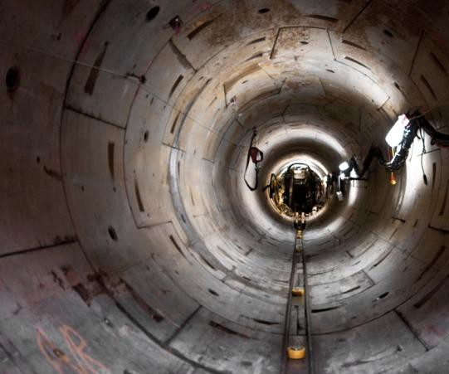  Sewerage pipe | 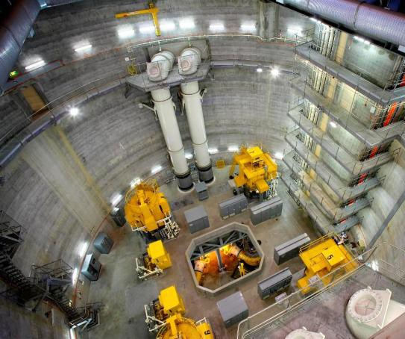  Pumping station

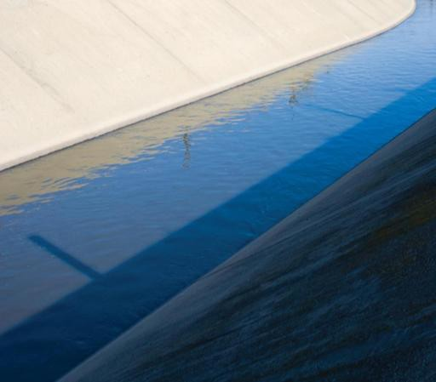  Western Treatment Plant channels | 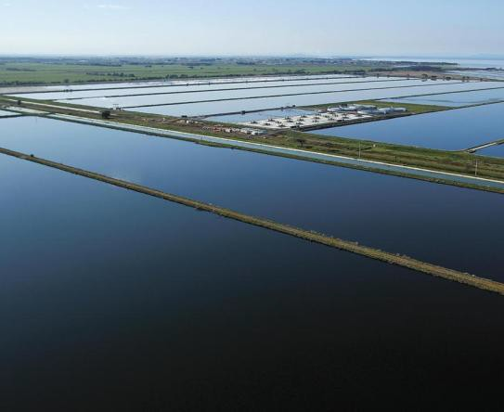  Western Treatment Plant lagoons
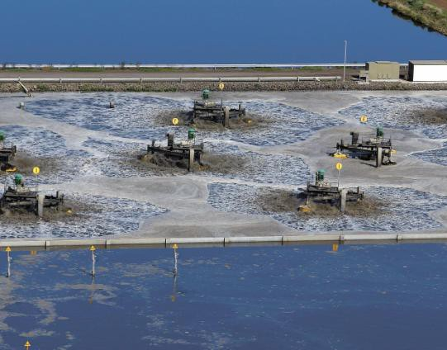  Western Treatment Plant aerators | 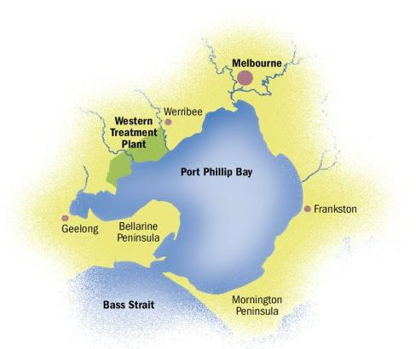  Sea (Port Phillip Bay)

Victorian Curriculum and Assessment Authority (VCAA) <http://victoriancurriculum.vcaa.vic.edu.au/> Accessed 14 August 2016.

