Waterwatch
Litter Trackers: reducing littering by education

Primary education resources

Introduction
Our city’s rivers and creeks receive stormwater that runs off roofs and roads in urban areas. This stormwater often contains litter carried from Melbourne’s streets. Once it enters the drainage system, it is transferred through a series of pipes into local wetlands, creeks and rivers.
Litter items may be trapped in stream-side vegetation, collected by litter traps, or transported along the waterway eventually ending up in Port Phillip Bay. Litter is a direct financial cost to local and state governments, and therefore to the community. It is also harmful to our wildlife in both freshwater and marine environments. The Victorian Government is working to reduce litter to protect our waterways and Port Phillip Bay.
Bottles containing Global Positioning System (GPS) trackers (pictured) were released in various creeks and rivers by schools and community groups to simulate the movement of litter through the stormwater drainage system. In all, 100 GPS-tracked bottles in 20 locations across Melbourne’s catchments have mapped precisely how litter makes its way from our streets to our beaches.
This resource is designed for students in Years 3 to 6. The case study gives an overview of the litter trackers launch and journey. Adapt the activity for your year level.

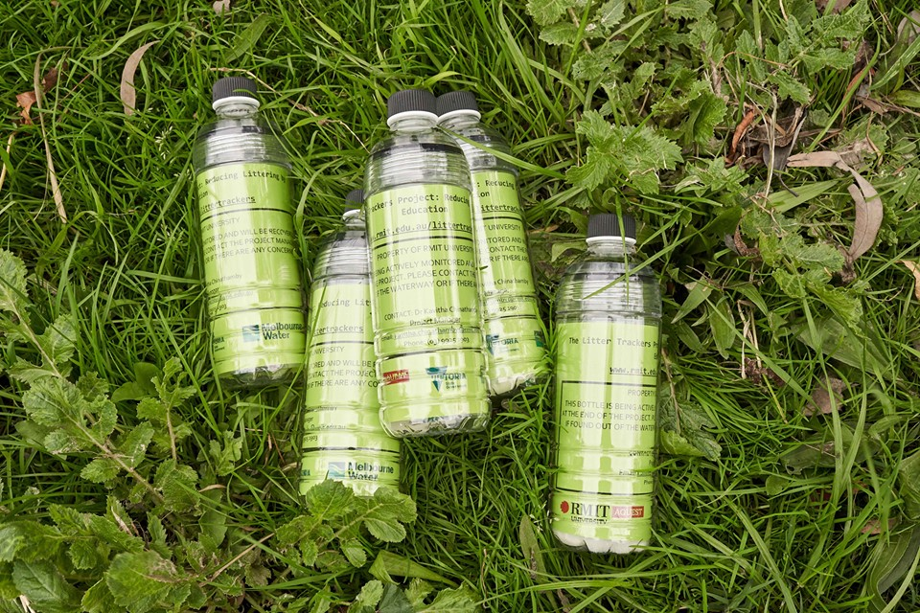
Litter Tracker bottles. Image courtesy of RMIT University.
Victorian Curriculum Year 3–6 links:

Science
Year 3 and 4 - Science understanding
Science knowledge helps people to understand the effects of their actions (VCSSU056)

Geography
Year 3 and 4 - Geographical knowledge
Types of natural vegetation and the significance of vegetation to the environment, the importance of environments to animals and people, and different views on how they can be protected; the use and management of natural resources and waste, and different views on how to do this sustainably (VCGGK082)
Year 5 and 6 -Geographical concepts and skills
Describe and explain interconnections within places and between places, and the effects of these interconnections (VCGGC087)
Collect and record relevant geographical data and information from the field and secondary sources, using ethical protocols (VCGGC088)
Geographical knowledge
Environmental and human influences on the location and characteristics of places and the management of spaces within them (VCGGK096)

Mathematics
Year 3 - Measurement and Geometry
Create and interpret simple grid maps to show position and pathways (VCMMG143)
Year 4 -Measurement and Geometry
Use simple scales, legends and directions to interpret information contained in basic maps (VCMMG172)
Year 5 –Measurement and Geometry
Choose appropriate units of measurement for length, area, volume, capacity and mass (VCMMG195)
Use a grid reference system to describe locations. Describe routes using landmarks and directional language (VCMMG199)
Year 6 - Measurement and Geometry
Measure, calculate and compare elapsed time (VCMMG227)

Design and Technologies
Year 3 and 4 - Creating Designed Solutions
Generate, develop, and communicate design ideas and decisions using appropriate technical terms and graphical representation techniques (VCDSCD029)
Year 5 and 6 - Creating Designed Solutions
Generate, develop, communicate and document design ideas and processes for audiences using appropriate technical terms and graphical representation techniques (VCDSCD039)

Activity 1: GPS trackers
Students are introduced to GPS trackers and practise using them around the school grounds.

Activity 2: Measuring time and distance
Students measure the length of time and distance of moving things online and in the school grounds.

Activity 3: Plotting the journey
Students discover the impact of rainfall, vegetation and landscape on the movement of litter in the environment.

Activity 4: Investigation
Students investigate their local waterway and the ways that litter moves through it.

Activity 5: Call to action
Students create an awareness campaign to highlight the importance of putting rubbish in the correct place.

Case study
Schools and community groups released bottles with GPS litter trackers into 20 rivers and creeks in Melbourne. Each group released five trackers per site, which were monitored for four weeks before being collected.
The table below details three of the releases (in May 2019) including the school and community groups, waterway, tracking data, location, date and weather. Five litter tracker bottles were released from each site.
School/community group | Waterway and general movement of tracker | Release location | Release date | Weather
Bentleigh West Primary School  First Friends of Dandenong Creek | Dandenong Creek  Trackers travel short distances and have less stops.  Tracking data | Vermont | 28 May 2019 | Top temperature: 15.7⁰C  Rain: 0.2 mm  Sun: 0.2 hours  Wind:  9am N 19 km/hr  3pm N 9 km/hr
Antonine College  Merri Creek Management Committee  Waterwatch | Merri Creek  Trackers travel long distances quickly. Can go back and forth (back up the Yarra River).  Tracking data | Brunswick East | 31 May 2019 | Top temperature:  14.3⁰C  Rain: 1.4 mm  Sun: 1.1 hours  Wind:  9 am SW 9 km/hr  3 pm SSW 9 km/hr
Our Lady of the Nativity Primary School | Maribyrnong River  Trackers travel long distances quickly. Can go back and forth (back up the Maribyrnong River).  Tracking data | Aberfeldie | 31 May 2019 | Top temperature:  14.3⁰C  Rain: 1.4 mm  Sun: 1.1 hours  Wind:  9 am SW 9 km/hr  3 pm SSW 9 km/hr
Over the next four weeks, the litter tracker bottles travelled along the waterway. Some found their way out into Port Phillip Bay.
Figure 1 shows the journey of one bottle from the Dandenong Creek release. You can also view this tracking data in an interactive map here. Each dot shows where the litter tracker bottle stopped and how far it moved within four weeks. More maps from the first launch can be found in Appendix 1.
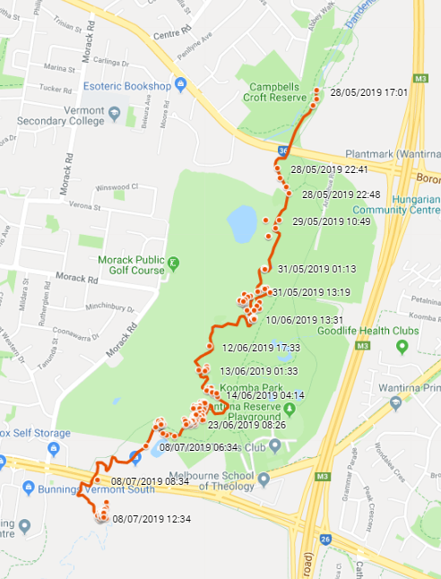
Figure 1. Dandenong Creek Bottle 1, released 28 May 2019.

Rainfall impacts the river level and flow of each waterway. Figure 2 shows the rainfall during the month of June at each launch site. It also includes the monthly average for June at that site.
Location | Monthly rainfall (mm) June 2019 | Average rainfall (mm) June
Dandenong Creek, Vermont | 51.6 | 66.8
Merri Creek, Brunswick East | 51.6 | 56.0
Maribyrnong River, Aberfeldie | 52.2 | 40.7
Figure 2. Rainfall at launch sites June 2019. Source: Rainfall and river levels, Melbourne Water
Tracking data
While the trackers were in the waterways, their data was documented using Google Maps. You can follow their complete journey using the Dandenong Creek Google Map. Each time a tracker completed a trip, the red dot appeared on the map as a trajectory. A ‘trip’ is when the tracker moves and then stops. The map allows you to select ‘street map’ (see Figure 3) or ‘satellite image’ (see Figure 4) view.
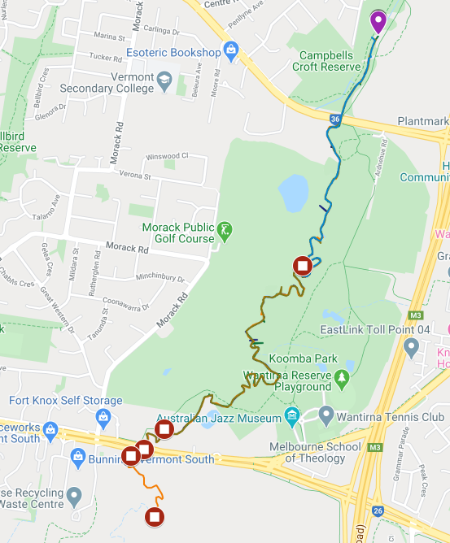
Figure 3. Street map view of the journey of the Dandenong Creek litter trackers, released 28 May 2019.
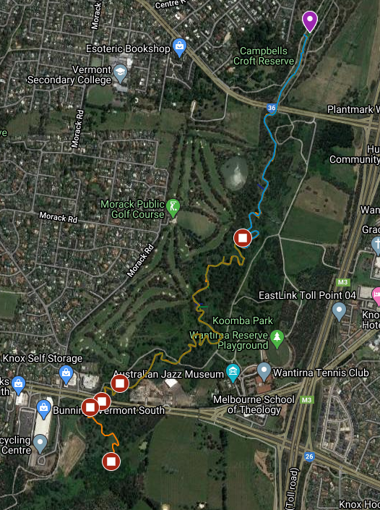
Figure 4. Satellite image of the journey of the Dandenong Creek litter trackers, released 28 May 2019.

The Litter Trackers project has now ended. Watch the following videos which show the beginning to end journeys of the GPS litter trackers, documented during the project, along four of Melbourne’s waterways.
- Dandenong Creek
- Elster Creek
- Maribyrnong River
- Merri Creek

You can also view the complete tracking data and interactive google maps of each waterway where litter trackers were released on the RMIT Litter Trackers web page under ‘Tracking data’.
According to the Keep Australia Beautiful National Litter Index (2017/2018), the top ten most littered items nationally are:
1. Cigarette butts (and their packaging)
2. Plastic snack bags and confectionary wrappers
3. Plastic straws
4. Plastic bottle tops
5. Metal bottle tops and can ring pulls
6. Carbonated soft drink and flavoured water in cans
7. Paperboard cups and paperboard takeaway food containers
8. Plastic takeaway containers and plastic cups
9. Paper shopping dockets and shopping lists
10. Paperboard coffee cups.
This rubbish enters our waterways every day, taking a similar journey to the litter tracker bottles.
The following activities incorporate information from the case study, data from the litter trackers map and real-life learning to assist students in understanding the litter trackers project and the problem of litter in our waterways.

Activity 1: GPS trackers

Students learn how GPS works and practise using it with a tablet device.
Equipment
For the teacher:
Whiteboard and markers
Smartboard or TV connected to the internet
How does GPS work? video [1:42] This video provides an overview of Global Positioning Systems.
Stormwater runoff pollutes animation [0:30] This animation uses text to explain where stormwater comes from.
Stormwater pollution the dirty truth: home activities animation [1:48] An animation that explains the products that shouldn’t go into stormwater.
Where does stormwater go? animation [2:13] Find out how quickly stormwater enters our waterways in urban areas.
Stormwater runoff model video [1:45] This video uses a stormwater runoff model (in a plastic tub) to demonstrate what is washed into our waterways when it rains.
For the student:
A tablet for each student or each group
Preparation
Download the Google Maps app onto each tablet. Ensure location services is turned on for that app.

Activity steps
- As a class, discuss Global Positioning Systems (GPS). What do students already know about GPS? Why is it useful?
- We use it for finding an address, calculating distance and time, exploring what is close by or when we’re walking or hiking. We can also use it for environmental purposes.
- Ask students if they can think of anything that might use GPS. For example:
- trucks, shipments, surveying
- animals (see the Arthur Rylah Institute project Tracking eel migration using satellites).
- Watch the video How does GPS work? [1:42]
- On the whiteboard, draw a simple map of the classroom. Ask a student to walk around the classroom. While they do this, another student plots their movements on the whiteboard with a marker. Explain that this is what GPS does.
- Draw a simple map of the school on the whiteboard. Include grid lines and direction.
- Introduce students to Google Maps (on a tablet). Explain that the blue dot is the device and it will move when the device moves (location services must be turned on for that app).
- Students move outside with their tablet to watch the blue dot move as they move around the school.
- Back in the classroom, discuss the accuracy of the map. (Google Maps knows your location up to around 20 metres.)
- Ask students to plot their movements on the whiteboard map. They could also draw their own map on paper and mark their movements on it.
- Introduce the Litter Trackers project. This project tracks litter and the movement of rubbish in our waterways. You can view the complete tracking data and interactive google maps of each waterway where litter trackers were released on the RMIT Litter Trackers web page under ‘Tracking data’.
- Watch one of the following videos about stormwater runoff pollution:
- Stormwater runoff pollutes animation [0:30]
- Stormwater pollution the dirty truth: home activities animation [1:48]
- Where does stormwater go? animation [2:13]
- Stormwater runoff model video [1:45]
- Discuss some things students may have seen on the ground that could eventually end up in our waterways. What can we do to prevent that?

Years 5 and 6 extension
- Students draw their own map of the classroom, including tables, chairs, shelving, storage rooms, entry and exit etc.
- In groups of four, two students walk around the classroom while two other students plot their journey on their own map. Then swap tasks.
- Students draw their own map of the school (or their area of the school if it’s a large school) using grid lines and directions.
- Brainstorm where the litter might start then end (e.g. starting as rubbish in the school yard, blowing into the gutter, washing into stormwater drains, out to creeks and rivers and eventually out to Port Phillip Bay and into the open ocean to become marine debris). Discuss the problems litter can cause in waterways and the ocean.

Activity 2: Measuring time and distance
Students learn how to measure distance and observe time on a digital and paper map.
Equipment
For the teacher:
Whiteboard and markers
Smartboard or TV connected to the internet
The Litter Trackers website
For each group:
A basketball or large round ball
For the student:
A tablet for each student or each group
Preparation
Download the Google Maps app onto each tablet. Ensure location services is turned on for that app.

Activity steps
- Choose one of the Litter Tracker journey videos below and view on the smartboard.
      - Dandenong Creek
      - Elster Creek
      - Maribyrnong River
      - Merri Creek
- After viewing one of the videos, choose the corresponding Tracking data and view on the smartboard/
      - Dandenong Creek
      - Elster Creek
      - Maribyrnong River
      - Merri Creek
- Compare the journey on the map to a local route. For example, display a map of the local area on the smartboard or TV. Show students the route from school to a local sporting oval or pool, or to the closest supermarket. With markers, draw the route over the top of the map on the whiteboard.
- Students draw a map of the school (or their year level area of the school) including grid lines and direction. It should also include the map’s scale (metres are best for this activity). Figure 6 shows a map of a sample school, including grid lines, scale and direction.
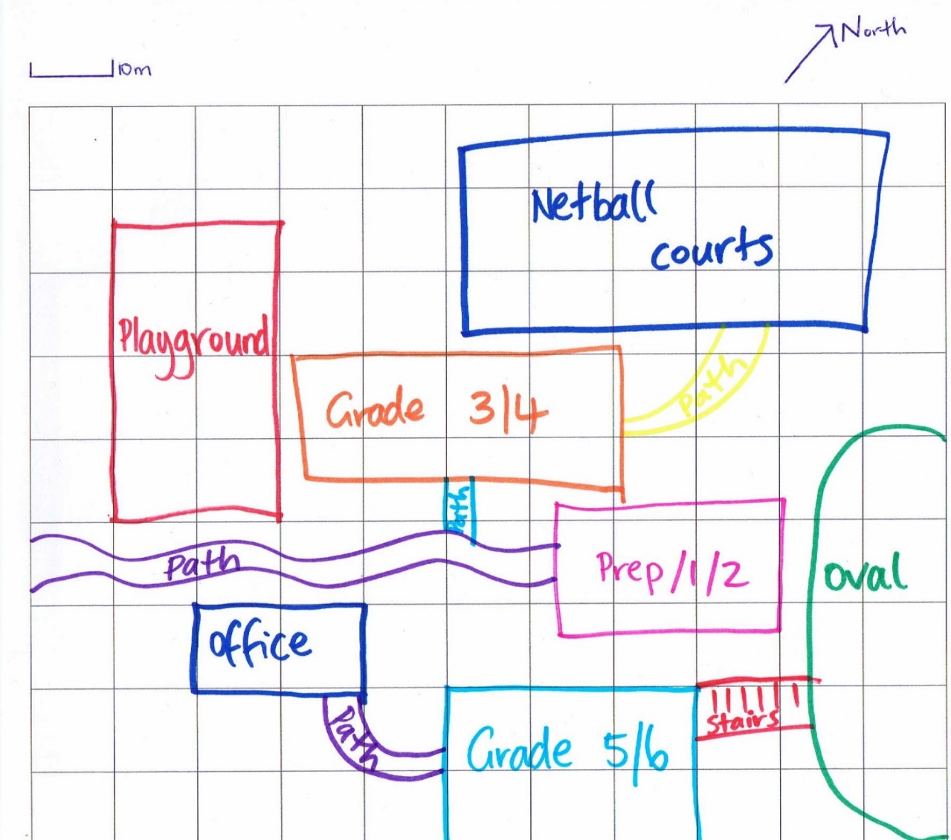
Figure 6. Map of a sample school.
- In groups, students take a ball and their map outside. Find a place clear of obstacles and ask students (in groups) to throw the ball. Students record the answers to the following questions:
- Where does the ball stop?
- Which path does it go down?
- What does it hit along the way?
One student can plot the ball’s path roughly on their map while outside.
- Back in the classroom, students plot the ball’s journey on their map and share their findings. What was common? (e.g. did the ball get stuck or stop in the same place? Did it travel down the same path? Did a gust of wind blow it off course? Was there a stick in the way that made it move in a different direction?) Explain that these things might happen to the litter tracker bottles while they’re in the water.
- Revisit the litter trackers map and discuss things that may have made the bottles stop and start up again.

Years 5 and 6 extension
- Measure the distance the ball travelled by using the grid lines and the map’s scale.
- As a class, look at the maps in the appendices:
- Appendix 1. Dandenong Creek bottles
- Where did the litter trackers start? Where did they stop? Where are the clusters of stop-starts (i.e. the clusters of dots)?
- Using Google Maps (app on a tablet or on the website), measure the distance the journey has taken. Refer to the following appendices for instructions on how to measure in Google Maps:
- Appendix 2. How to measure distance on Google Maps (app)
- Appendix 3. How to measure distance on Google Maps (internet)
- Look at the starting point date and time of the trackers and the end point date and time. How long has it taken each litter tracker bottle to travel the distance it has travelled? Is that slow or fast, in your opinion?
- Discuss the differences in the waterways that might make the litter trackers speed up, slow down or go backwards. For example, is there vegetation stopping the bottles or is the waterway paved?
- Choose another waterway where litter trackers were released and view the complete tracking data and interactive google maps on the RMIT Litter Trackers web page under ‘Tracking data’.
- Investigate the distance and time it has taken other litter tracker bottles to move.

Activity 3: Plotting the journey
Students determine the factors that affect the movement (or lack of movement) of the litter tracker bottles.
Equipment
For the teacher:
Smartboard or TV connected to the internet
Google Maps app
Google Earth app
The Litter Trackers website
Bureau of Meteorology climate data website
For the student:
A tablet for each student or each group
Preparation
Download the Google Maps app onto each tablet. Ensure location services is turned on for that app.
Download the Google Earth app onto each tablet.

Activity steps
- Revisit the ‘litter trackers’ maps in the appendices.
- Using the rainfall charts in the case study and the maps, students complete the following:
- Look at the overall rainfall for June 2019 compared with the average for June. Is it more or less?
- What effect would rainfall have on the movement of the litter tracker bottles?
- Using Google Maps or Google Earth, turn on satellite view then type in the address of a launch site. Zoom in on the waterways. Trace the route of the litter tracker bottles along the waterway.
- Is the waterway surrounded by trees or grass?
- Are there houses and factories nearby?
- Can you see any boat ramps, boats or ships?
- Do the waterways travel through built up areas or bushland?
- Can you see any wetlands?
- Can you see any diversions?
- Can you see what the base of the waterway is (e.g. concrete, mud, paving etc.)?
- Discuss what this might mean for the litter tracker bottles.
For example, the trackers may:
- get stuck in reeds or rocks
- bump into boats
- be dragged along by a ship
- be stuck in a wetland
- be stuck with other rubbish
- bump into a bridge.

Years 5 and 6 extension

Figure 7 shows the location of litter traps in Melbourne’s waterways (orange dots). Litter traps are large structures anchored in the river that collect floating rubbish. Have any litter trackers been caught by a litter trap?

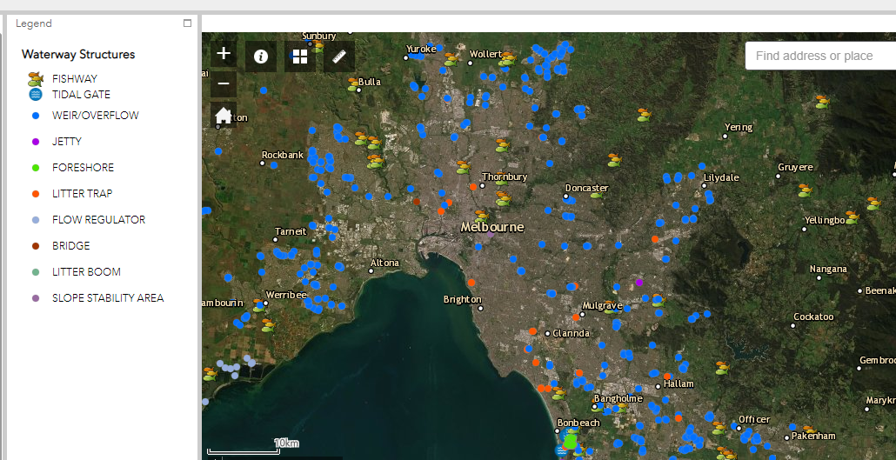
Figure 7. Location of litter traps along Melbourne’s waterways.

Activity 4: Investigation
Students devise solutions to litter problems in their local area.
Equipment
For the teacher:
Smartboard or TV connected to the internet
The Litter Trackers website
Clean Up Australia website
Paper map of local area
For the student:
A tablet for each student or each group
Paper map of local area
Preparation
Download the Google Earth app onto each tablet.

Activity steps
- Discuss how litter can travel from the ground, into stormwater drains, into the waterways and eventually end up in the bay.
- Using a paper map of your local area, students find the closest waterway (river, creek etc.) to school or to where they live. Trace a pencil along the waterway, following its twists and turns until it reaches Port Phillip Bay. Discuss:
- How far would it have to travel?
- What locations would it pass through?
- Is there anything that might stop the litter?
- Look at the same waterway on Google Earth. Can you add to your answers?
- As a class, using the top ten most littered items in the case study (p. 8), list one environmental impact for each litter item. For example: cigarette butts can take up to five years to break down but they don’t degrade. They also add harmful chemicals into a waterway. Plastic bags can choke animals that ingest them.

Years 5 and 6 extension
Investigate the impacts of litter on the environment. Students choose one item from the list of the top ten most littered items in the case study (p. 8) and investigate how it might travel from someone’s hand or pocket to our waterways and beaches. Include details such as:
- where it has come from (e.g. thrown from a car, dropped on the street, blown from an overflowing bin)
- what factors contributed to it getting to the waterway (e.g. heavy rain, strong wind)
- what happens once it’s in the waterway (e.g. harms aquatic life, is trapped in the creek for years).

Activity 5: Call to action
Students design an awareness campaign to help combat the litter problem.
Equipment
For the teacher:
Smartboard or TV connected to the internet
The Litter Trackers website
For the student:
Access to a tablet or video and video editing software (see Useful resources for suggestions)
Preparation
Download video editing software onto each tablet.

Activity steps
- Students create a slogan and awareness campaign to help others in your school and community to think about litter and where it ends up. Detail the problems and the solutions. They could:
- create a poster or digital presentation
- act out a skit, video or radio ad
- produce an animation.
- Promote students’ ideas and products in the school newsletter, the school website or on your school Facebook page or blog (if you have one). Follow the Litter Trackers Facebook page for current launches and information.

Years 5 and 6 extension
- Design and write a pledge to use less plastic, put rubbish in the bin or organise a clean-up day.
- Run a neighbourhood or school litter audit
- Consider participating in one of the following campaigns with your class or school:
- Clean Up Australia Day
- Nude Food Day
- Plastic Free July

Useful resources

AQUEST (Aquatic Environmental Stress Research Group)
The Aquatic Environmental Stress research group assesses the health of aquatic ecosystems, inland waterways and estuaries, using a weight-of-evidence approach based on environmental outcomes. The AQUEST team are involved in the Litter Trackers project.

Australian Marine Debris Initiative (Tangaroa Blue)
Tangaroa Blue Foundation is an Australia-wide not-for-profit organisation dedicated to the removal and prevention of marine debris: one of the major environmental issues worldwide.

Bureau of Meteorology
The Bureau of Meteorology is Australia's national weather, climate and water agency.

Google Maps
Google Maps is a web mapping service developed by Google. It offers satellite imagery, aerial photography, street maps, 360° panoramic views of streets, real-time traffic conditions, and route planning for traveling by foot, car, bicycle and air or public transportation.

Google Earth
Google Earth is a computer program that renders a 3D representation of Earth based primarily on satellite imagery. The program maps the Earth by superimposing satellite images, aerial photography, and GIS data onto a 3D globe, allowing users to see cities and landscapes from various angles.

Keep Australia Beautiful National Litter Index (2017/2018)
The Keep Australia Beautiful National Litter Index (NLI) is Australia’s only national, annual, quantitative measure of what litter occurs where and in what volume. Litter counts are done twice annually across 983 sites nationally to create an annual report on litter in each State and Territory that can be compared to the national average.

The Litter Trackers: reducing littering by education
The Litter Trackers is a collaborative project between RMIT University and Melbourne Water, supported by the Victorian Government. As part of the Litter Trackers project, scientists will work with schools and community groups to launch GPS tracked bottles into Melbourne’s waterways to demonstrate how and where litter travels once it enters our waterways.

Melbourne Water
Melbourne Water is a statutory authority owned by the Victorian Government. It is their role to manage and protect Melbourne's major water resources on behalf of the community. Melbourne Water is involved in the Litter Trackers project.

National Map
National Map is an online map-based tool to allow easy access to spatial data from Australian government agencies. It was an initiative of the Department of Communications and the Arts (DCA) now currently managed by the Digital Transformation Agency (DTA) and the software has been developed by Data61 working closely with the DCA, Geoscience Australia and other government agencies.

The Pesticide Detectives
The Pesticide Detectives is an extensive national Citizen Science project investigating the occurrence and concentrations of pesticides used in homes and gardens as well as agricultural and urban settings in Australia’s waterways.
Funded by the Department of Industry, Innovation and Business, Pesticide Detectives is a collaborative project combining the scientific expertise of RMIT University’s Aquatic Environmental Stress Research Group (AQUEST) scientists and Citizen Science volunteers in the collection of sediment samples from waterways across Australia.

Scribble Maps
With Scribble Maps you can create and share custom maps, embed maps on websites, and create images or PDF.

Video editing software
- Blender
- Lightworks
- Shotcut
- Openshot

Media links
You can follow the Litter Trackers project on Facebook: @littertrackers
The project has received widespread media coverage.
Please refer to the links below:
From the burbs to the bay: GPS tracking reveals how litter travels
A rubbish idea: GPS-tracked bottles show how litter moves through Melbourne’s waterways
Litter tracking project launches in Healesville
It’s legit, miss: The kids who litter to save the environment
Oyster2 used as ‘simulated litter’ in RMIT campaign
Tracking litter on Merri Creek
Williamstown students use the GPS bottles to track litter
Williamstown High School—Marine biology

Learn more about what is being done to stop litter
Australian Marine Debris Initiative
Tangaroa Blue Foundation is an Australia-wide not-for-profit organisation dedicated to the removal and prevention of marine debris: one of the major environmental issues worldwide
Beach Patrol
Beach Patrol is an organised network of volunteers and community beach cleaning groups who clean the beaches of Melbourne to make them safer and more enjoyable for everyone.
Clean Up Australia Day
Clean Up Australia inspires and empowers communities to clean up, fix up and conserve our environment. The website has information on clean-up events and resources about the impact of litter.
Environment Education Victoria
Environment Education Victoria (EEV) is a professional association of educators for sustainability. EEV offers membership for teachers and free classroom resources.
Keep Australia Beautiful
Keep Australia Beautiful is a national organisation that is recognised as Australia’s independent litter prevention thought and practice leader, for a litter free and sustainable Australia.
National Litter Index
A national measure of the presence of litter across the country.
Responsible Runners
An organisation that asks the community to join them across Australia for a fun 30 minute clean-up to meet like-minded people and protect our marine environment. They also help sort recyclables and collect data for the Australian Marine Debris Initiative.
Victorian Litter Action Alliance, Sustainability Victoria
Sustainability Victoria supports state and local government, land managers and other partners to address litter and illegal dumping issues.
Waterwatch Victoria
Waterwatch is a citizen science community engagement program connecting local communities with river health and sustainable water issues and management.

Appendix 1
You can also view the tracking data and journeys of the litter trackers on The Litter Trackers website.

Dandenong Creek maps
Dandenong Creek Bottle 1 journey with dates.

Dandenong Creek Bottle 2 journey with dates.

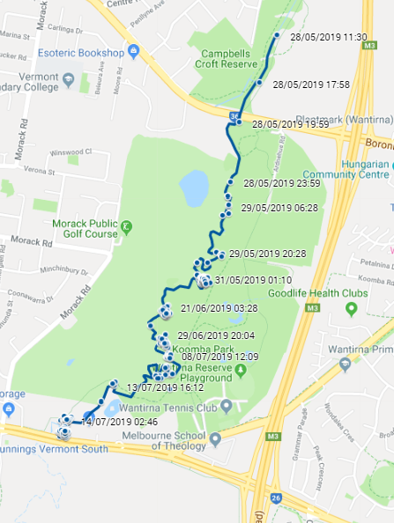

Dandenong Creek Bottle 3 journey with dates.

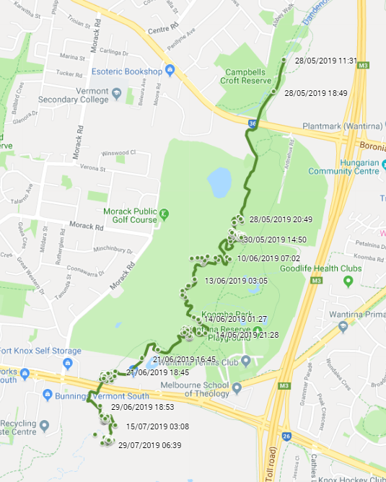

Dandenong Creek Bottle 4 journey with dates.

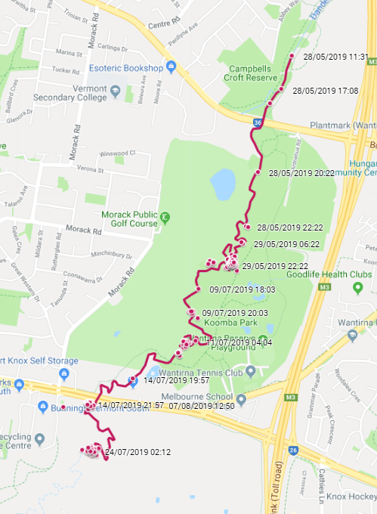

Dandenong Creek Bottle 5 journey with dates.

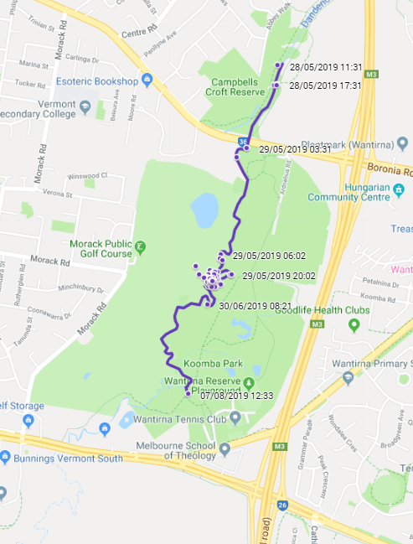

Appendix 2

How to measure distance on Google Maps (app)
Type into the search bar the name of the site (e.g. Maribyrnong River Trail).
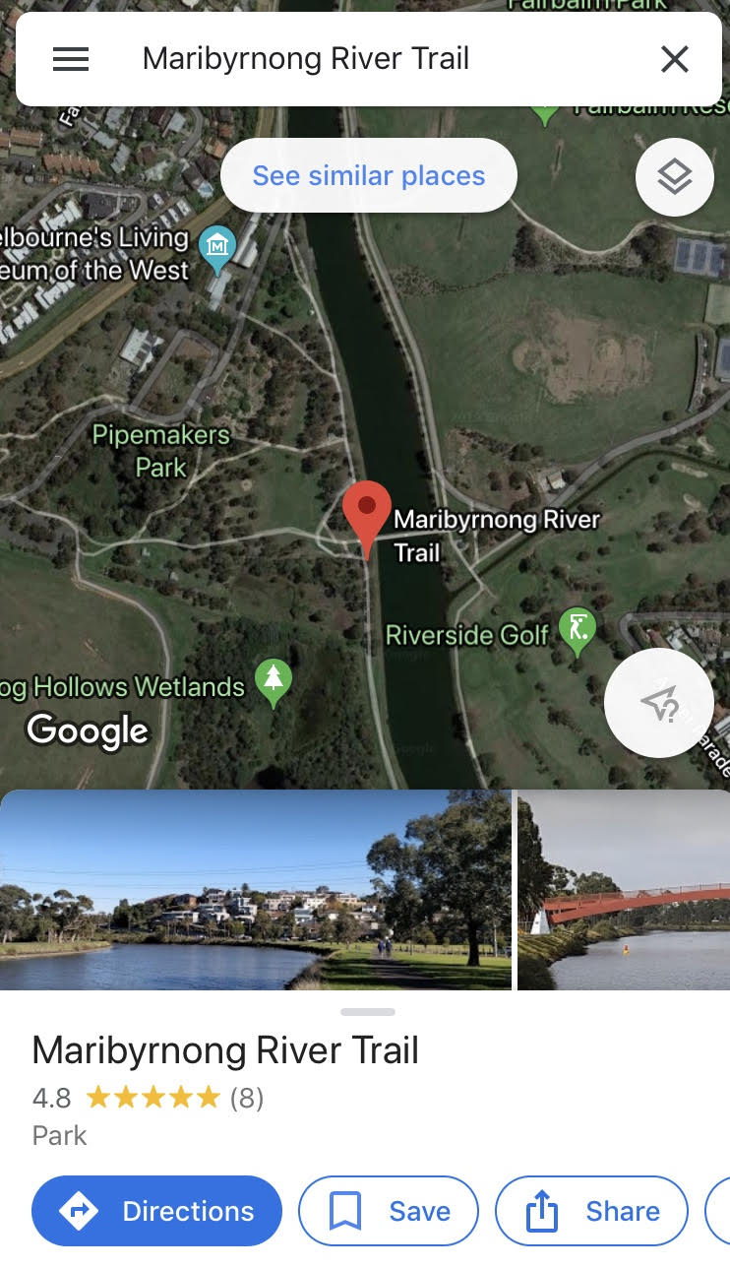

Select exact location and hold screen. Dropped pin will appear along with a red place marker. Tap the ruler ‘Measure distance’.
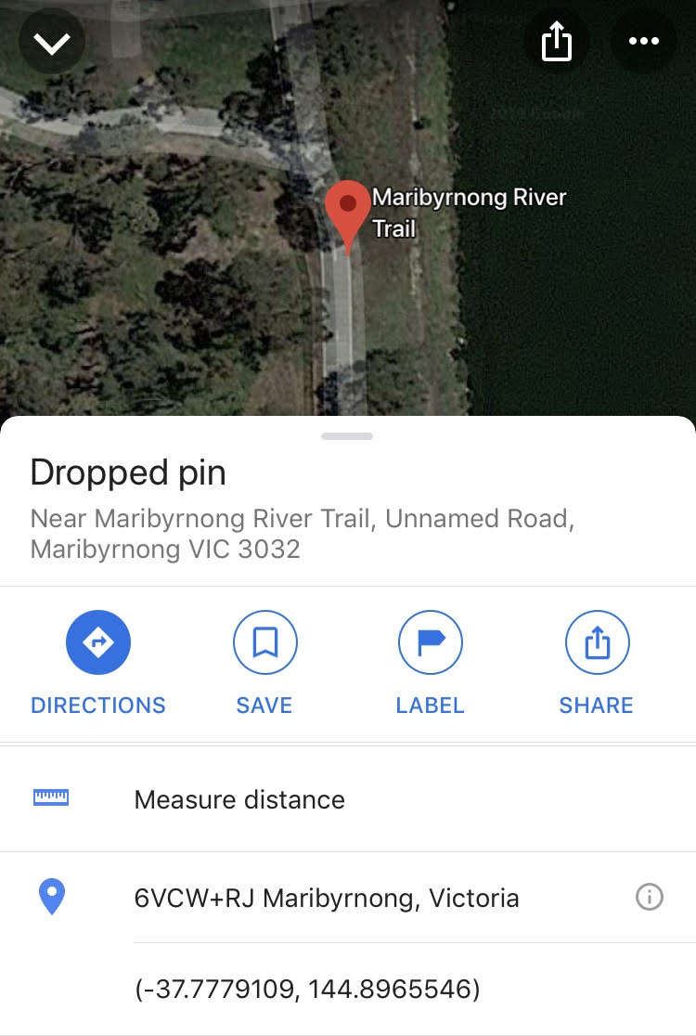

As per the instructions on the screen, drag the map and tap ‘Add point’ (plus sign inside the blue circle). The distance shows beneath.
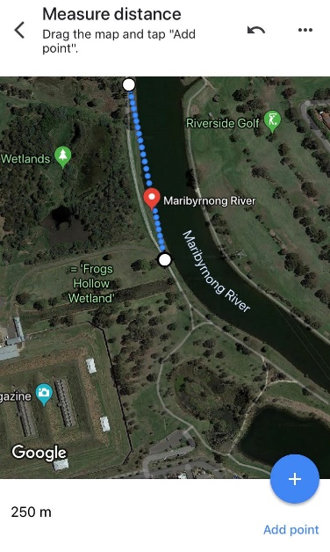

Continue adding points until you have reached the end point.
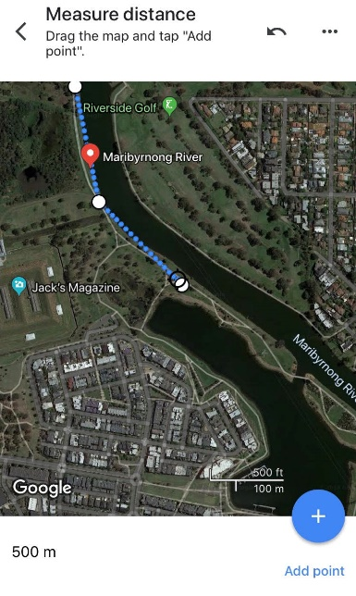

Appendix 3

How to measure distance on Google Maps (internet)
Right click on dropped pin and select ‘Measure distance’.

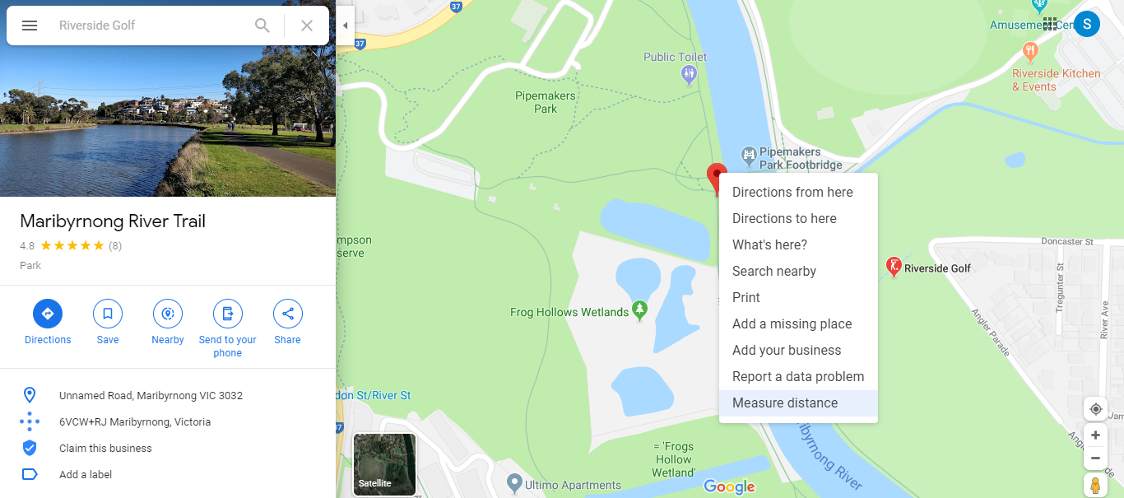

Click another location on the map and distance will show in the box.
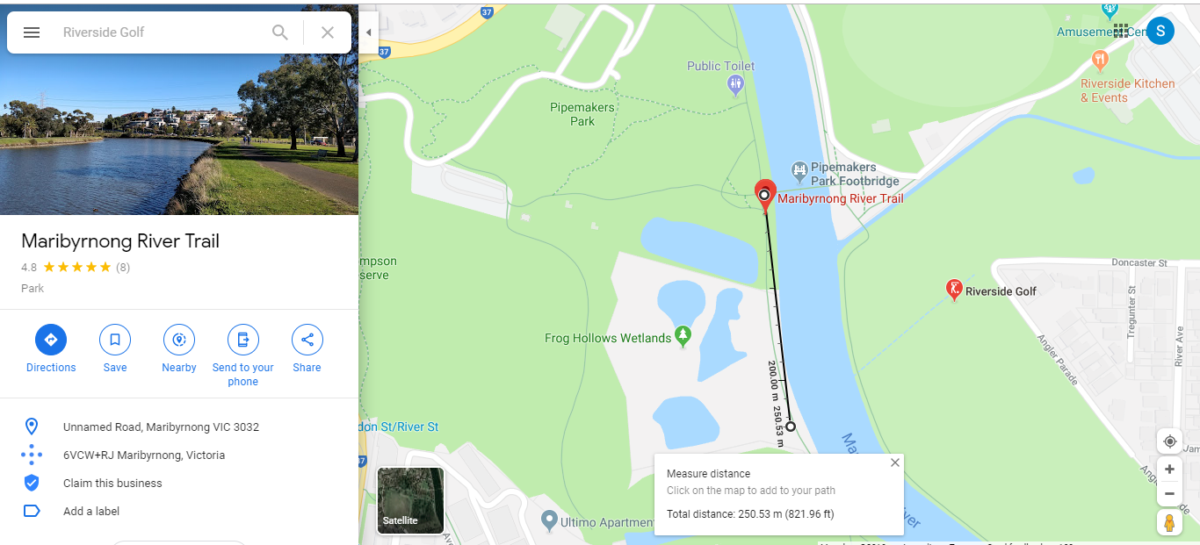
Continue adding locations to measure the full distance. Total distance is displayed in the box.
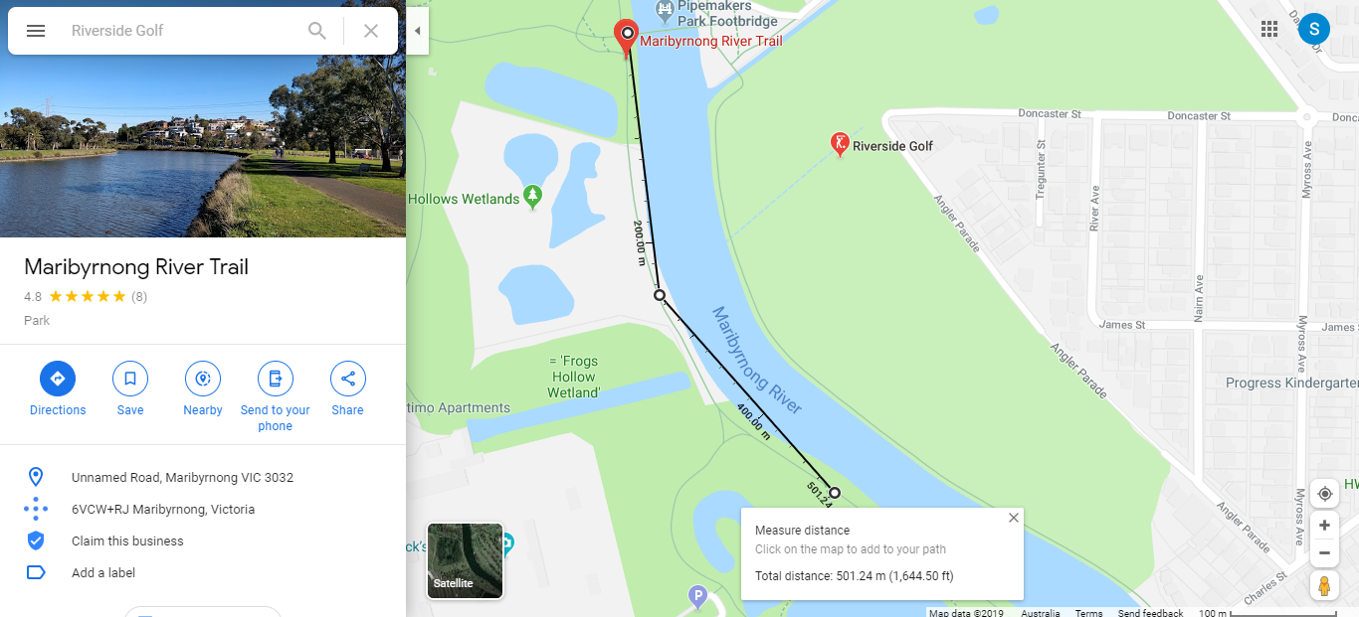

Appendix 4
Litter Trackers – Dandenong Creek | RMIT University (YouTube)
Check out our litter trackers journey through Dandenong Creek.
Litter Trackers – Elster Creek | RMIT University (YouTube)
Check out our litter trackers journey through Elster Creek.
Litter Trackers – Maribyrnong River | RMIT University (YouTube)
Check out our litter trackers journey through Maribyrnong River.
Litter Trackers – Merri Creek | RMIT University (YouTube)
Check out our litter trackers journey through Merri Creek.

Video links also available at…

https://www.rmit.edu.au/research/research-institutes-centres-and-groups/research-groups/aquest/rmit-litter-trackers

Reference
AQUEST Research Group at RMIT
AQUEST- Aquatic Environmental Stress Research Group @ RMIT University

The Victorian Curriculum F-10 content elements are © VCAA, licensed CC-BY-NC-SA. In addition to the content published on the Victorian Curriculum F–10 website, F–10 curriculum support resources can be accessed from the VCAA website. Accessed 10 September 2019.

